Notes on TDA2x Stereo Use Cases

- There are two stereo use cases for TDA2x
  - \vision_sdk\apps\src\rtos\usecases\lvds_vip_single_stereo
    - Stereo use case after calibration
  - \vision_sdk\apps\src\rtos\usecases\lvds_vip_single_stereo_auto_calib
    - Stereo calibration use case to generate rectification table

- First of all, make sure that you set stereo parameters properly. You can find the parameters and their value in the attached file (TDAx_Disparity_Calc_Dim.xls). Make sure that the right camera is connected to the first FPD link cable and left camera to the second FPD link cable.

- Before running the stereo use case, it is required to run stereo calibration first to have right rectification table into flash memory on TDA2x. Run first \vision_sdk\apps\src\rtos\usecases\lvds_vip_single_stereo_auto_calib.
This use case uses natural stereo images for calibration. Once you start, you will see the following menu:
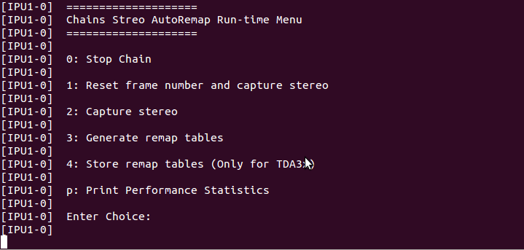
1: Reset frame number and capture stereo will remove all feature points collected previously (if any), and collect new feature points from stereo input.
2: Capture Stereo will collect new feature points without removing previous feature points. This option enables to collect feature points from multiple stereo inputs to have enough feature points for calibration.
3: Generate remap tables will generate rectification tables from collected feature points. You have to run 3 after collecting feature points using 1 and 2.
0: Stop chain will store tables into the flash memory.
Please note that we do not need any chart to collect feature points. This stereo calibration is applied using feature points from natural images. But it is recommended to get enough features across a whole image area. That’s why it is allowed to collect features from multiple stereo inputs. Maximum number of features the stereo calibration algorithm uses is set to 2000. In order to remove rectification table in flash memory, simply run 0: Stop chain as soon as you start this use case.
- If you do not have rectification tables in flash memory, stereo use case will use tables defined in \vision_sdk\apps\src\rtos\alg_plugins\remapmerge\rectMapLeft_int_converted.c and \vision_sdk\apps\src\rtos\alg_plugins\remapmerge\rectMapRight_int_converted.c. These two files are generated by offline calibration. For details about offline, please refer to \vision_sdk\docs\FeatureSpecificUserGuides\VisionSDK_UserGuide_TDA2xx_StereoCalibrationGuide.pdf. To dump input stereo images for offline stereo calibration, you need to run vision_sdk\apps\src\rtos\usecases\lvds_vip_single_stereo_calibration. But this is very time consuming, so it is recommend only if users want to have more precise rectification table, e.g. acquired by chart-based calibration.

- After calibration, you are ready to run the stereo use case. If you are not satisfied calibration, then repeat stereo calibration.

