I use the following command to set the frequency:（DEV_A72SS0_ARM_CLK_CLK）：k3conf set clock <dev_id> <clk_id> <freq>

here：dev_id=4, clk_id=2

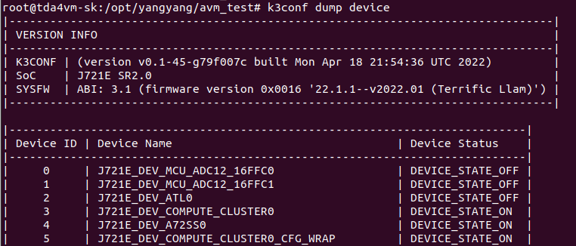

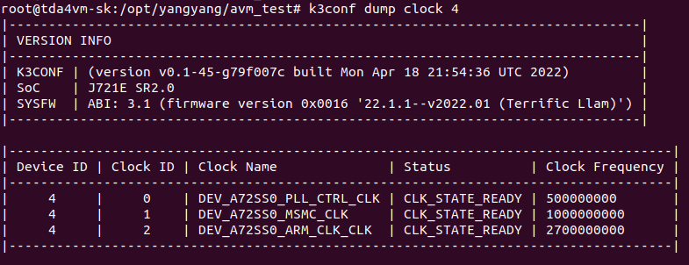

There is a demo program of YUV420 to RGB. The resolution of the input image is 1280*960，It takes about 15ms to execute on TDA4，Is this a reasonable time？

The performance of different frequencies are as follows:

|  |  |
| --- | --- |
| freqency（G Hz） | Avg Time（ms） |
| 2 | 16.1977 |
| 1.2 | 13.4982 |
| 0.8 | 13.5546 |
| 0.4 | 13.4973 |
| 0.1 | 13.4965 |
| 2.7 | 12.0583 |

2GHz performance：

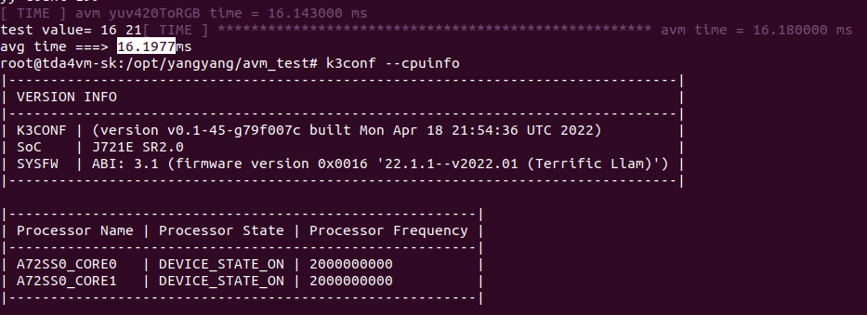

1.2GHz performance：

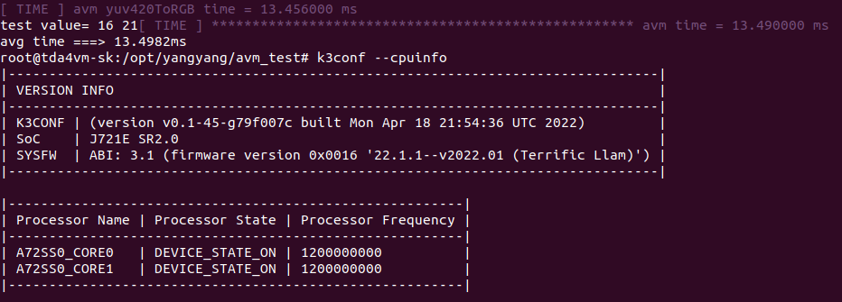

0.8GHz performance：

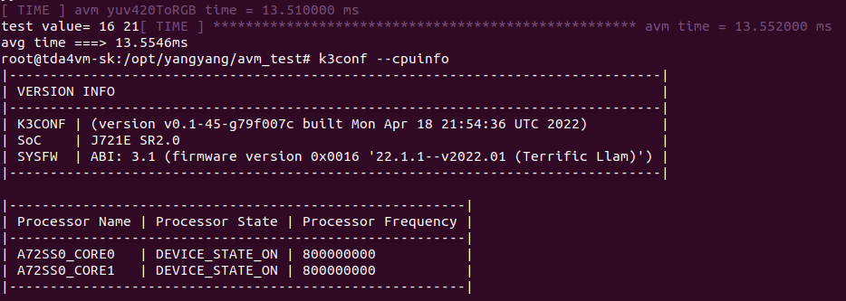

0.4GHz performance：

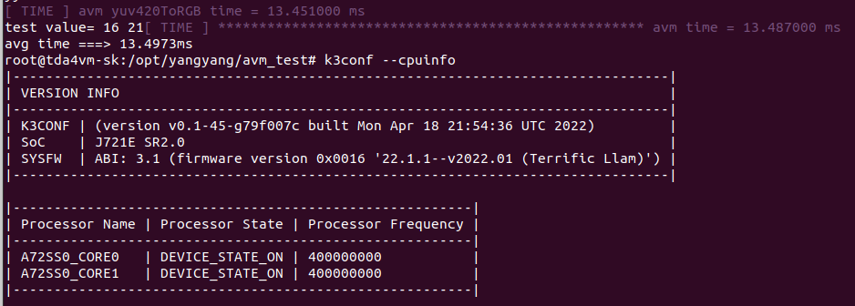

0.1GHz performance：

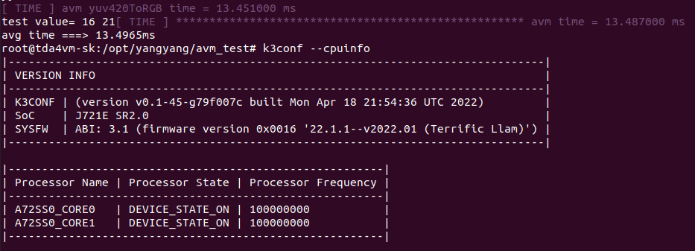

2.7GHz performance：

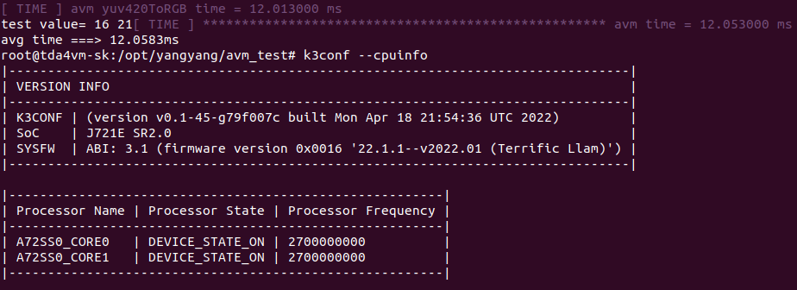

The source code of YUV420 to RGB is as follows：

void yuv420ToRGB(const uint8_t* pYuv, uint8_t* pRgb, const uint32_t width, const uint32_t height)

{

uint32_t width_min = width >> 1;

uint32_t height_min = height >> 1;

const uint8_t* Y = pYuv;

const uint8_t* U = Y + width * height;

const uint8_t* V = U + width_min * height_min;

timeval time_1{}, time_2{};

gettimeofday(&time_1, nullptr);

for (uint32_t j = 0; j < height; j++)

{

for (uint32_t i = 0; i < width; i++)

{

uint8_t y = Y[width * j + i];

uint8_t u = U[(j >> 1) * width_min + (i >> 1)];

uint8_t v = V[(j >> 1) * width_min + (i >> 1)];

int16_t r = y + 1.402 * (v - 128);

int16_t g = y - 0.34414 * (u - 128) - 0.71414 * (v - 128);

int16_t b = y + 1.772 * (u - 128);

pRgb[(j * width + i ) * 3 + 0] = b < 0 ? 0 : ((b > 255) ? 255 : b);

pRgb[(j * width + i ) * 3 + 1] = g < 0 ? 0 : ((g > 255) ? 255 : g);

pRgb[(j * width + i ) * 3 + 2] = r < 0 ? 0 : ((r > 255) ? 255 : r);

}

}

DELTA_TIME(time_1, time_2, "avm yuv420ToRGB time = %f ms");

}