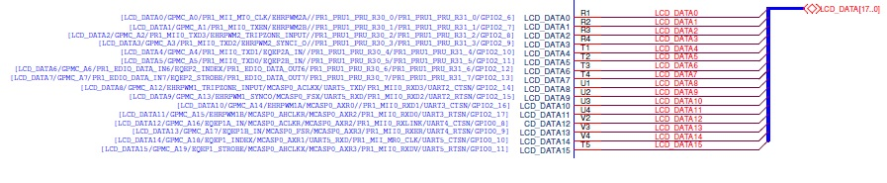
Fig.1

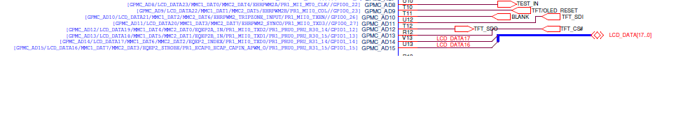
Fig.2

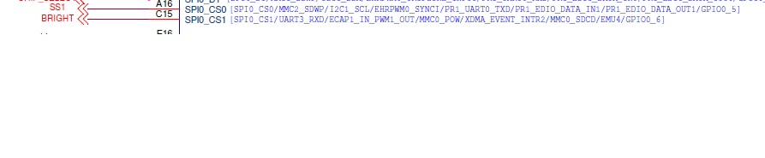
Fig.3

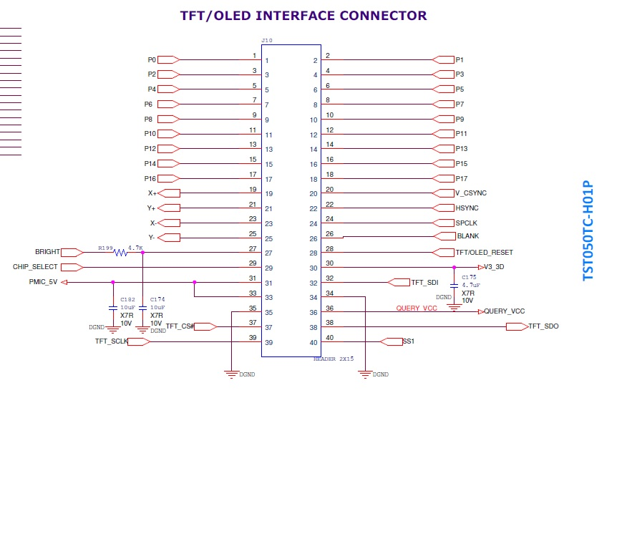
Fig. 4

Fig.1,2&3 (TFT Pins connection from the controller)
Fig.4 (interfacing the TFT connection from controller card to TFT Card)
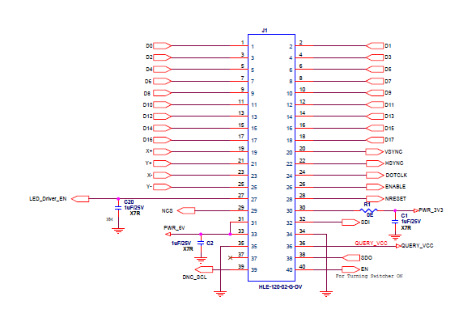
Fig.5
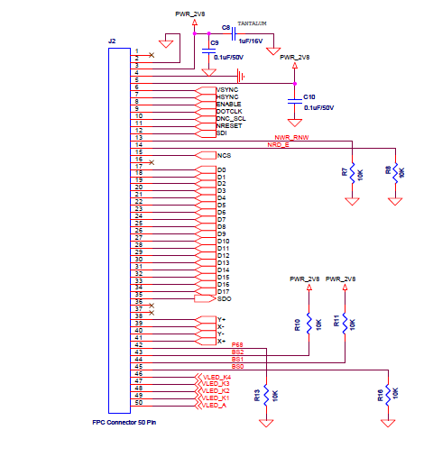
Fig.6
Fig.5( Connection from controller card to TFT Card)
Fig.6( Connection to TFT from TFT card)

