The machines (Windows and Linux) that I installed the tools on were clean machines in that they had never had any of the TI tools installed on them before. I did not get any indication that the installation of Code Composer or the SDK was impacted by a corrupted installation
Below is a screenshot showing the files that were downloaded from the TI website for the Windows Installation of Code Composer and the AM57XX and K2G RTOS SDKs.
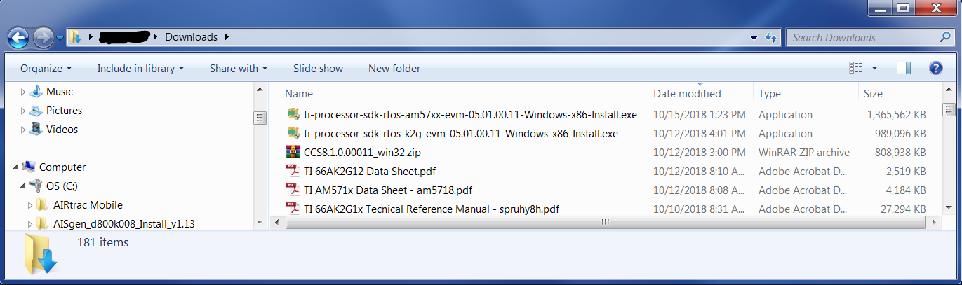
I know the release notes say one thing but the picture below is the directory structure created on my PC after installing Code Composer and the two SDKs. Note the missing triangles next the mathlib and dsplib folders indicating these are empty.
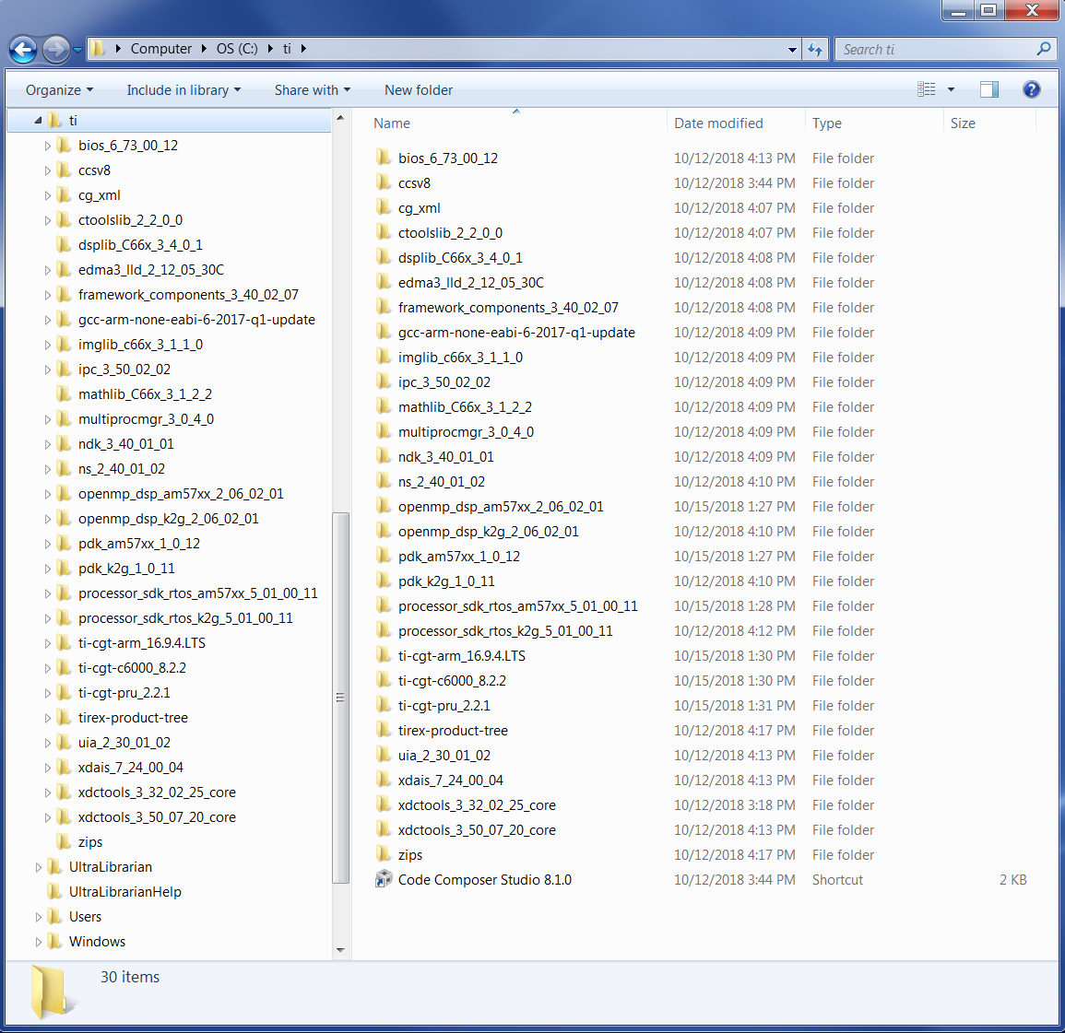
Perhaps you have different results because you had prior versions of Code Composer or the SDKs installed on your machine.

