Hi,
Thank you for support.

The answers to your questions are as follows.
1. Are both graphs in the same context?
--> answer：
The two apps are different processes,2 graphs are not in the same context.
We have 3 apps(each app is one process ,A total of three process ), APP2 and APP3 do not exist at the same time, so APP3 was not mentioned in the previous discussion.
CASE1: APP1 is running "1 senor nodes; 1 capture nodes; 1 (viss +aewb) nodes; 1 ldc nodes; 1 miscoa node; 1 display node,APP2 is running "TIDL node".Everything is working fine. The structure is shown in the figure.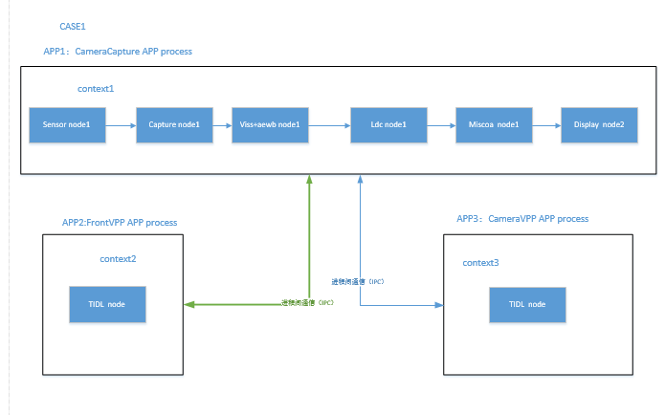
CASE2:APP1 is running "3 senor nodes; 3 capture nodes; 3 (viss +aewb) nodes; 3 ldc nodes; 1 miscoa node; 1 display node,APP2 is running "TIDL node". The structure is shown in the figure.
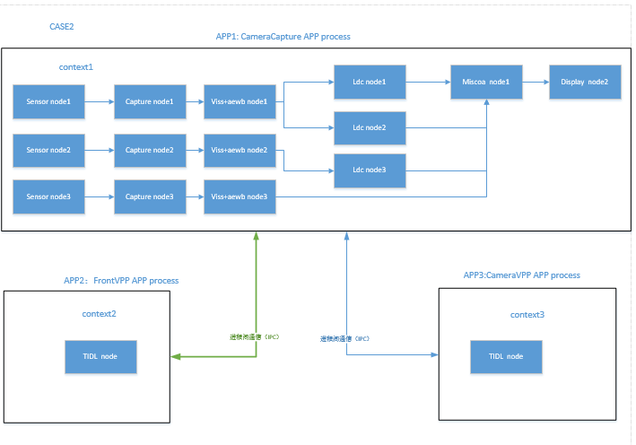
In this case, you are seeing the below error in Second Graph i.e. in the TIDL node
VX_ZONE_ERROR:[ownGraphCreateNodeCallbackCommands:983] Node create user callback command at index 0 failed
62.959650 s: VX_ZONE_ERROR:[vxVerifyGraph:2024] Create node callback commands failed
62.959663 s: VX_ZONE_ERROR:[vxVerifyGraph:2109] Graph verify failed
2. What are the graph parameters you are using here?
--> answer：
Parameter case1 is the same as parameter case2. There are many parameters, which parameters do you care about?

3. The change which you have done, i.e., 3 capture nodes, 3 viss etc. May I know what is the usecase? We could control multiple sensors with 1 capture node and 1 viss node (As done in the multi-cam demo in the SDK)
--> answer：
There are three groups based on camera functions(front of the wide angle+ two sides of the front、front of the narrow angle+ two sides of the rear、look around).
Each functions requires a different viss 、aewb、ldc effect。

4. In CASE 1, where everything is working, are the memory changes present there?
or are the memory related changes mentioned in the description a part of changes made during CASE 2?
--> answer：
In CASE 1，The memory configuration has not changed。
In CASE 2，APP1 starts first and APP2 starts later，APP2 print log。We suspect that there is not enough memory，so we modified the memory configuration。But the error persists。

