芯片：TI-AM6254A

设备树关键配置：

main_mdio1_pins_default: main-mdio1-pins-default {

pinctrl-single,pins = <

AM62X_IOPAD(0x160, PIN_OUTPUT, 0) /* (AD24/V17) MDIO0_MDC */

AM62X_IOPAD(0x15c, PIN_INPUT, 0) /* (AB22/U16) MDIO0_MDIO */

>;

};

main_rgmii1_pins_default: main-rgmii1-pins-default {

pinctrl-single,pins = <

AM62X_IOPAD(0x14c, PIN_INPUT, 1) /* (AB17/W15) RMII1_RD0 */

AM62X_IOPAD(0x150, PIN_INPUT, 1) /* (AC17/Y16) RMII1_RD1 */

AM62X_IOPAD(0x158, PIN_INPUT, 7) /* (AA15/Y15) GPIO0_84*/

AM62X_IOPAD(0x148, PIN_INPUT, 1) /* (AD17/AA16) RMII1_RXC */

AM62X_IOPAD(0x144, PIN_INPUT, 1) /* (AE17/W14) RMII1_RX_CTL */

AM62X_IOPAD(0x134, PIN_OUTPUT, 1) /*(AE20/U14) RMII1_TD0 */

AM62X_IOPAD(0x138, PIN_OUTPUT, 1) /*(AD20/AA19) RMII1_TD1 */

AM62X_IOPAD(0x130, PIN_OUTPUT, 1) /* (AE19/W16) RMII1_TXC */

AM62X_IOPAD(0x12c, PIN_OUTPUT, 1) /* (AD19/V15) RMII1_TX_CTL */

>;

};

&cpsw3g {

pinctrl-names = "default";

pinctrl-0 = <&main_rgmii1_pins_default>;

};

&cpsw_port1 {

phy-mode = "rmii";

phy-handle = <&cpsw3g_phy0>;

};

&cpsw3g_mdio {

status = "okay";

pinctrl-names = "default";

pinctrl-0 = <&main_mdio1_pins_default>;

cpsw3g_phy0: ethernet-phy@1 {

reg = <1>;

ti,rx-internal-delay = <DP83867_RGMIIDCTL_2_00_NS>;

ti,fifo-depth = <DP83867_PHYCR_FIFO_DEPTH_4_B_NIB>;

ti,min-output-impedance;

};

};

&cpsw3g {

pinctrl-names = "default";

pinctrl-0 = <&main_rgmii1_pins_default &main_rgmii2_pins_default>;

cpts@3d000 {

/* MAP HW3_TS_PUSH to GENF1 */

ti,pps = <2 1>;

};

};

&cpsw_port2 {

phy-mode = "rmii";

phy-handle = <&cpsw3g_phy1>;

};

&cpsw3g_mdio {

reset-gpios = <&main_gpio0 83 GPIO_ACTIVE_LOW &main_gpio1 5 GPIO_ACTIVE_LOW>;

reset-delay-us = <100>; /* set reset hold time to 100us */

cpsw3g_phy1: ethernet-phy@3 {

reg = <3>;

ti,rx-internal-delay = <DP83867_RGMIIDCTL_2_00_NS>;

ti,fifo-depth = <DP83867_PHYCR_FIFO_DEPTH_4_B_NIB>;

ti,min-output-impedance;

};

};

main_rgmii2_pins_default: main-rgmii2-pins-default {

pinctrl-single,pins = <

AM62X_IOPAD(0x184, PIN_INPUT, 1) /* (AE23) RMII2_RD0 */

AM62X_IOPAD(0x188, PIN_INPUT, 1) /* (AB20) RMII2_RD1 */

AM62X_IOPAD(0x190, PIN_INPUT, 7) /* (AE22) GPIO1_6*/

AM62X_IOPAD(0x180, PIN_INPUT, 1) /* (AD23) RMII2_RXC */

AM62X_IOPAD(0x17c, PIN_INPUT, 1) /* (AD22) RMII2_RX_CTL */

AM62X_IOPAD(0x16c, PIN_OUTPUT, 1) /* (Y18) RMII2_TD0 */

AM62X_IOPAD(0x170, PIN_OUTPUT, 1) /* (AA18) RMII2_TD1 */

AM62X_IOPAD(0x168, PIN_OUTPUT, 1) /* (AE21) RMII2_TXC */

AM62X_IOPAD(0x164, PIN_OUTPUT, 1) /* (AA19) RMII2_TX_CTL */

>;

};

main_phy_reset_pins_default: main_phy_reset_pins_default {

pinctrl-single,pins = <

AM62X_IOPAD(0x018c, PIN_OUTPUT, 7) /* (E24) OSPI0_CSn3.GPIO0_14 */

AM62X_IOPAD(0x0154, PIN_OUTPUT, 7) /* (E24) OSPI0_CSn3.GPIO0_14 */

>;

};

启动日志关键打印：

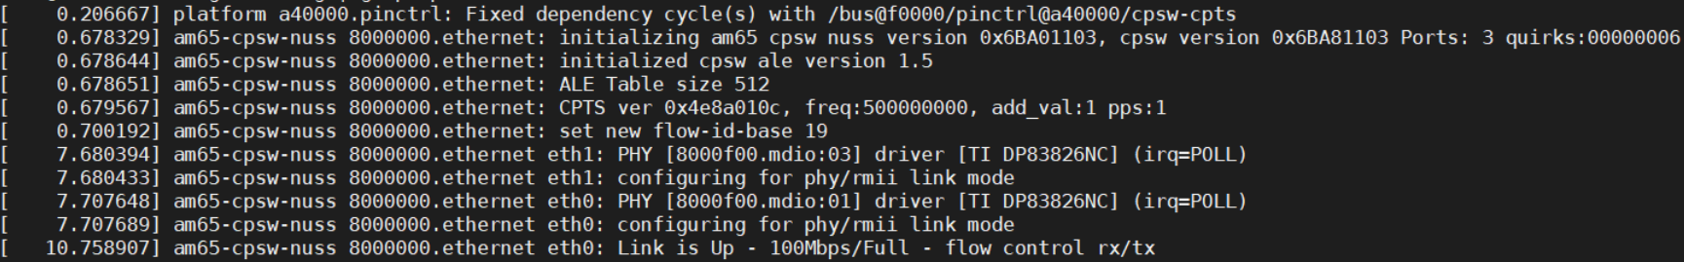

问题现象：

1. 配置相应IP，ping PC端失败

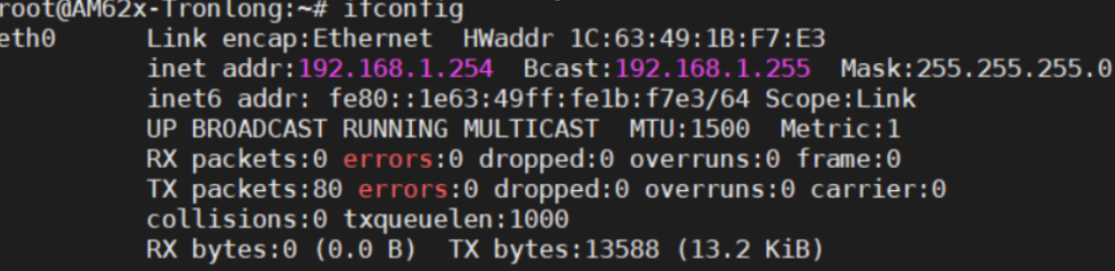

1. Wireshark抓取报文，可见cpu侧已经正常发送报文，且PC端已回复ARP报文

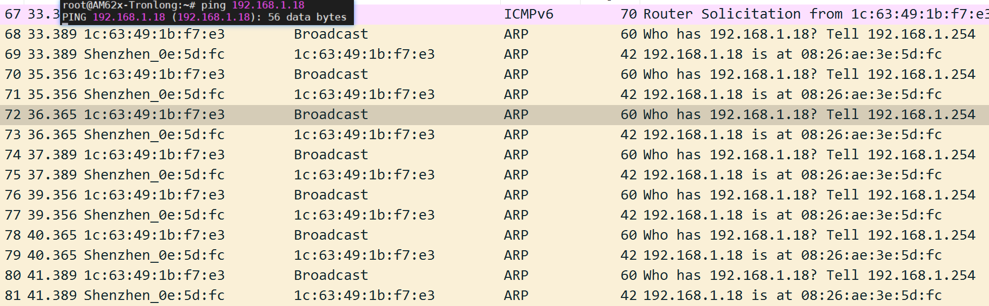

1. 使用ethtool查看，rx_good_frame始终为0，tx_good_frame为正常计数

