TMDSEMU560V2STM-U Is Not Working:
- The USB LED is always red. never turn to green. It cannot connect to my computer or CCS. The mode LED is always blinking green. So, it failed at the beginning. It never works.
I borrowed a USB560V2 System Trace from another department of my company. It works fine with my computer and CCS5.5.
I have experience using USB560V2 System Trace. I knew how to set it up.

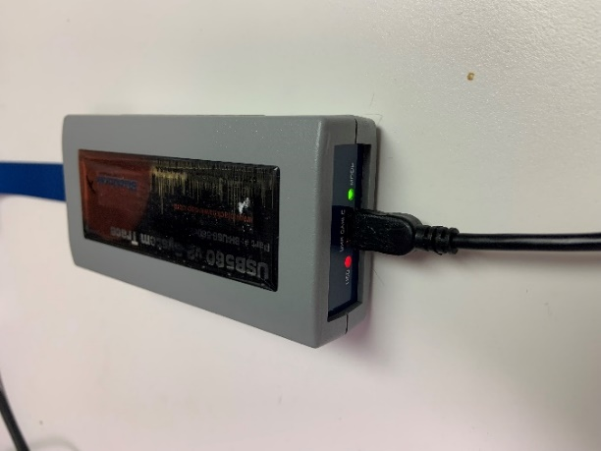

- When I opened the package, the box was open. And there were two layers of seals that were broken. so, it was opened at least twice.
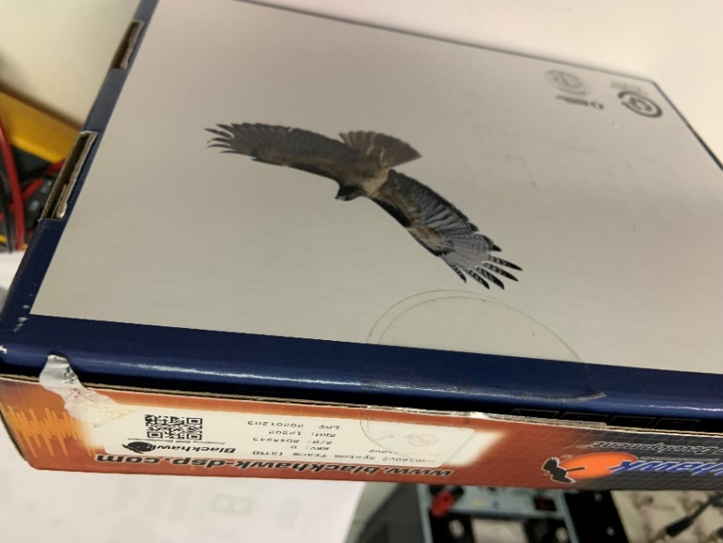

- There are some old labels that were covered with new labels or blank labels. That means the unit was second hand at least.
