In the trace, I can see in the traffic leading up to the stuck case, there is a number of duplicate Start Split (SSplit) transactions being issue from the host.
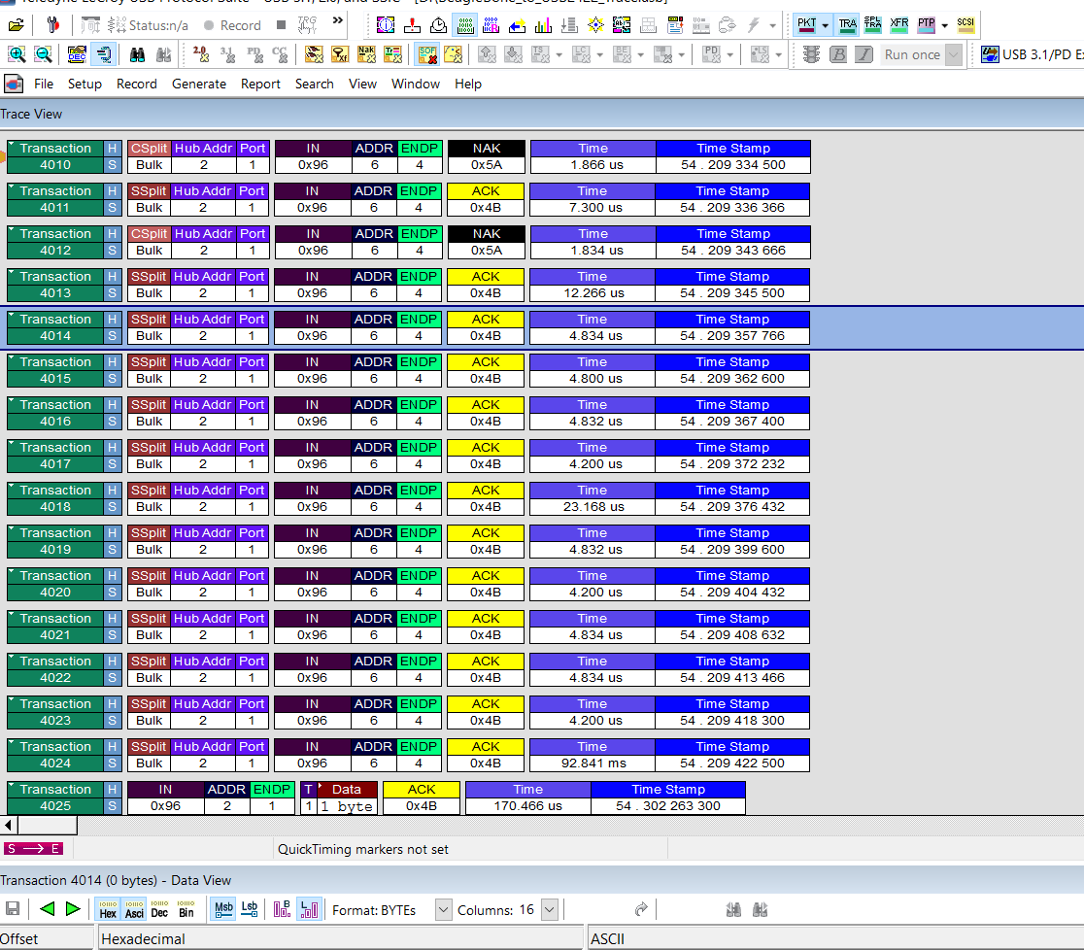

Then the Suspend/Resume event happens.
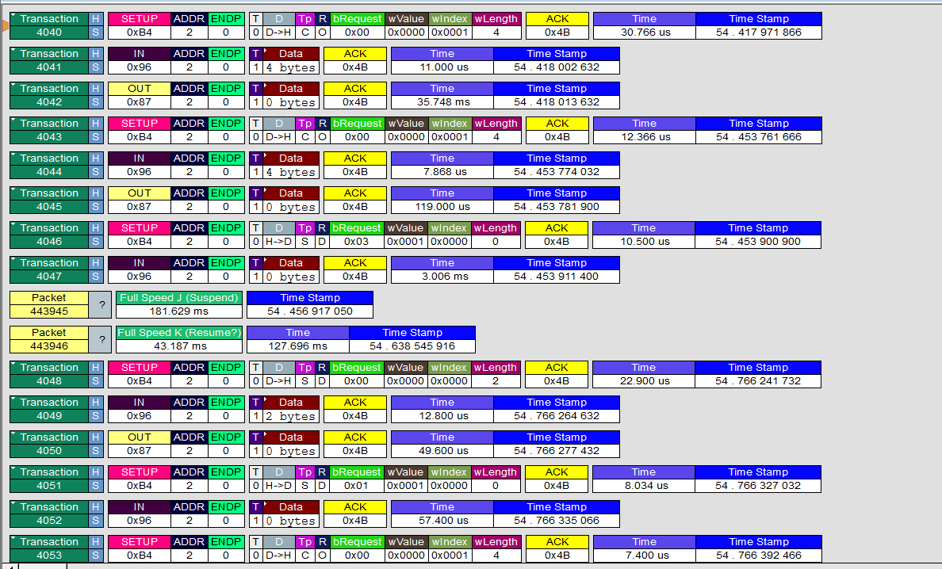

The problem is that the host never issues the Complete Split (CSplit) command after those SSplit commands to complete the transaction, so the data is left in the buffer. The TT is required to respond with a NAK if the buffer is full (unless the buffer contains the exact same info that is being sent, then the response is an ACK.)
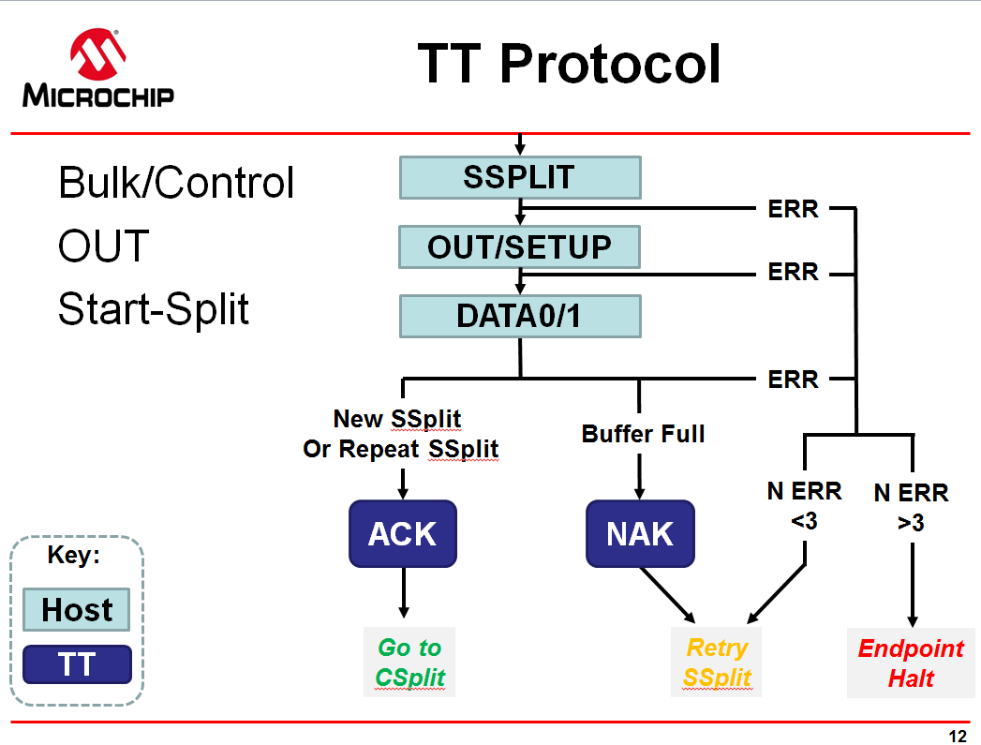

So, when the USB host tries to re-establish the connection with the device, the response is always NAK, since the buffer is still full from before the Resume.

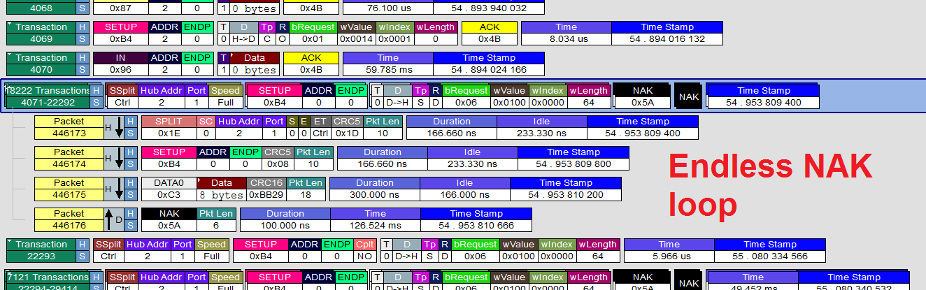

There would be a few ways to deal with this.

- The driver/scheduler should always be sure to finish a CompleteSplit if it has issued a StartSplit
- If the driver/scheduler loses track of what is in the buffer, then as an error recovery mechanism it should issue a RESET_TT or CLEAR_TT_BUFFER command to return the TT into a known state.

