According to your advice, I changed the file owner on my SD card, including boot and roofs partitions.
As showing below, I have changed the folder test_input and subdirectory to normal user jiakun, group jiakun.
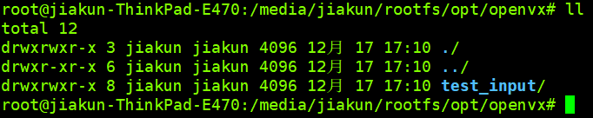
Besides, I changed the file and folder owner and group id of rootfs partition.
