There are six DSP boards and five out of which function normally. However, one of them failed after it was power on for some time while its DSP test was normal.
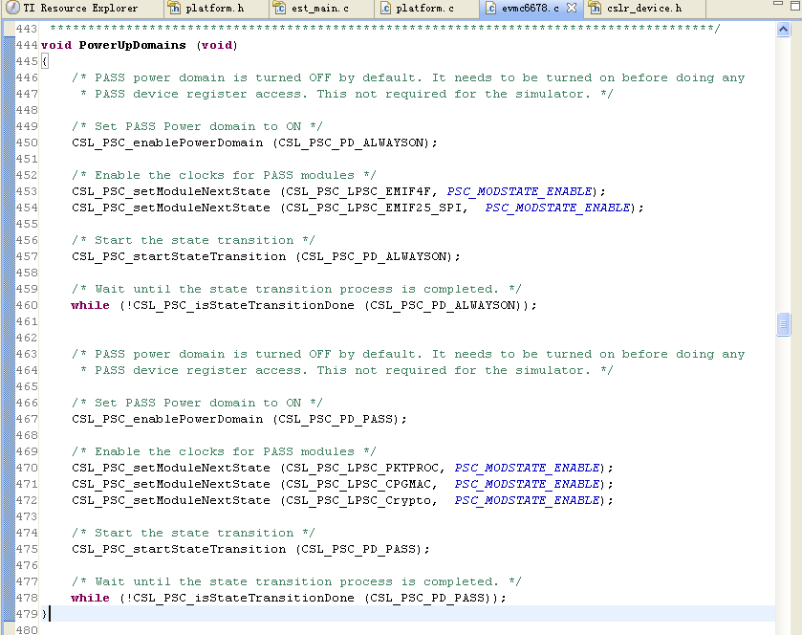
It keeps programing at “while (!CSL_PSC_isStateTransitionDone (CSL_PSC_PD_PASS))” and presents that PASS model keeps excuting translation its power status.

The value of 0x128 registeris 0x00000004 and it shows that PASS Model is conducting status translation.
The value of 0x208 register is 0x00000301 and it shows that PASS Model is power on normally.

After checking the PSC MODULE register.
0x81c is normally.
The value of 0x820 register is abnormally 0x00001F0B (in reserved status, meaningless) while the normal value should be 0x00001F03.
0x824 is normally。

