Ok so looks like this works like:

2-Channel Duplex Mode 1 will make A transmit and B receive - see below .. but...

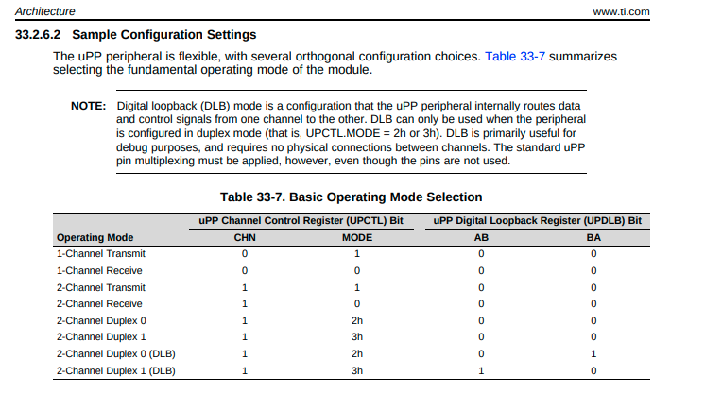

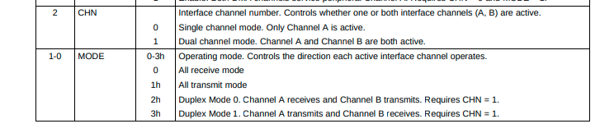

But pin usage would be determined:

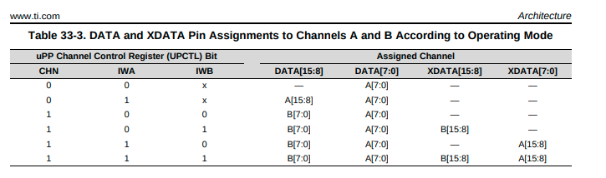

I believe he is asking for the 3rd row CHN, IWA, IWB = {1, 0, 0}

