Hello, I am on the run TIDL routines, according to the site to see this part of http://downloads.ti.com/mctools/esd/docs/tidl-api/example.html
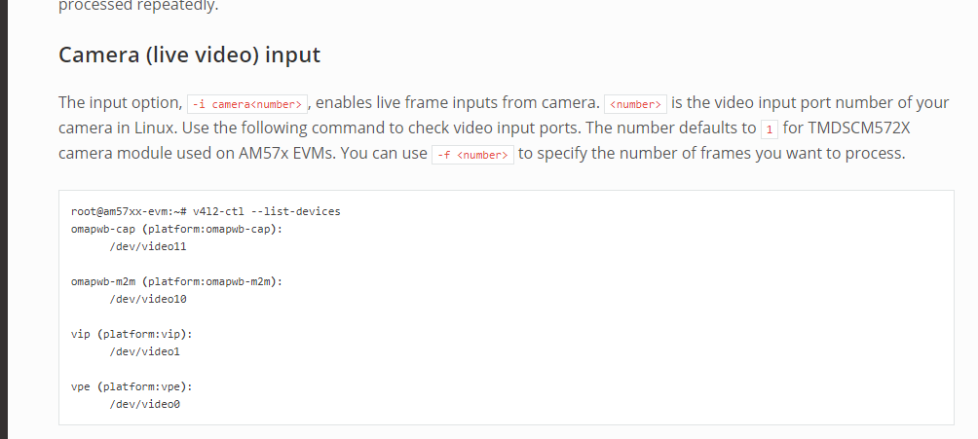
The camera can collect and process the video in real time. I input the command to run in the terminal according to the above instructions, but an error is reported. I don't know why
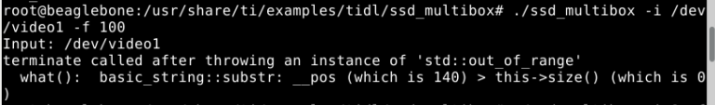
Here's my message from the camera I connected to BBAI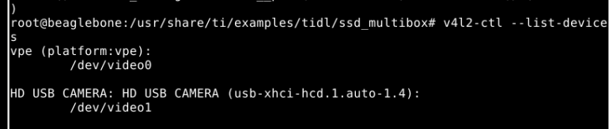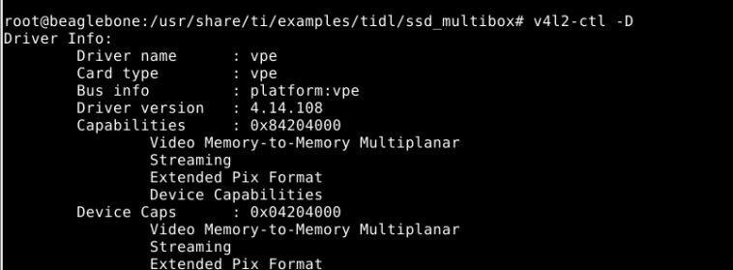
How can I enter the port number after -i to open the camera correctly
Could you please help me solve the problem?
thank you

