Hello dear engineer, I have some questions about the EDMA3 technology of C6678.

I wrote a simple case based on the data transposition section of User Manual 3.3, where EDMA3 uses the CSL library.

The code is as follows:

**#include** <stdio.h>

**#include** <ti/csl/csl_edma3.h>

**#include** <ti/csl/csl_edma3Aux.h>

**#include** <ti/csl/csl_cacheAux.h>

**#include** <stdlib.h>

Int32 **Data_Sorting** (Int32 instNum, Uint8 channelNum,**float** * srcBuff,**float** *dstBuff,Int32 aCnt,

Int32 bCnt,Int32 cCnt,Int32 srcBidx,Int32 dstBidx,Int32 srcCidx,Int32 dstCidx)

{

CSL_Edma3Handle hModule;

CSL_Edma3Obj edmaObj;

CSL_Edma3ParamHandle htrans;

CSL_Edma3ChannelObj chObj;

CSL_Edma3CmdIntr regionIntr;

CSL_Edma3ChannelHandle hChannel;

CSL_Edma3ParamSetup myParamSetup;

CSL_Edma3Context context;

CSL_Edma3ChannelAttr chAttr;

CSL_Status status;

/* Module initialization */

**CSL_edma3Init**(&context) != CSL_SOK;

/* Open the EDMA Module using the provided instance number */

hModule = **CSL_edma3Open**(&edmaObj, instNum, NULL, &status);

/* Channel open */

chAttr.regionNum = CSL_EDMA3_REGION_GLOBAL;

chAttr.chaNum = channelNum;

hChannel = **CSL_edma3ChannelOpen**(&chObj, instNum, &chAttr, &status);

/* For EDMA instance 1 and 2 maximum of 4 TCs and 4 event queues are supported

* Change Channel Default queue setup from 0 to 3

*/

**CSL_edma3HwChannelSetupQue**(hChannel,*CSL_EDMA3_QUE_3*) ;

/* Map the DMA Channel to PARAM Block 2. */

CSL_edma3MapDMAChannelToParamBlock (hModule, channelNum, 1);

/* Obtain a handle to parameter set 2 */

htrans = **CSL_edma3GetParamHandle**(hChannel, 1, &status);

myParamSetup.option = CSL_EDMA3_OPT_MAKE(CSL_EDMA3_ITCCH_EN, \

CSL_EDMA3_TCCH_DIS, \

CSL_EDMA3_ITCINT_DIS, \

CSL_EDMA3_TCINT_EN, \

0, CSL_EDMA3_TCC_NORMAL,\

CSL_EDMA3_FIFOWIDTH_NONE, \

CSL_EDMA3_STATIC_DIS, \

CSL_EDMA3_SYNC_AB, \

CSL_EDMA3_ADDRMODE_INCR, \

CSL_EDMA3_ADDRMODE_INCR );

myParamSetup.srcAddr = (Uint32)srcBuff;

myParamSetup.aCntbCnt = CSL_EDMA3_CNT_MAKE(aCnt,bCnt);

myParamSetup.dstAddr = (Uint32)dstBuff;

myParamSetup.srcDstBidx = CSL_EDMA3_BIDX_MAKE(srcBidx,dstBidx);

myParamSetup.linkBcntrld= CSL_EDMA3_LINKBCNTRLD_MAKE(0xffff,0);

myParamSetup.srcDstCidx = CSL_EDMA3_CIDX_MAKE(srcCidx,dstCidx);

myParamSetup.cCnt = cCnt;

/* Ping setup */

**CSL_edma3ParamSetup**(htrans,&myParamSetup);

/* Interrupt enable (Bits 0-1) for the global region interrupts */

regionIntr.region = CSL_EDMA3_REGION_GLOBAL;

regionIntr.intr = 0x3;

regionIntr.intrh = 0x0000;

**CSL_edma3HwControl**(hModule,*CSL_EDMA3_CMD_INTR_ENABLE*,&regionIntr);

/* Trigger channel */

**CSL_edma3HwChannelControl**(hChannel,*CSL_EDMA3_CMD_CHANNEL_SET*,NULL);

regionIntr.region = CSL_EDMA3_REGION_GLOBAL;

regionIntr.intr = 0;

regionIntr.intrh = 0;

/* Poll on IPR bit 0 */

**do** {

**CSL_edma3GetHwStatus**(hModule,*CSL_EDMA3_QUERY_INTRPEND*,&regionIntr);

} **while** (!(regionIntr.intr & 0x1));

/* Clear the pending bit */

**CSL_edma3HwControl**(hModule,*CSL_EDMA3_CMD_INTRPEND_CLEAR*,&regionIntr);

/* Close channel */

**CSL_edma3ChannelClose**(hChannel) ;

/* Close EDMA module */

**CSL_edma3Close**(hModule) != CSL_SOK;

/* The test passed. */

}

**int** **main**(){

**float** *a = **malloc**(**sizeof**(**float**)*4*1024);//array a，put in DDR3

**float** b[4096];//array b put in SHRAM(share ram)

**int** i=0;

//a initialization

**for**(i=0;i<4096;i++)

{

a[i]=(**float**)i;

**printf**("%f ",a[i]);

**if**(i%1024==0 && i!= 0)

**printf**("\n");

}

**printf**("\n");

**printf**("******************************************************\n");

//EDMA3 PARM set

**int** aCnt,bCnt,cCnt,srcBidx,dstBidx,srcCidx,dstCidx;

aCnt=4;//ACNT

bCnt=1024;//bcnt

cCnt=4;//CCNT

srcBidx=aCnt;//srcBidx

dstBidx=aCnt*cCnt;//dstBidx

srcCidx=aCnt*bCnt;//srcCidx

dstCidx=aCnt;//dstCidx

//EMDA3

Data_Sorting(0,0,a,b,aCnt,

bCnt,cCnt,srcBidx,dstBidx,srcCidx,dstCidx);

// print result

**for**(i=0;i<4096;i++)

{

**printf**("%f ",b[i]);

**if**(i%4==0 && i!=0)

**printf**("\n");

}

**return** 0;

}

The output of the simulator is as follows:

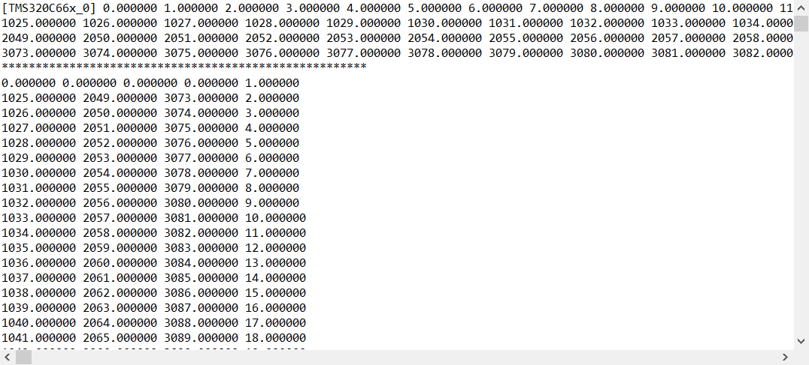

Question 1: There are some issues with the simulation data, and the transposed results are not quite correct. Is it a parameter issue?

Question 2: I am running this code on the C6678 development version and cannot output results. EDMA3 polling has fallen into a dead loop. What is the reason?

Looking forward to your reply! Thank you very much.