hello everyone....
I am new to ccsv5 and trying to run a basic program on dskC6713 through ccsv5. Program is about generation of sine wave through look up table which is as follows.....
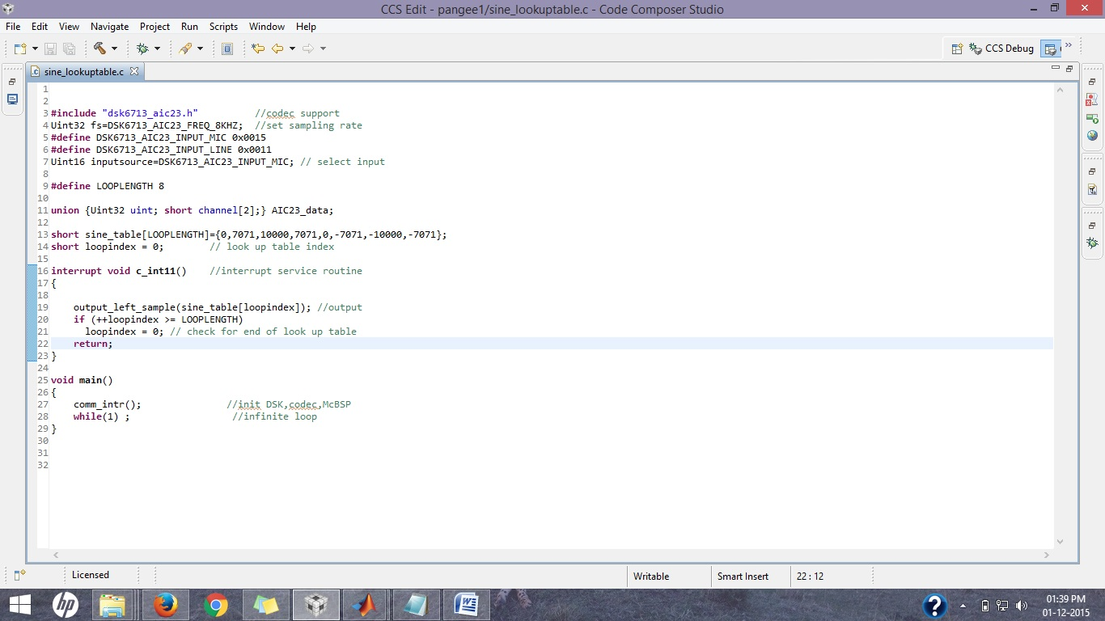
when i tried to build this program i got an error as follows.....
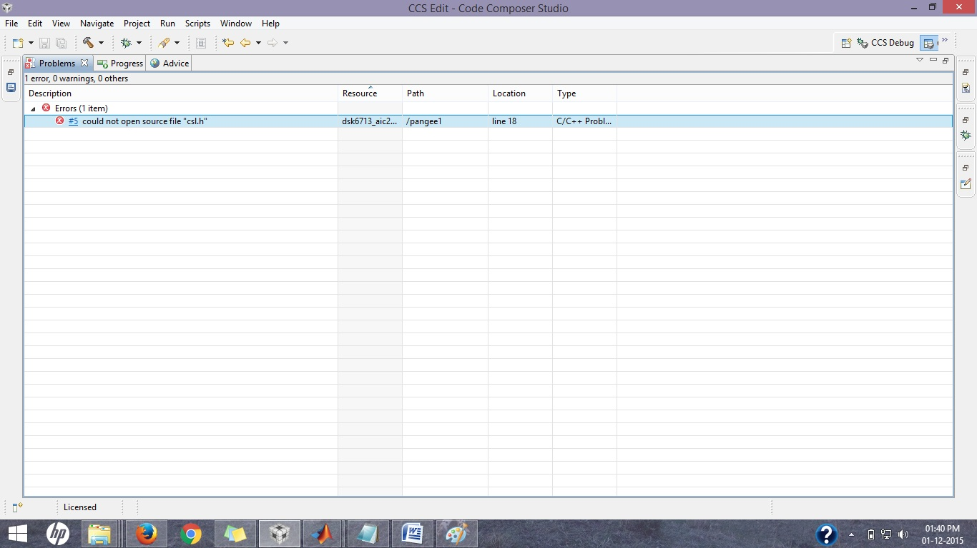
i have included csl.h file in project explorer as shown below...
csl.h file which i included is as follows......
/******************************************************************************\
* Copyright (C) 2000 Texas Instruments Incorporated.
* All Rights Reserved
*------------------------------------------------------------------------------
* FILENAME...... csl.h
* DATE CREATED.. 06/13/2000
* LAST MODIFIED. 08/02/2004 - Adding support for C6418
* 07/24/2004 - Re-introducing BIOS components from CSL due to compatibility issues.
* 06/26/2003 Added CHIP_6411
* 06/17/2003 Added CHIP_6712C
* 05/28/2003 Added CHIP_6711C
* 03/26/2003 - 6412,DM642 check libraries
* 10/10/2001 - 6712-6713-6414-6416-6415 check libraries
* 11/19/2003 - Removed BIOS components from CSL - _CSL_Config
*
\******************************************************************************/
#ifndef _CSL_H_
#define _CSL_H_

#include <csl_chip.h>
#include <csl_irq.h>
#include <csl_timer.h>

/******************************************************************************\
* scope and inline control macros
\******************************************************************************/
#ifdef __cplusplus
#define CSLAPI extern "C" far
#else
#define CSLAPI extern far
#endif

#undef USEDEFS
#undef IDECL
#undef IDEF

#ifdef _CSL_MOD_
#define IDECL CSLAPI
#define USEDEFS
#define IDEF
#else
#ifdef _INLINE
#define IDECL static inline
#define USEDEFS
#define IDEF static inline
#else
#define IDECL CSLAPI
#endif
#endif

/******************************************************************************\
* global macro declarations
\******************************************************************************/

/******************************************************************************\
* global typedef declarations
\******************************************************************************/

/* if this structure changes, be sure to also change it in csl_irq_.asm */
typedef union {
struct {
Uint32 biosPresent;
_IRQ_Dispatch *dispatchTable;
Uint32 timerUsed;
Uint32 timerNum;
} args;
struct {
TIMER_Handle hTimer;
Uint32 *event2IntTbl;
Uint32 *int2EventTbl;
} ret;
} _CSL_Config;
/******************************************************************************\
* global variable declarations
\******************************************************************************/

/******************************************************************************\
* global function declarations
\******************************************************************************/
CSLAPI void _CSL_init(_CSL_Config *config);

CSLAPI void CSL6201_LIB_();
CSLAPI void CSL6202_LIB_();
CSLAPI void CSL6203_LIB_();
CSLAPI void CSL6204_LIB_();
CSLAPI void CSL6205_LIB_();
CSLAPI void CSL6211_LIB_();
CSLAPI void CSL6701_LIB_();
CSLAPI void CSL6711_LIB_();
CSLAPI void CSL6712_LIB_();
CSLAPI void CSL6713_LIB_();
CSLAPI void CSLDA610_LIB_();
CSLAPI void CSLDM642_LIB_();
CSLAPI void CSLDM640_LIB_();
CSLAPI void CSLDM641_LIB_();
CSLAPI void CSL6412_LIB_();
CSLAPI void CSL6414_LIB_();
CSLAPI void CSL6415_LIB_();
CSLAPI void CSL6416_LIB_();
CSLAPI void CSL6711C_LIB_();
CSLAPI void CSL6712C_LIB_();
CSLAPI void CSL6411_LIB_();
/* next two options are DRI300 versions */
CSLAPI void CSL6410_LIB_();
CSLAPI void CSL6413_LIB_();
CSLAPI void CSL6418_LIB_();

/******************************************************************************\
* inline function declarations
\******************************************************************************/

/******************************************************************************\
* special inline function
\******************************************************************************/

/* This function checks to make sure that the correct library is being */
/* linked in compared to the CHIP_XXXX definition. */

static inline void CSL_init() {

#if (CHIP_6201)
CSL6201_LIB_();
#elif (CHIP_6202)
CSL6202_LIB_();
#elif (CHIP_6203)
CSL6203_LIB_();
#elif (CHIP_6204)
CSL6204_LIB_();
#elif (CHIP_6205)
CSL6205_LIB_();
#elif (CHIP_6211)
CSL6211_LIB_();
#elif (CHIP_6701)
CSL6701_LIB_();
#elif (CHIP_6711)
CSL6711_LIB_();
#elif (CHIP_6712)
CSL6712_LIB_();
#elif (CHIP_6713)
CSL6713_LIB_();
#elif (CHIP_DA610)
CSLDA610_LIB_();
#elif (CHIP_DM642)
CSLDM642_LIB_();
#elif (CHIP_DM640)
CSLDM640_LIB_();
#elif (CHIP_DM641)
CSLDM641_LIB_();
#elif (CHIP_6412)
CSL6412_LIB_();
#elif (CHIP_6414)
CSL6414_LIB_();
#elif (CHIP_6415)
CSL6415_LIB_();
#elif (CHIP_6416)
CSL6416_LIB_();
#elif (CHIP_6711C)
CSL6711C_LIB_();
#elif (CHIP_6712C)
CSL6712C_LIB_();
#elif (CHIP_6411)
CSL6411_LIB_();
/* next three are DRI300 versions */
#elif (CHIP_6410)
CSL6410_LIB_();
#elif (CHIP_6413)
CSL6413_LIB_();
#elif (CHIP_6418)
CSL6418_LIB_();
#endif

_CSL_init((_CSL_Config*)INV);
}

/*----------------------------------------------------------------------------*/

/******************************************************************************\
* inline function definitions
\******************************************************************************/
#ifdef USEDEFS
/*----------------------------------------------------------------------------*/
/*----------------------------------------------------------------------------*/
/*----------------------------------------------------------------------------*/
#endif /* USEDEFS */

#endif /* _CSL_H_ */
/******************************************************************************\
* End of csl.h
\******************************************************************************/
PROBLEM:- Why is this error coming ?? Is it a compatibility issue ?? What do i need to do ??

