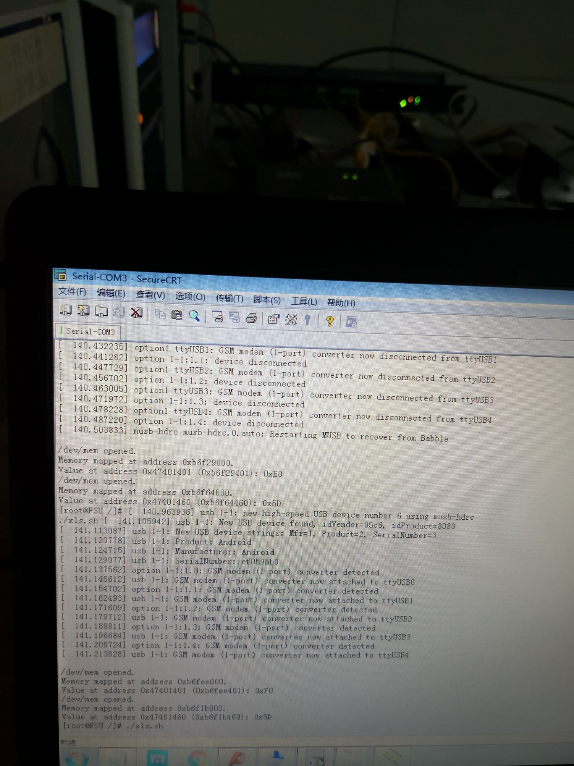

P1.0: Read Reatarting all

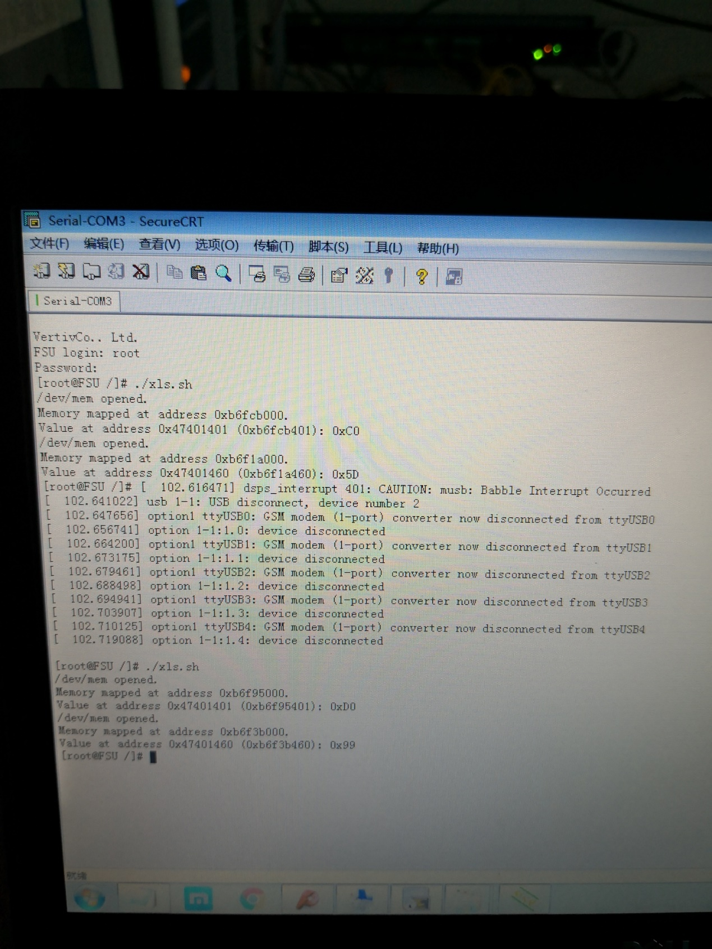

P2.0 :Read Full Speed all

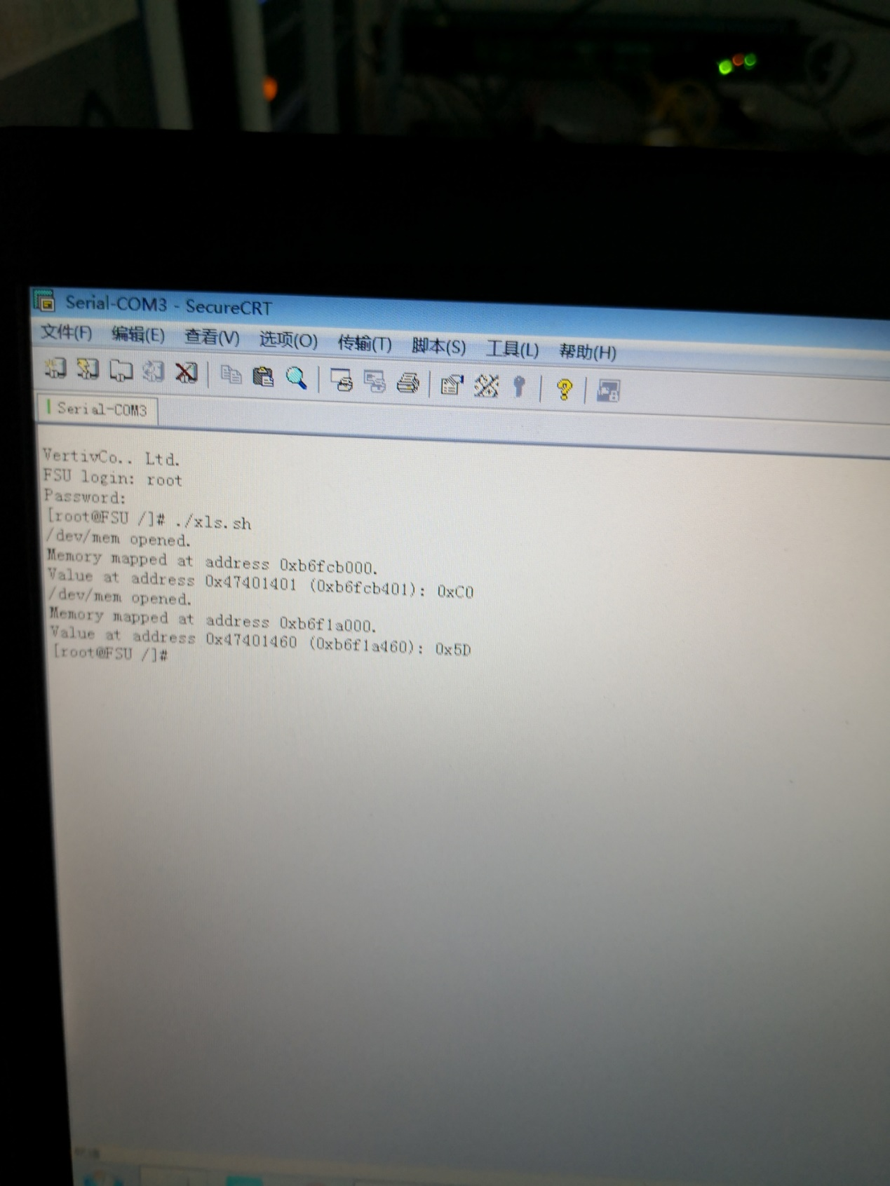

P2.1 :Read Full Speed ok

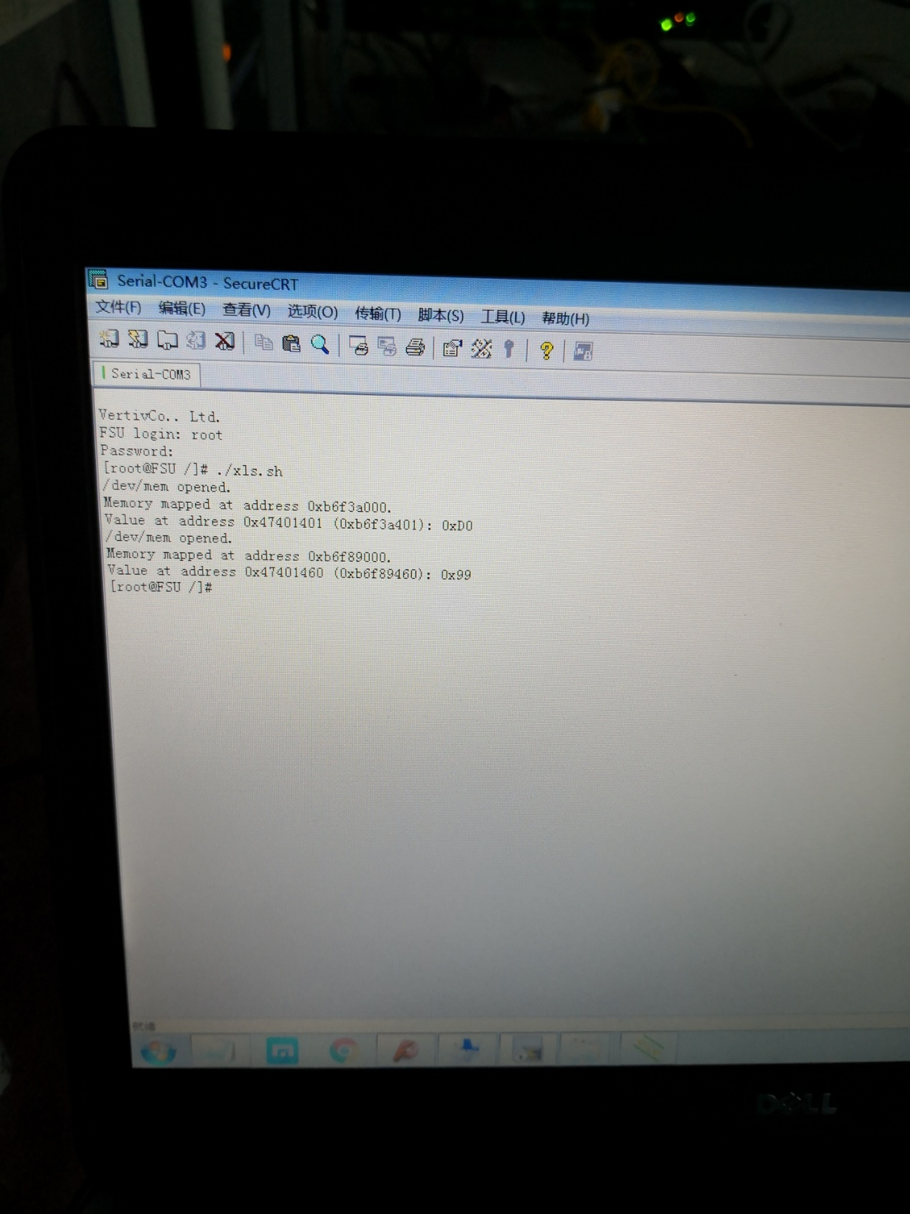

P2.2 :Read Full Speed error

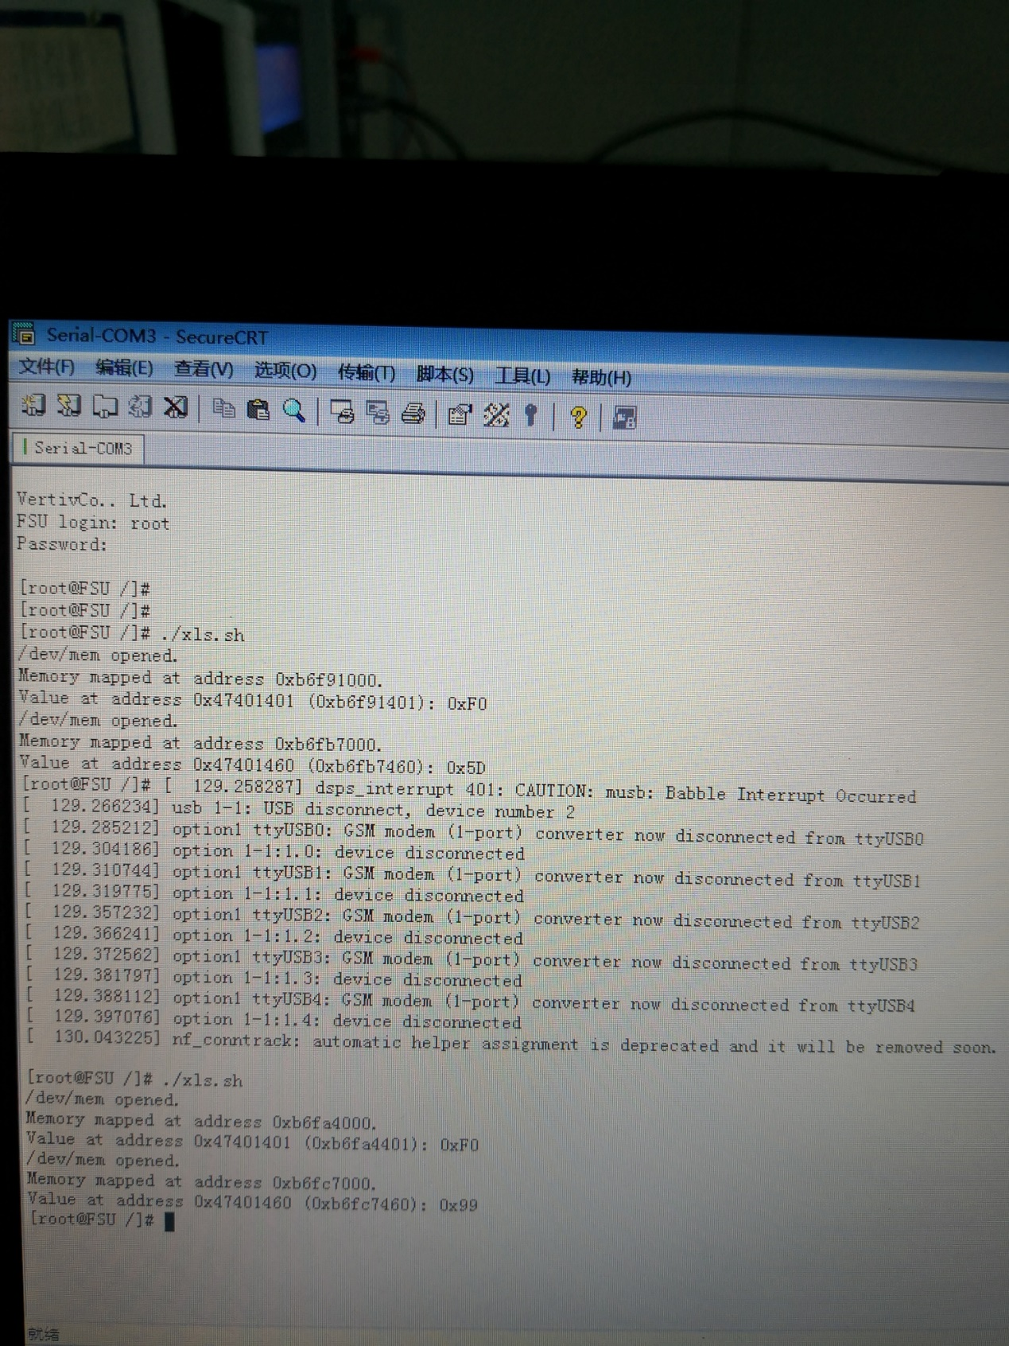

P3.0 :Read High Speed all

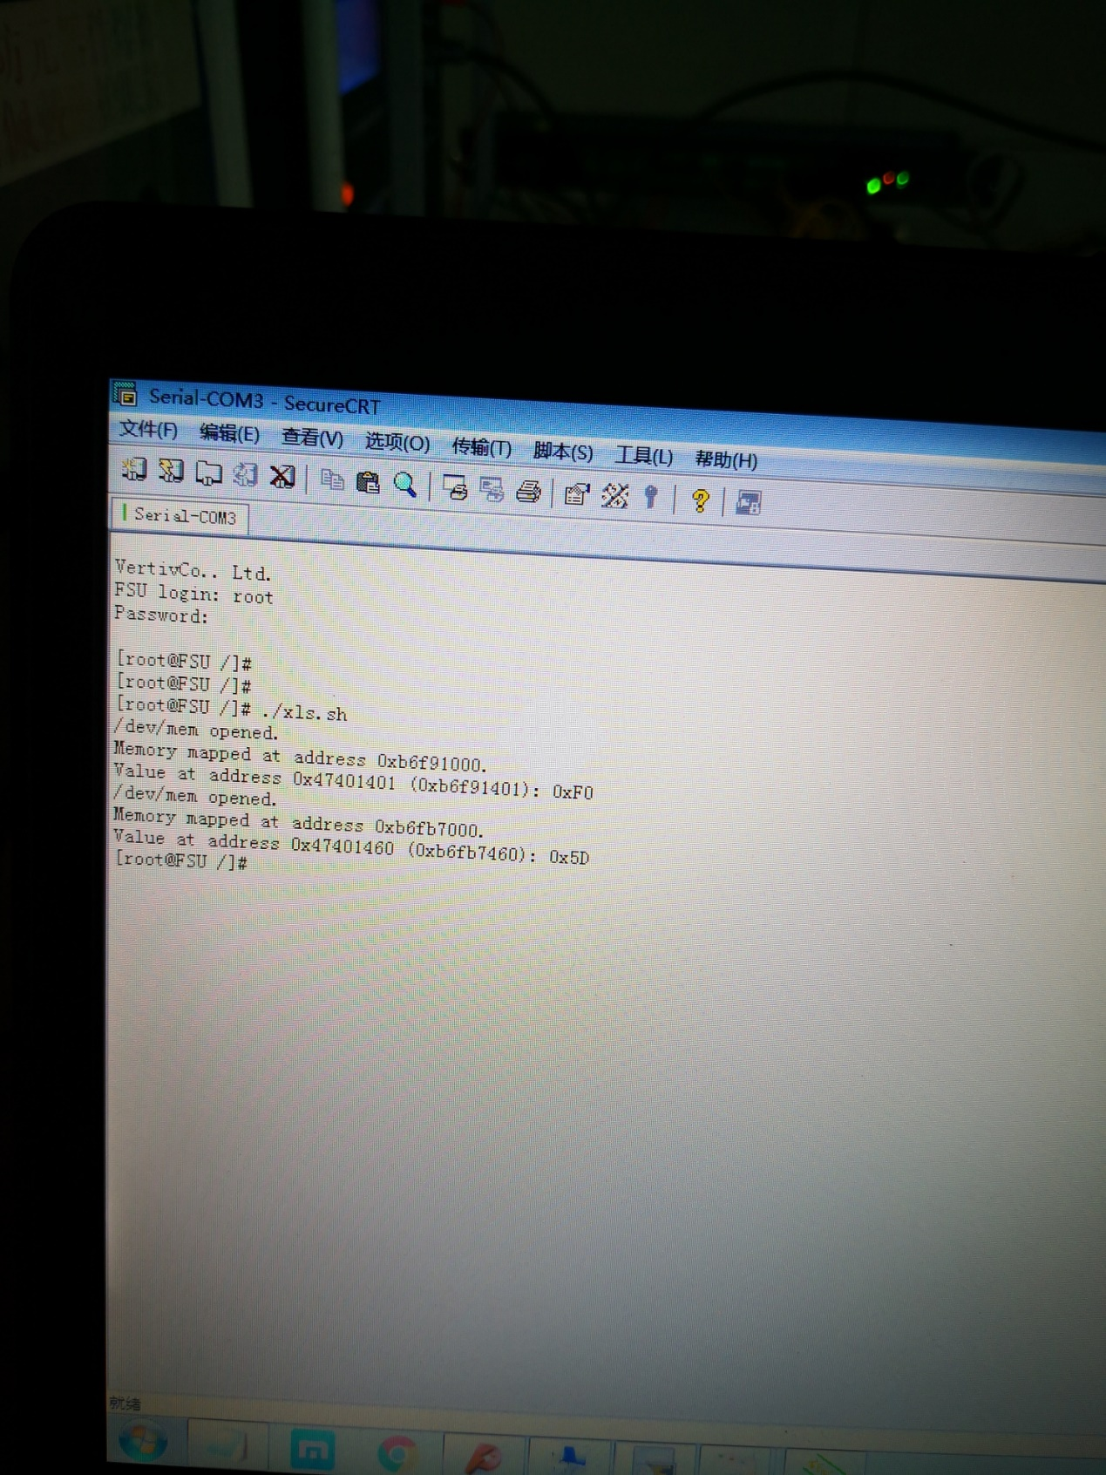

P3.1 :Read High Speed ok

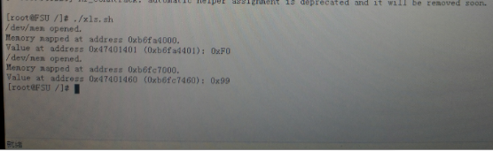

P3.2 :Read High Speed ok