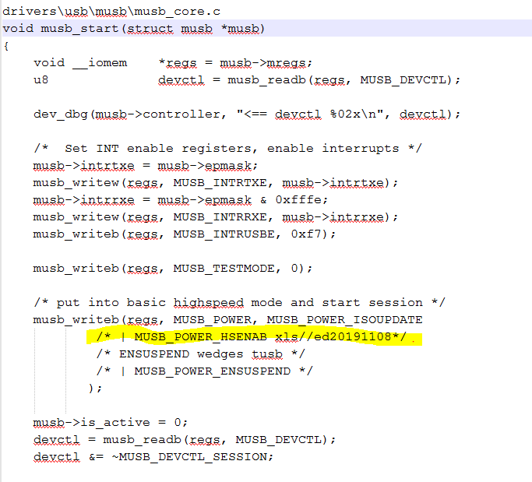

P1 : Full Speed code

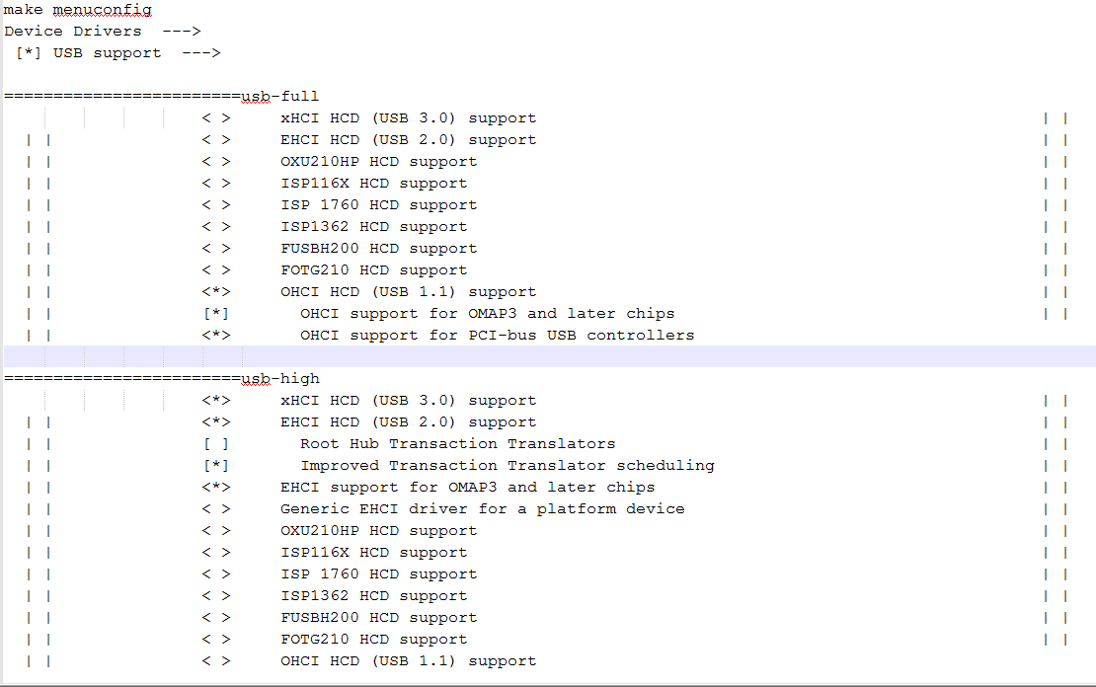

P2 : Full Speed set

drivers\usb\musb\musb_core.c

void musb_start(struct musb *musb)

{

void __iomem *regs = musb->mregs;

u8 devctl = musb_readb(regs, MUSB_DEVCTL);

dev_dbg(musb->controller, "<== devctl %02x\n", devctl);

/* Set INT enable registers, enable interrupts */

musb->intrtxe = musb->epmask;

musb_writew(regs, MUSB_INTRTXE, musb->intrtxe);

musb->intrrxe = musb->epmask & 0xfffe;

musb_writew(regs, MUSB_INTRRXE, musb->intrrxe);

musb_writeb(regs, MUSB_INTRUSBE, 0xf7);

musb_writeb(regs, MUSB_TESTMODE, 0);

/* put into basic highspeed mode and start session */

musb_writeb(regs, MUSB_POWER, MUSB_POWER_ISOUPDATE

/* | MUSB_POWER_HSENAB xls//ed20191108*/

/* ENSUSPEND wedges tusb */

/* | MUSB_POWER_ENSUSPEND */

);

musb->is_active = 0;

devctl = musb_readb(regs, MUSB_DEVCTL);

devctl &= ~MUSB_DEVCTL_SESSION;

/* session started after:

* (a) ID-grounded irq, host mode;

* (b) vbus present/connect IRQ, peripheral mode;

* (c) peripheral initiates, using SRP

*/

if (musb->port_mode != MUSB_PORT_MODE_HOST &&

(devctl & MUSB_DEVCTL_VBUS) == MUSB_DEVCTL_VBUS) {

musb->is_active = 1;

} else {

devctl |= MUSB_DEVCTL_SESSION;

}

musb_platform_enable(musb);

musb_writeb(regs, MUSB_DEVCTL, devctl);

}