1. The number of samples per channel to capture per trigger can be reduced by adding a new parameter in the INI File present at the following location,
a. Default Location of the INI File: C:\Program Files (x86)\Texas Instruments\High Speed Data Converter Pro\14J56revD Details\Device and File Info.ini
2. Open the “Device and File Info.ini” from the above mentioned location, add the new parameter nSamples Multiple = "1024" under the section [ADC DAC]. After adding this parameter we will able to do a capture with only 1024 samples per channel.
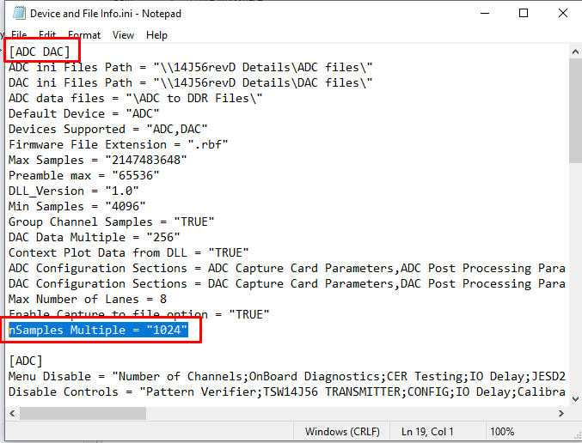
3. We have tested this parameter to work up to 1024 samples per channel as the lowest.

