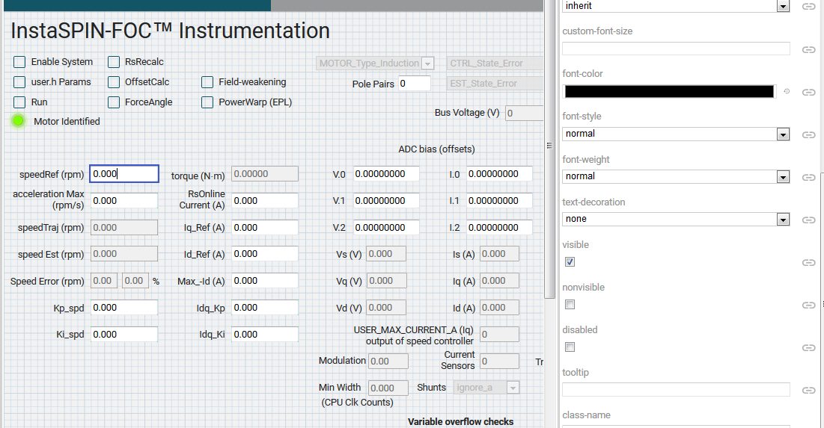

I can’t find a check box for read only. I can modify the Value for **widget.ti_widget_numberbox_speedref.value** this can also been seen in the debugging environment. The value (1000) is passed down to the function in the index.js file but it doesn’t go further to the **my_xds.gMotorVars.SpeedRef_krpm.**

How is it possible to modify the setpoint (my_xds.gMotorVars.SpeedRef_krpm) so that the real motor spins at the desired speed?

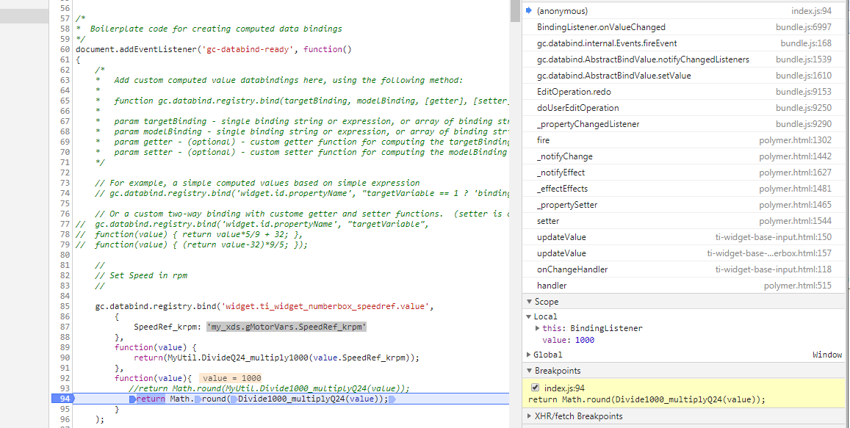

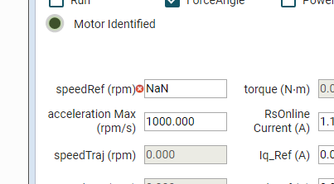

Error message

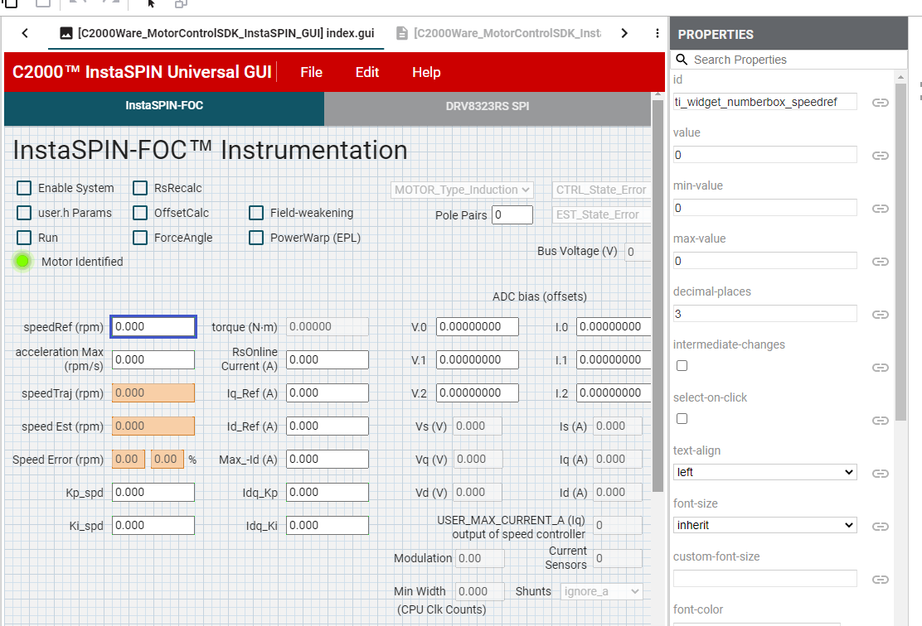

GUI Composer