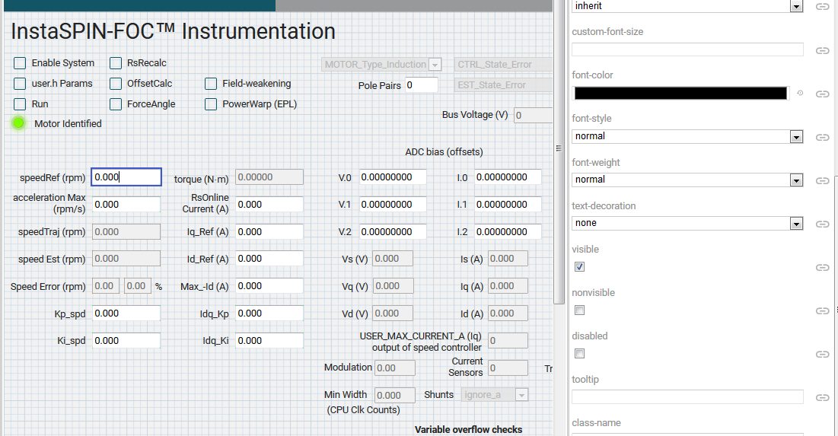

I can’t find a check box for read only. I can modify the Value for **widget.ti_widget_numberbox_speedref.value** this can also been seen in the debugging environment. The value (1000) is passed down to the function in the index.js file but it doesn’t go further to the **my_xds.gMotorVars.SpeedRef_krpm.**

How is it possible to modify the setpoint (my_xds.gMotorVars.SpeedRef_krpm) so that the real motor spins at the desired speed?

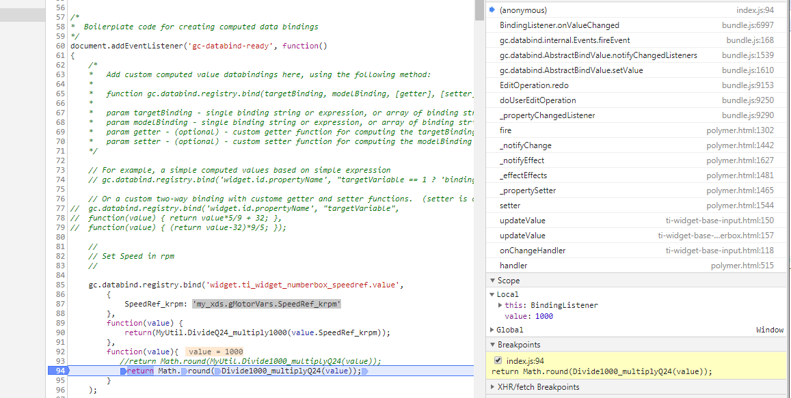

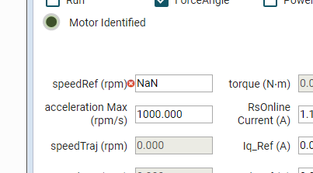

Error message

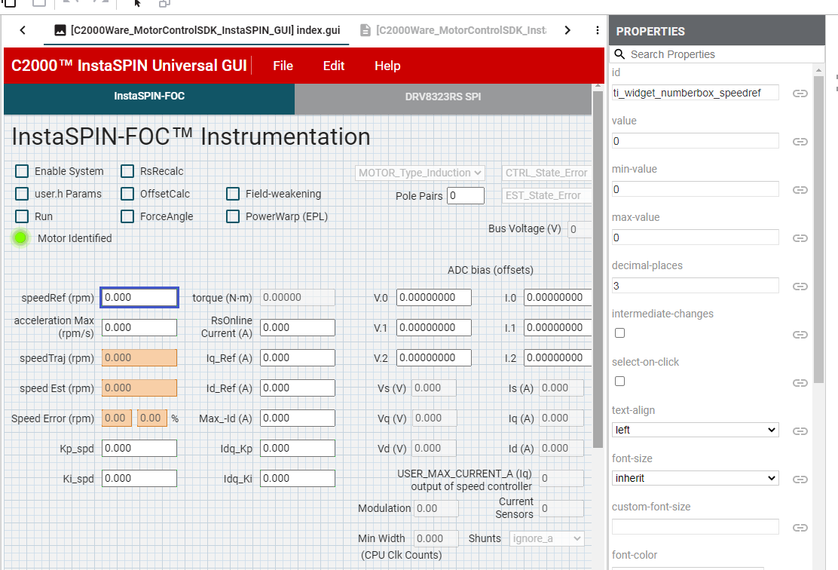

GUI Composer

Hi Patrick,

The direction from CCS program to GUI is still not working, when I start the GUI a little red cross comes up and when I hover over it, it says

MyUtil.DivideQ24_multiple1000 is not a function

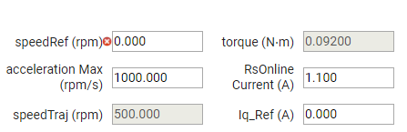

I’ve a second file “”MyUtil.js” that collects all this functions

It starts like

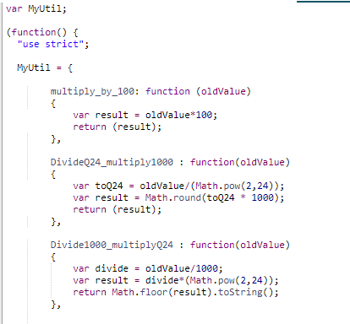

End ends like   
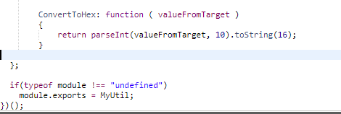  
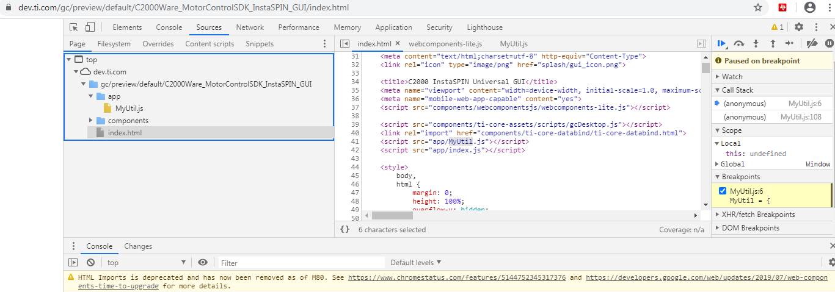  
after pushing play it looks like:

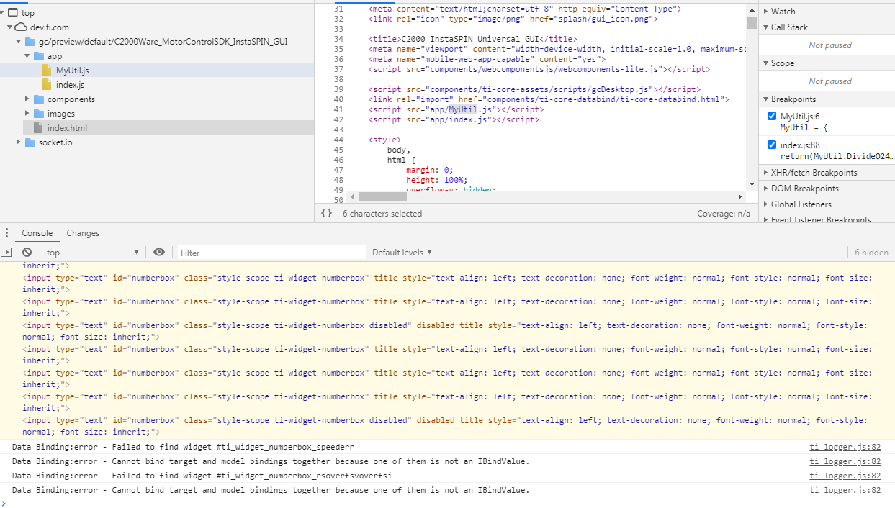

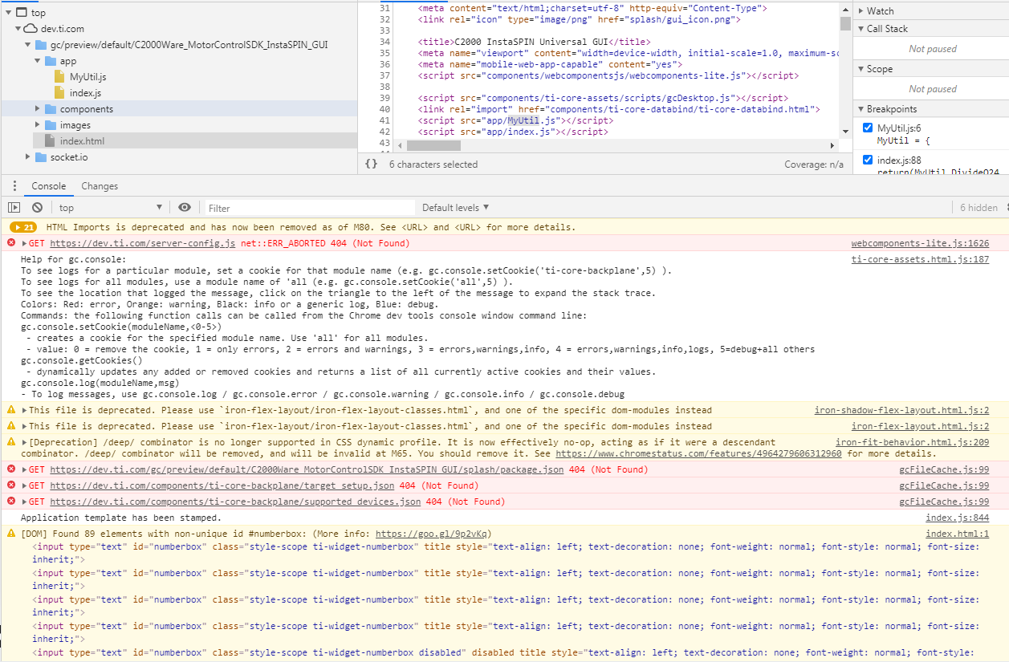

18.06.2020 Debugging

The setter function is called

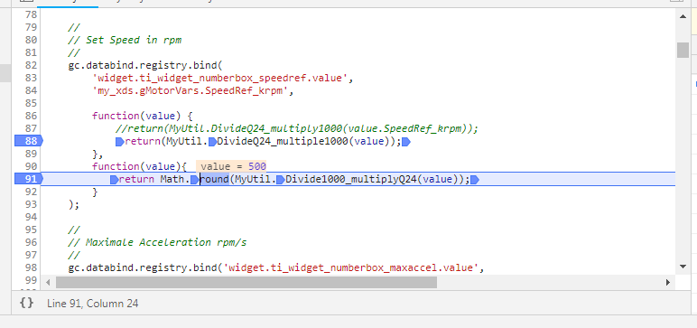

The value is passed further

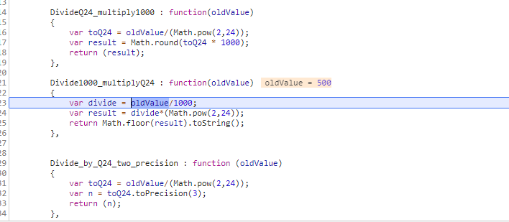

Getter function is called due to the value in the application SW has changed

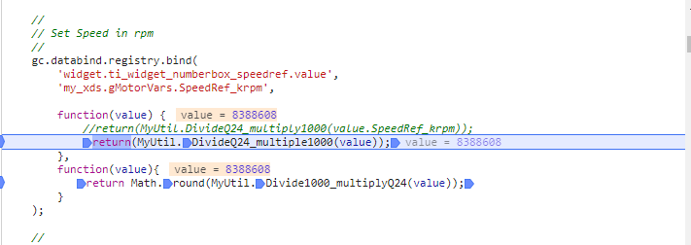

The next debug step leads to the following Error

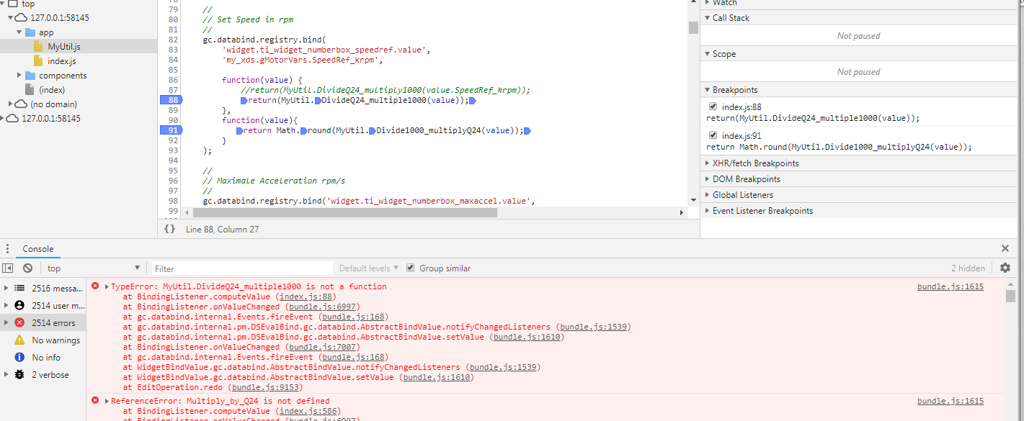

The function ***MyUtil.DivideQ24_multiply1000*** and ***MyUtil.Divide1000_multiplyQ24*** are written in the same manner – so why is one working and the other crashes