- Compiler Optimization Level issue
Test Condition: DCDC application, input VDC is 50V, output VDC is 55V, output current is 45A. the main controller is TMS320F28374s. and CCS version is 6.1.0.00104;
Issues Description: in same condition, the power module used similar source code(only with 3 different variables), which generate 2 different test result： output Voltage and Current worked normal(figure 1), output voltage and current oscillated(figure 2).

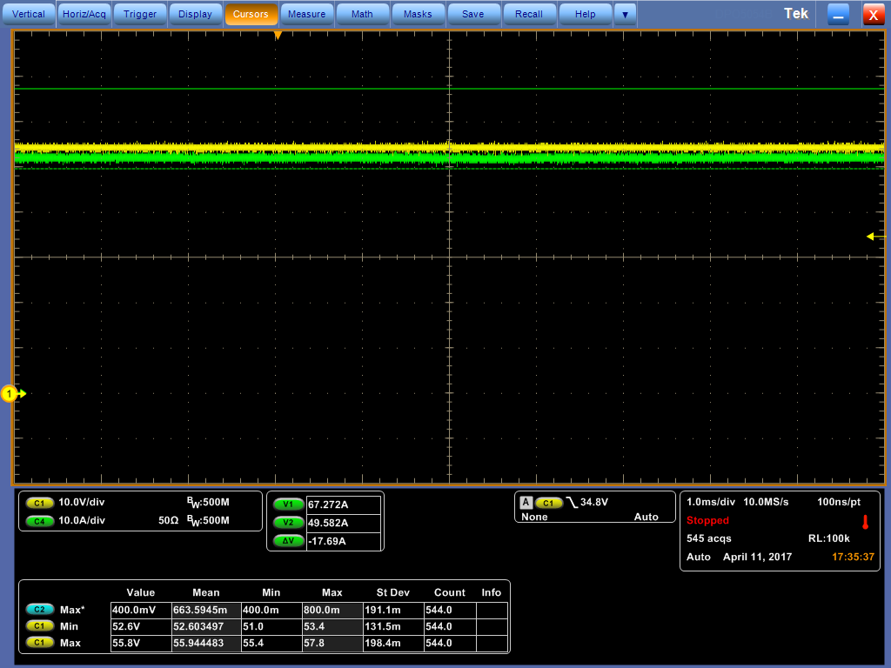

Figure 1 Output voltage & Current normal
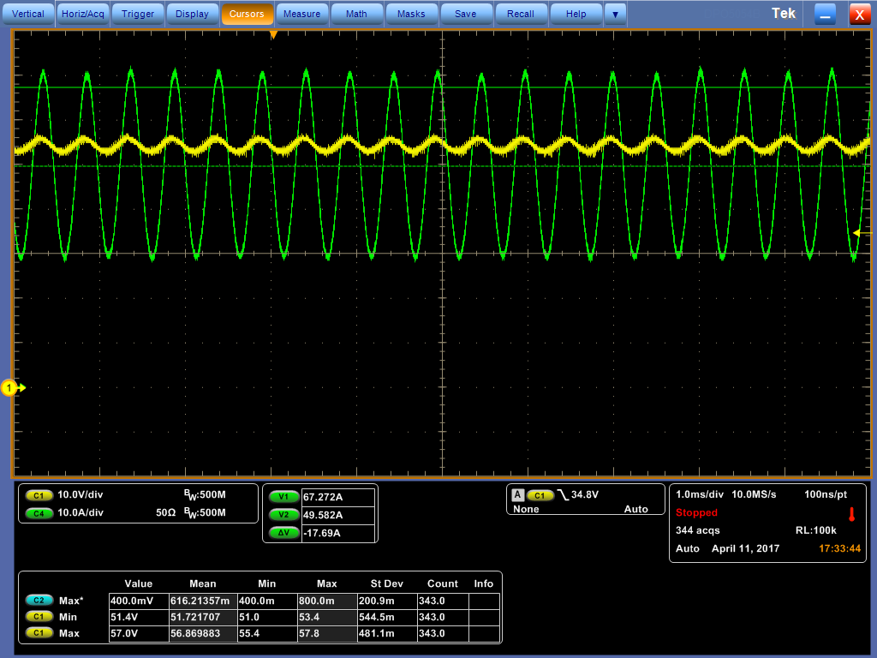
Figure 2 Output voltage & Current abnormal
Compared with the code differences, shown as figure 3, only few changes with 3 variables(Left), and the 3 variables is not used on the code other place except initialization; the right side without the 3 variables; the left side code caused the abnormal, and right code worked normally.
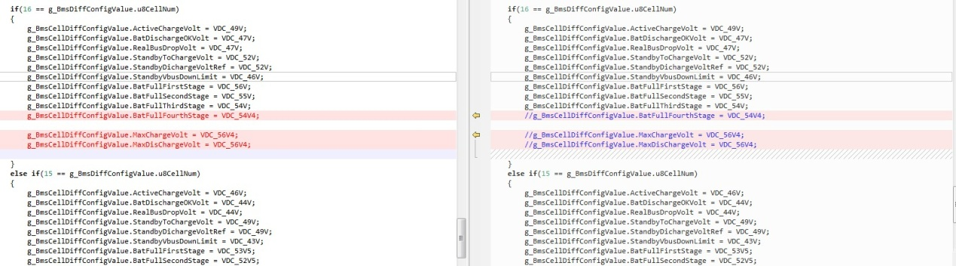
Figure 3 Source code comparison

Solution: for the left side code, modified the optimization level to Off 0, shown as figure 4;
The .map files before & after optimization level modification shown as below.
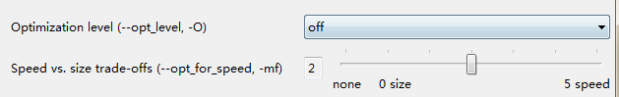

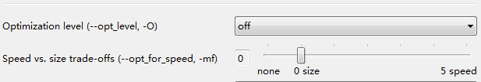
Figure 4 Optimization level from 2 to 0
Note: in previous rectifier products which used F280200 with CCS3.3 reported same issues. With optimization level –o3, the ADC sample value decreased half of expected, without optimization level, the ADC sample worked as expected.

2. Same source code, different compiler version, the module executed different
Test Condition and result: using CCS 6.1.0.00104 to build the source code project, and DOWNLOAD to TMS320F28066, the code run to unexpected fault and caused watchdog reset. Using CCS3.3.83.19 to build the same source code, the code run normally.
Root cause: Step by step debug and found that memcpy() prototype caused the issue.
Solution： don’t using the memcpy() defined in lib but with the prototype build by Customer Own, fixed this issue.

