Console of the working project
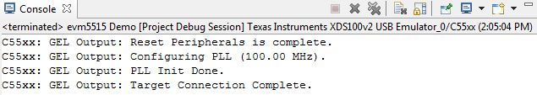

Console of the not working project
