I installed ccs11. There is no problem importing and compiling the old project No1, including online simulation and debugging. And the chip can be selected. As shown below: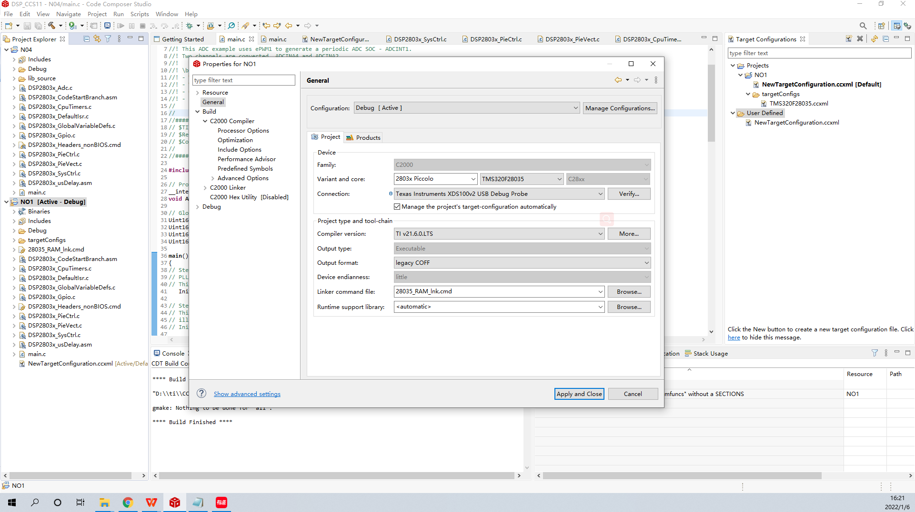

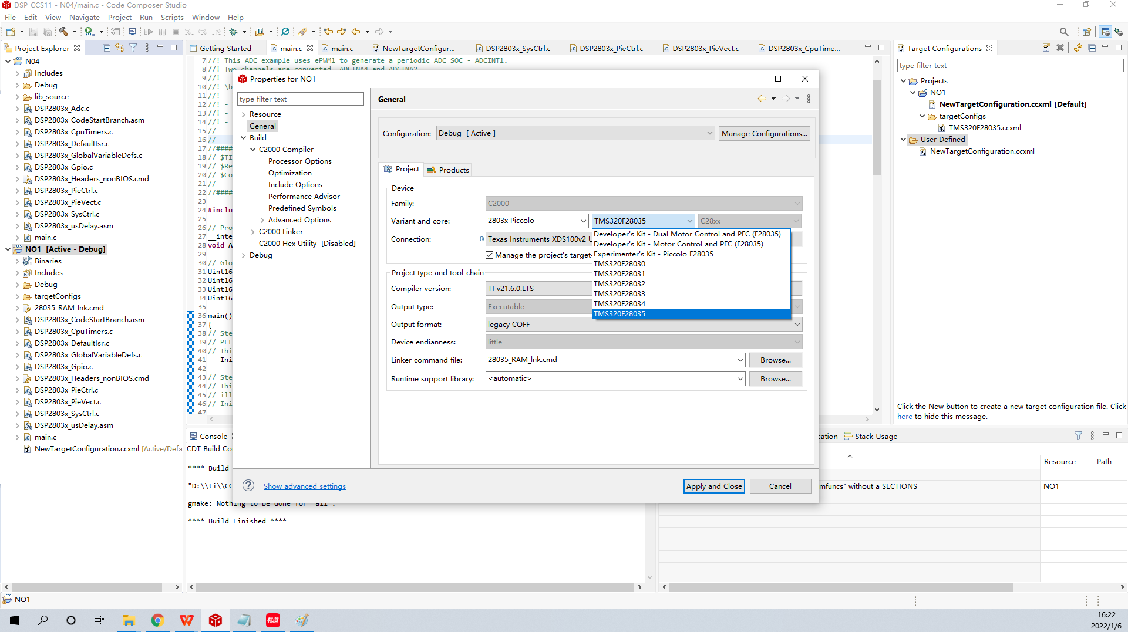

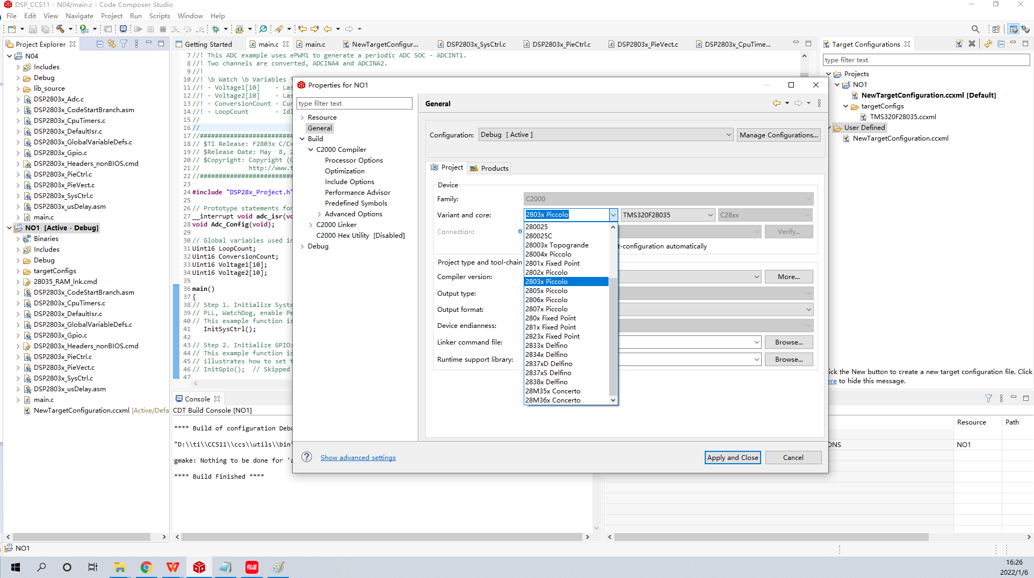
A new project No4 is built, but the chip C2000 DSP cannot be selected. Without this chip, please see the following figure: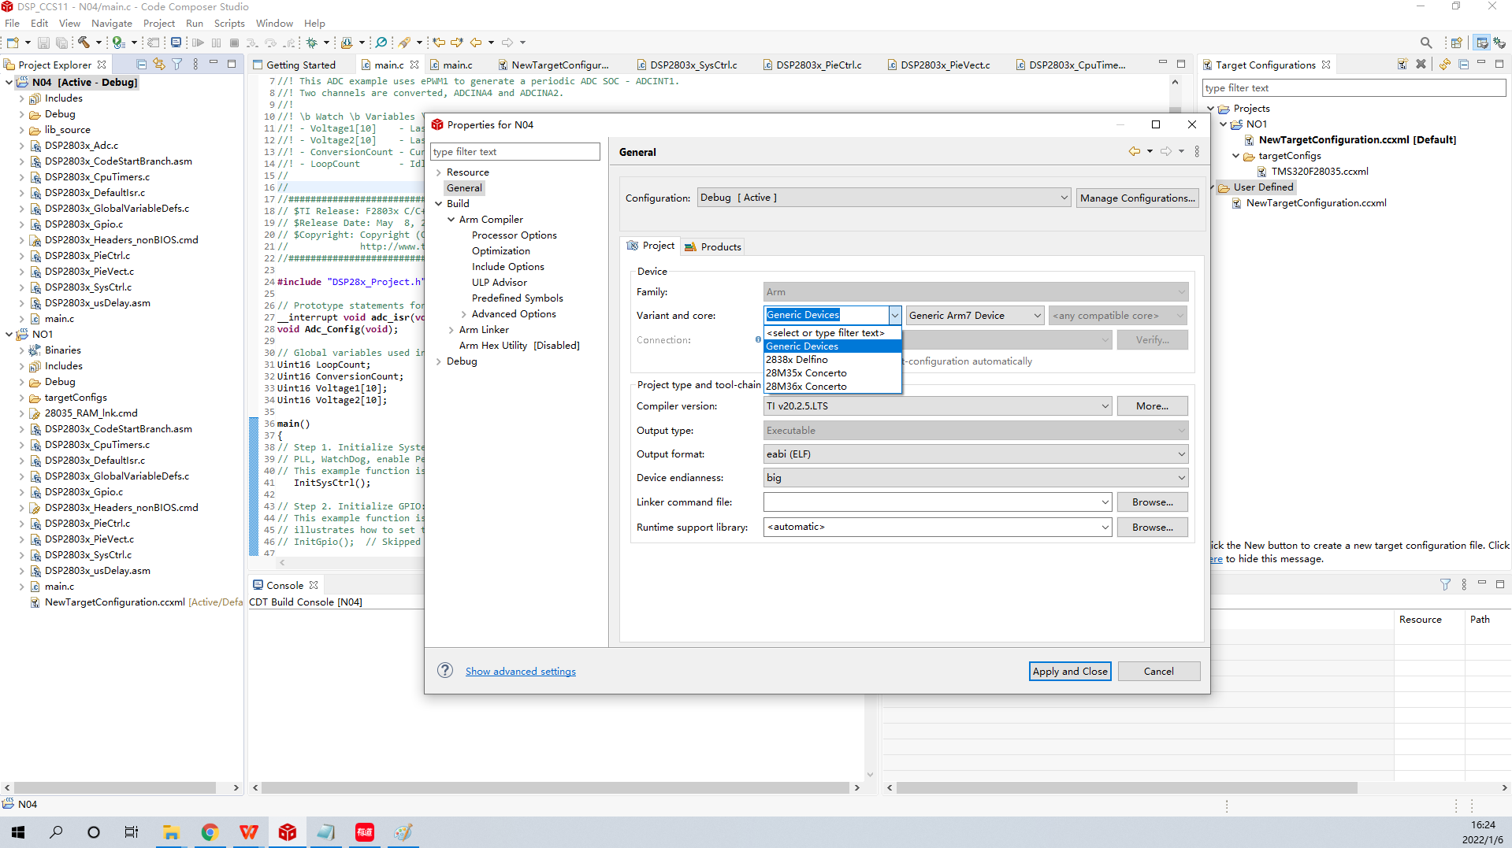
How can I have C2000 DSP series?

