Using the Stellaris In-Circuit Debug Interface:
When the Debug button is used in CCS 7.2, the program downloads and runs to main()
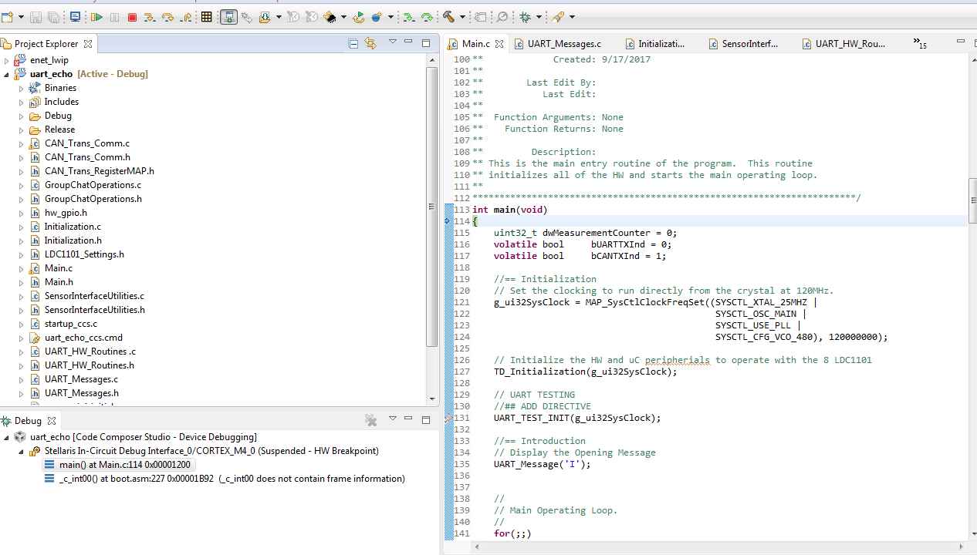

When I select the Debug button in CCS when using the XDS200 on the 10 pin JTAG connector of my EK-TM4C1294XL Eval board, the debugger opens but the program does not appear to have been loaded and the Probe shows “Disconnected”
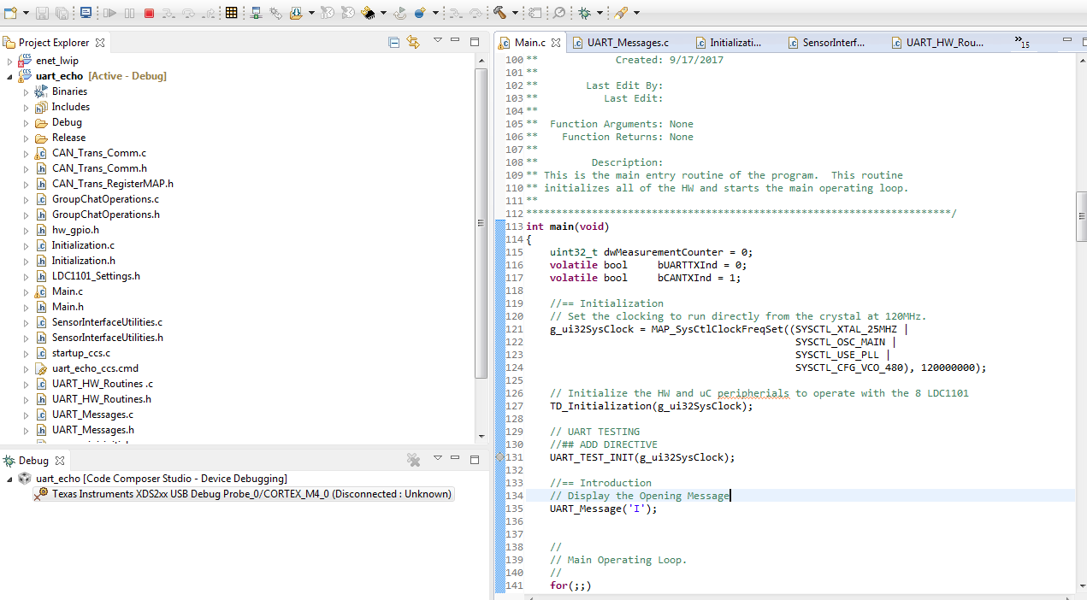

I tried to select “Connect Target” and this is the error I see.
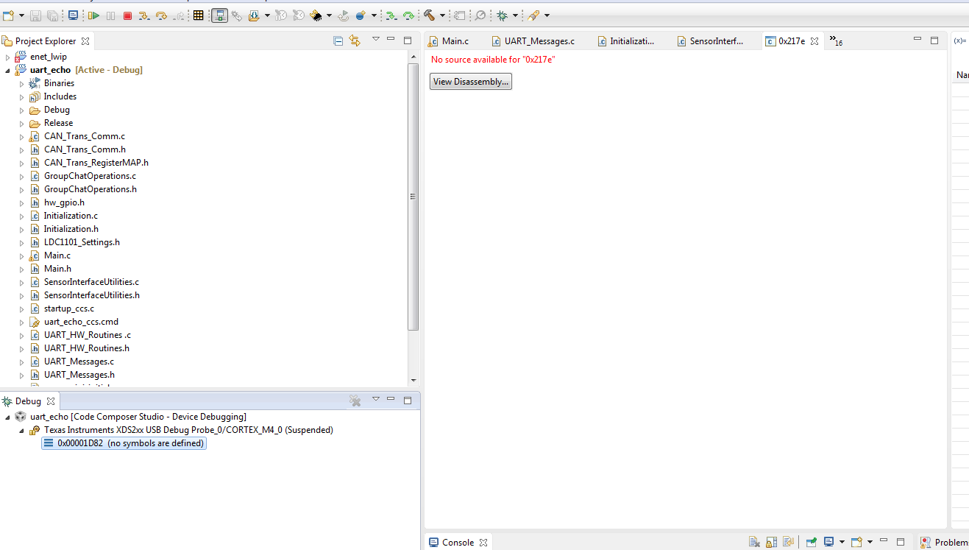

The “Test Connection” operation for the Target Configuration I created for the XDS200 is successful so I know the probe is communicating with the processor.

