Does this PN have a different Default firmware?

1,Use Hilo systems check checksum result is shown: 00004608

2 Use TI GUI: shows “USB Adapter”

Use Hilo systems check checksum result is shown: 00004608

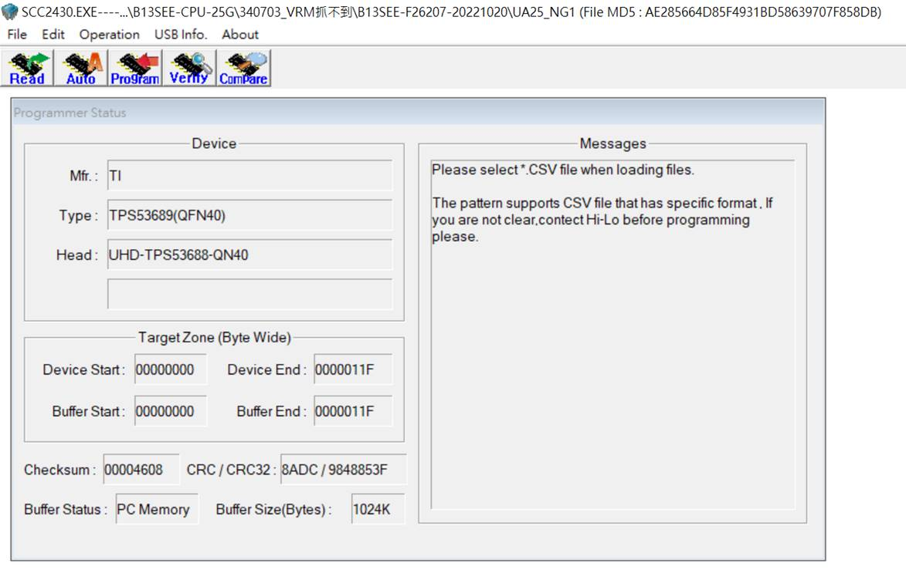

>>使用第三方offline燒錄治具搭配TI GUI，會出現找不到USB Adapter

Use TI GUI: shows “USB Adapter”

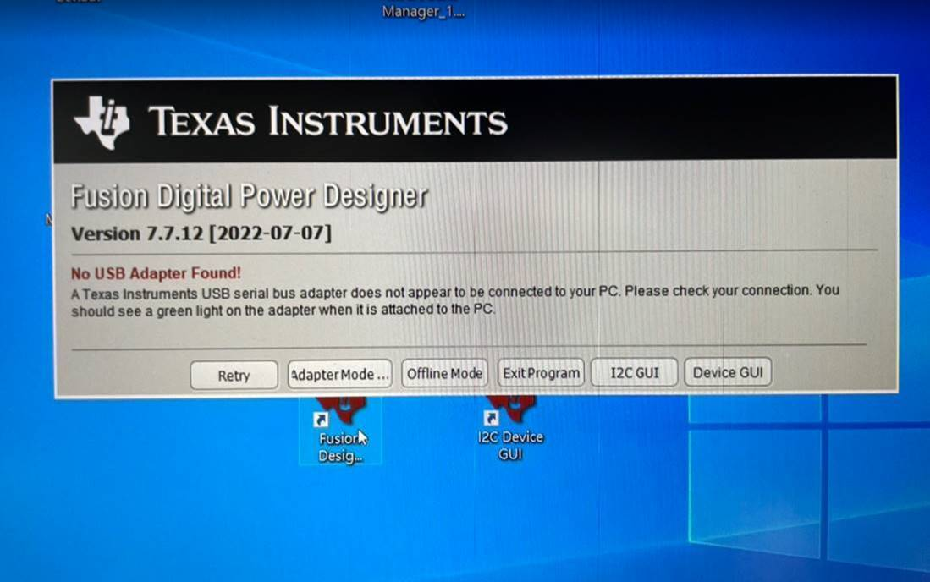

|  |  |  |  |  |
| --- | --- | --- | --- | --- |
| WIH Material P/N | Vendor | TI's P/N | Defect Symptom | TI's CPR |
| TTL-2083H-TXN | TI | TPS53689RSBR | Failure Symptoms: TCV,VRM FAIL Name:B13SEE-CPU-25G Location: UA25 Failure Qty/Rate:67% (402/600) Component Lot/DC:202401-**202401** | CPR241103355 |
| TTL-2235H-TXN | TI | TPS536C9RSLR | Failure Symptoms: TCV,VRM FAIL Name:B13SEE-CPU-25G Location: UA1 Failure Qty/Rate:56% (252/450) Component Lot/DC:202315-**202315** | CPR241103362 |