Try the following:

1. We can make the TSW14J56RevD board to start a “Capture” by using an external trigger. When using an external trigger, an external pulse must be given to the TSW14J56RevD’s board at “EXT_TRG_INPUT” (TRG_IN) input SMA Pin to start a capture. For more details kindly refer to the “3.1.3.3 Trigger Operation” section (Page no. 16) in the HSDC Pro user Guide.
a. Default location of the HSDC Pro User Guide: C:\Program Files (x86)\Texas Instruments\High Speed Data Converter Pro\HighSpeedDataConverterPro.pdf
b. Trigger Mode can be set in Menu Option (Data Capture Options -> Trigger Option) or using the “Trigger_Option” Automation API and then the data captured after the trigger occurred at “EXT_TRG_INPUT” (TRG_IN) input SMA Pin, can be read by using the “Read_DDR_Memory” Automation API.

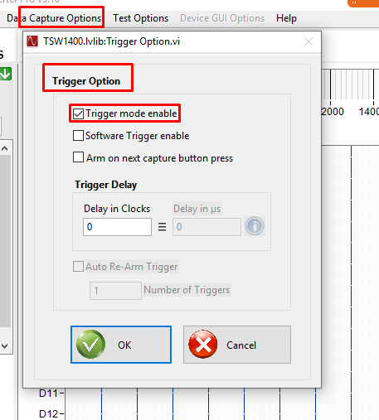

2. We cannot make the TSW14J56RevD board to “Capture” for a particular amount of time explicitly. However we can make the TSW14J56RevD board to capture a particular Number of samples per channel, which indirectly specifies the Capture period. For this the Number of samples per channel has to be specified, based on the operating mode of the ADC (ADC Resolution and ADC Sampling frequency).
a. The Number of samples per channel can be set in Menu Option (Data Capture Options -> Capture Option) or using the “Set_Number_of_Samples” Automation API function.

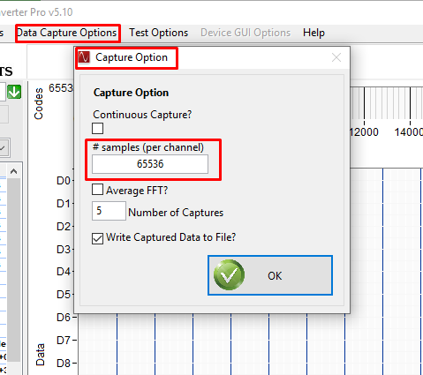

3. Refer to the attached “Sample Code for External Trigger Capture.py” Sample Code for external trigger capture.
4. The “Set_AdditionalFrequencyParametersForTwoTone” automation function API is used for setting the input target frequencies (both the first and second target frequencies) in HSDC Pro which is used for Two Tone Signals measurement in FFT Calculations. And this function cannot be used to set the start time and time period for the capture process to take place.

