- #136 namespace "f360" has no member "F360_Host_Calib_T" VSE_Core.h /F360_Tracker/F360Tracker/VSE line 51 C/C++ Problem
#ifdef F360_LIB_INC
namespace f360
{

#endif
typedef struct F360_Host_Calib_Tag
{
/* Vehicle properties */
float dist_rear_axle_to_vcs_m; // [m] distance bewteen center of rear axis to VCS origin
float rear_cornering_compliance; // [rad*m/s*s] The rear cornering compliance.
float steer_gear_ratio; // Ratio of steering wheel angle to wheel angle
float wheelbase_m; // [m] wheelbase in meters
float understeer_coefficient; // Understeer coefficient
float vehicle_width_m; // [m] Width of the vehicle
float vehicle_length_m; // [m] Length of the vehicle
float cog_x; // [m] Center of gravity
float cog_y; // [m] Center of gravity
float front_wheel_radius_m; // [m] Wheel radius when vehicle is loaded to GVW
float front_track_width_m; // [m] Front Track Width
uint32_t raw_host_signal_latency_ms; // [ms] latency of raw host signal
} F360_Host_Calib_T;
#ifdef F360_LIB_INC
}

- #20 identifier "Concrete_Wall_Sample_T" is undefined f360_concrete_wall_measurements.h /F360_Tracker/F360Tracker/Core/Fusion360/static_environment/include line 38 C/C++ Problem
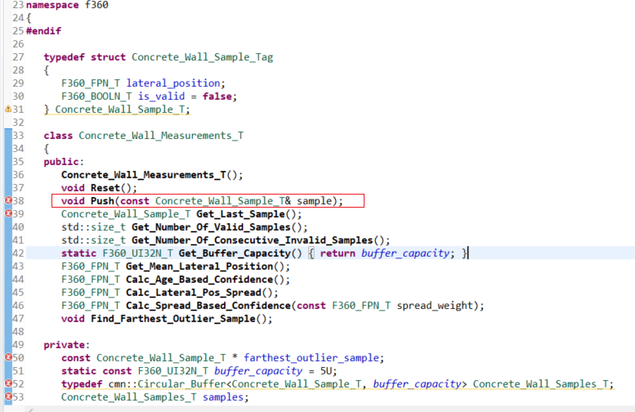

- #20 identifier "N" is undefined
- #20 identifier "size_type" is undefined
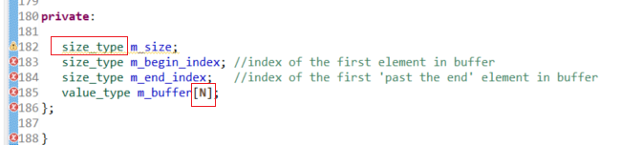

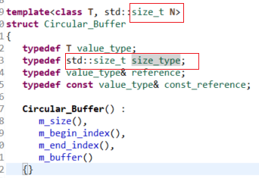

- #20 identifier "Static_Env_Poly_Status_T" is undefined
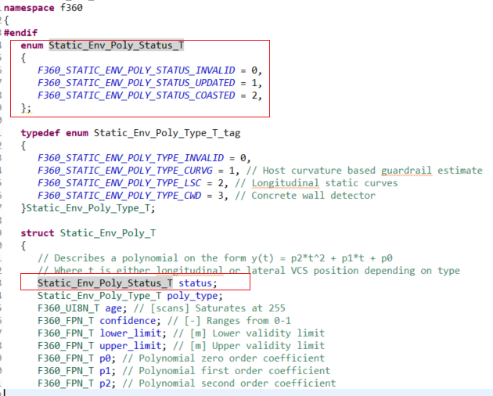

- #20 identifier "VSE_buffer" is undefined
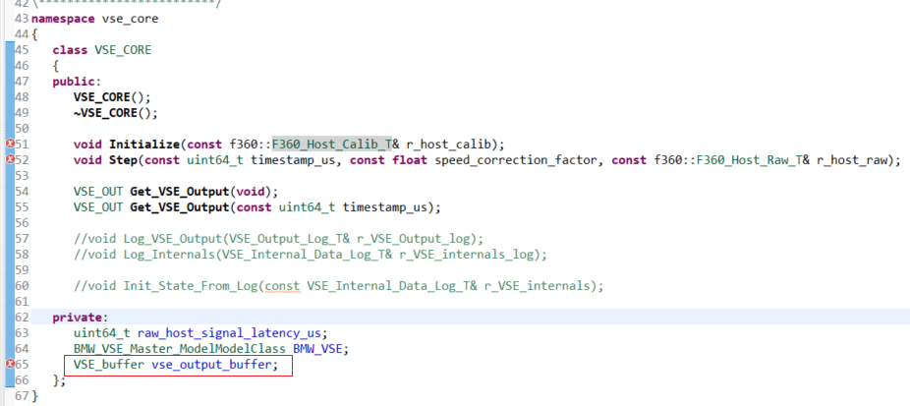

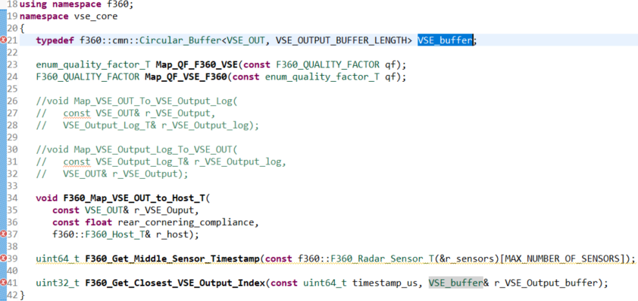

- #278 name followed by "::" must be a class or namespace name
