To retrieve and flash load *.out file into “Texas Instrument” IC Chips TMS320F240 DSP using Spectrum Digital XDS510-USB JTAG EMULATOR with Code Composer Studio version 3.3.
Issues:
- Unable to flash load *.out file into a new IC Chip P/N: TMS320F240 DSP.
The XDS510USB to the target board connection diagram

14 pin cable
USB Cable
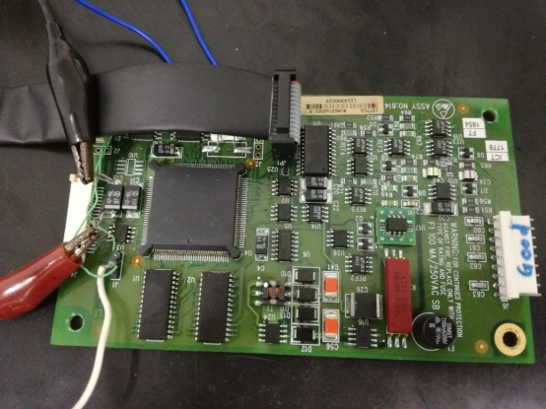
+5V
XDS510 USB
PC
TMS320F240

Advice from Texas Instrument:
You are getting what is known as a "data verification error". Basically the program load failed because there is a mismatch between the actual data vs the data that was written to memory. Often, the main issue is that the program loader could not successfully write to the specified memory location.
There are many potential causes for this issue. Please see the article below for more details. Note that the article was written for a more recent version of CCS. But much of the information in the article is applicable for all CCS versions.
http://dev.ti.com/tirex/explore/node?node=APy2XbLelxyqBB2Yz0WR.w__FUz-xrs__LATEST
Issues:
- Unable to re-solve “Data Verification Error”
- Unable to build my application with the correct linker file.

