My CCS Version
My CCS, SYS/BIOS, and UIA versions are shown in Figure 1-1.
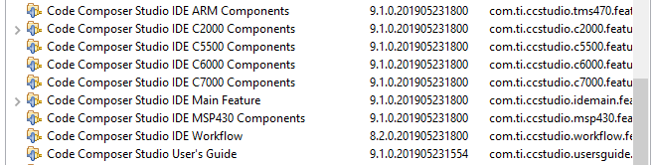
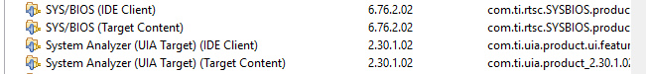
Figure 1-1 CCS Version Information

App Configuration
My app.cfg is shown below.
Figure 2-1 shows that the generic HWI module is enabled.
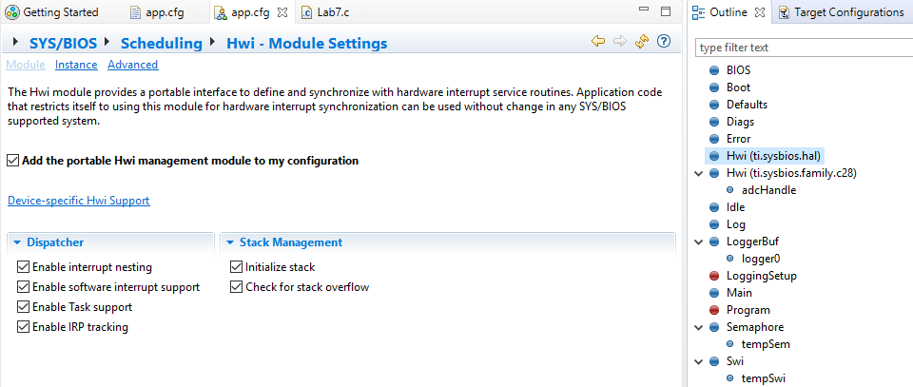
Figure 2-1 Generic Hwi module is enabled
Figure 2-2 shows that the device-specific HWI module is enabled.
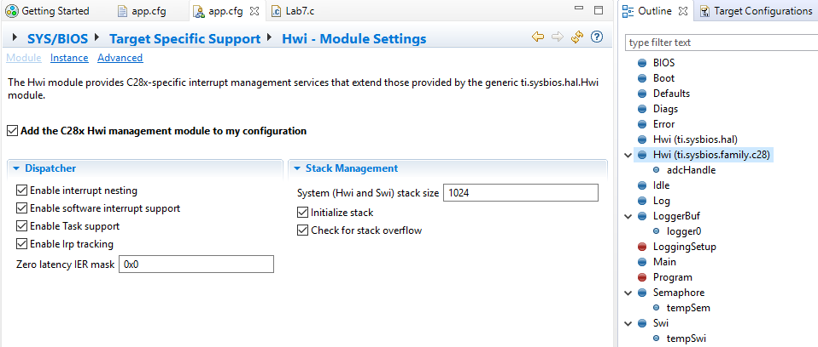
Figure 2-2 Device-specific HWI module is enabled

ROV
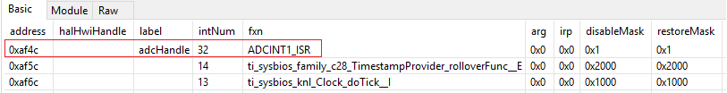

Application HWI name is not shown
The Execution Graph Figure 4-1 does not show the HWI function name but its address.
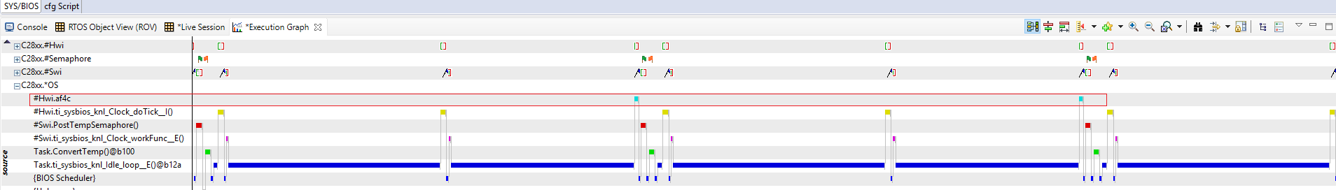
Figure 4-1 Application HWI name is not shown

Application HWI name is shown
The Execution Graph Figure 5-1 shows the HWI function name correctly.
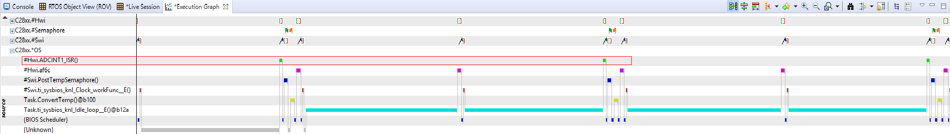
Figure 5-1 Application HWI name is shown

