After reset, code A works. It initializes the peripherals and calls two functions by absolute address. These two functions are in code B and C.

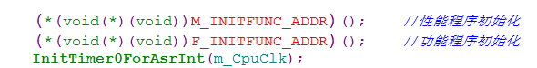

The address of these functions are as below:

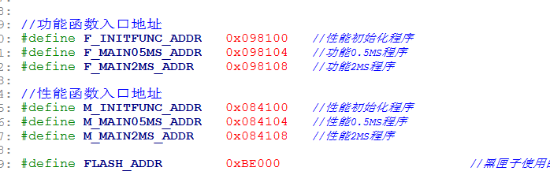

Code A is located here:

cid:image001.png@01D36931.0F2CE1F0

After reset, code A (FLASH_PUBLIC) calls M_INITFUNC_ADDR(), illegal interrupt happens. We stopped the code and PC stopped in illegal ISR.

Resume again and few times, we found that PC will go to 3FE468, in boot rom.

