Procedure to Flash the LM1 with Linux Production Image

This document provides the steps required to flash the eMMC with the Linux production image

Diagram

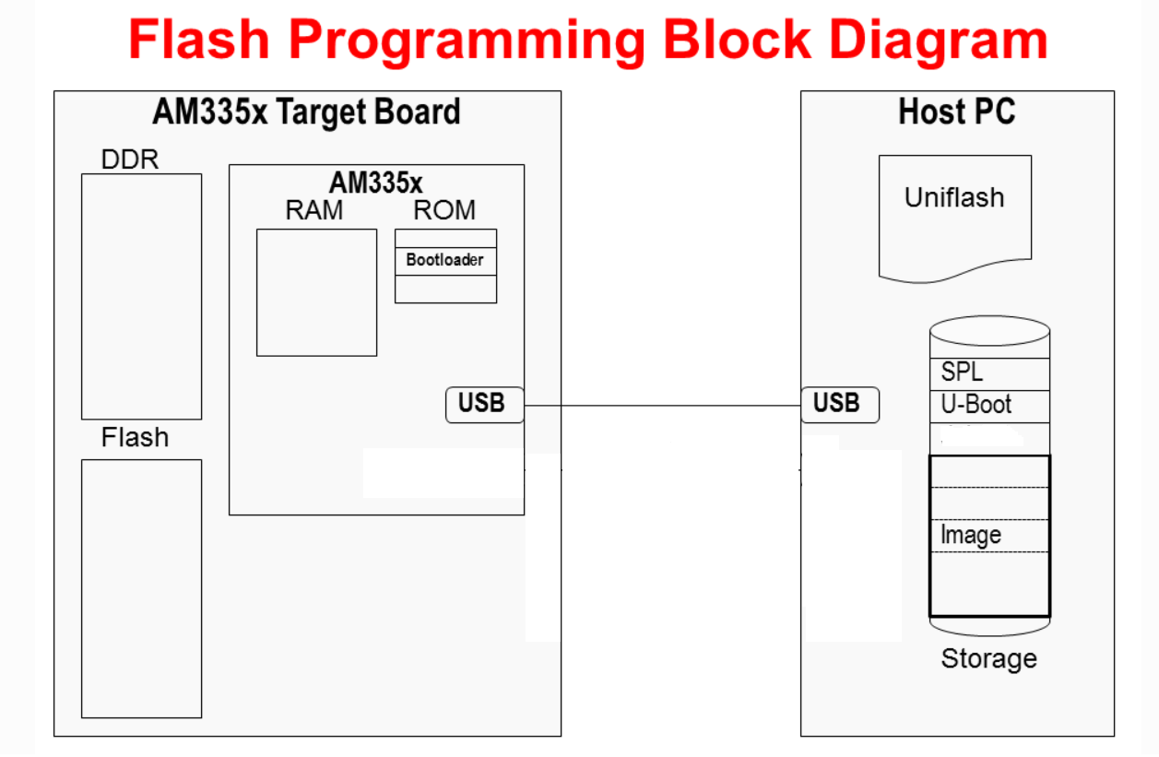

## Setup Pre-requisite:

1. **Test PC**

**System requirements for Android to Linux migration**

|  |  |
| --- | --- |
| **Operating System** | Windows 10 |
| **Applications to install:** | Tera Term – version 4.106  Link: <https://osdn.net/projects/ttssh2/downloads/74780/teraterm-4.106.exe/>  CCS Uniflash – version 3.4.1  Link: <https://software-dl.ti.com/ccs/esd/uniflash/docs/v3_4/uniflash-v3.4.1_release_notes.html>  Note: TI account need to be created to download this software  LM1 software package (Uniflash package) – version 21A_R8  Link (3M SharePoint): <https://skydrive3m.sharepoint.com/:f:/r/teams/FSD-CleanTrace-3MExt/Shared%20Documents/From_TATA_To_3M/MilestoneReleases/21A_R8/OSMigrationImage_WithInstallerDownloadSupport?csf=1&web=1&e=0P5IoV>  LM Service Application – version 1.3  Link (3M SharePoint): <https://skydrive3m.sharepoint.com/:u:/r/teams/FSD-CleanTrace-3MExt/Shared%20Documents/From_TATA_To_3M/MilestoneReleases/21A_R8/LM1ServiceApplication/LMServiceApplication_v1.3_07Jul2022.zip?csf=1&web=1&e=sBbu5l> |
| **Hardware/ General PC Requirements** | CPU: Intel core i3 3rd generation or newer  CPU speed: 1 GHz or above  Disk Space: 20 GB (available space on C drive or OS drive)  Memory: 4 GB  Display: 1366 x 768 (or) above  USB: version 2.0  Internet access not required  Wi-Fi not required  Ethernet not required |
| **Supported browsers** | Google Chrome (any latest version)  Microsoft Edge (any latest version)  Note:  The browser is only required to download the required software and files |
| **Network Requirements** | **Firewall requirement:**  The firewall needs to be configured to allow,  Port: 67, 68  Protocol: UDP  Bound: inbound and outbound  Application: uniflash.exe  Path: C:\ti\uniflash_3.4\eclipse  Notes:   1. Require IT support to apply the above firewall rule in the PC   There is no standard way for the user to check whether the ports are open. So, IT support engineer need to confirm that the ports are open. |
| **LM1 Luminometer Requirements** | LM1 Luminometer shall be running any Android APK version.  USB cable to connect LM1 Luminometer with PC. |

|  |  |
| --- | --- |
| **Sr.No** | **Tools (Software and Hardware)** |
| 3 | Windows 10 Host PC |
| 4 | TeraTerm for Windows  Download latest version from <https://download.cnet.com/Tera-Term/3000-2094_4-75766675.html> |
| 5 | CCS Uniflash on Windows (uniflash_3.4.1.00012_win32.zip) |
| 6 | WinSCP version 5.19.4 software |
| 7 | TI website login details – Register as user on TI website to download CCS Uniflash  <https://login.ti.com/as/authorization.oauth2?response_type=code&scope=openid%20email%20profile&client_id=DCIT_ALL_WWW-PROD&state=gmiHTzOz_qC49fwpAp9jcxU4RBs&redirect_uri=https%3A%2F%2Fwww.ti.com%2Foidc%2Fredirect_uri%2F&nonce=MEwte0JzTbHmUoOvFoTe2l2fDTDvE9GIAo9LvVW7mn8&response_mode=form_post> |

## Configuring CCS Uniflash

As there is no data on eMMC, LM1 device needs to be booted through USB RNDIS. This can be done through configuring of CCS Uniflash tool which is mentioned in detail below

#### Register user on TI

1. Click on below link to register on TI website to be able to download the Uniflash tool

<https://login.ti.com/as/authorization.oauth2?response_type=code&scope=openid%20email%20profile&client_id=DCIT_ALL_WWW-PROD&state=gmiHTzOz_qC49fwpAp9jcxU4RBs&redirect_uri=https%3A%2F%2Fwww.ti.com%2Foidc%2Fredirect_uri%2F&nonce=MEwte0JzTbHmUoOvFoTe2l2fDTDvE9GIAo9LvVW7mn8&response_mode=form_post>

1. Click on link “Register Now” for registering or enter login details if already registered

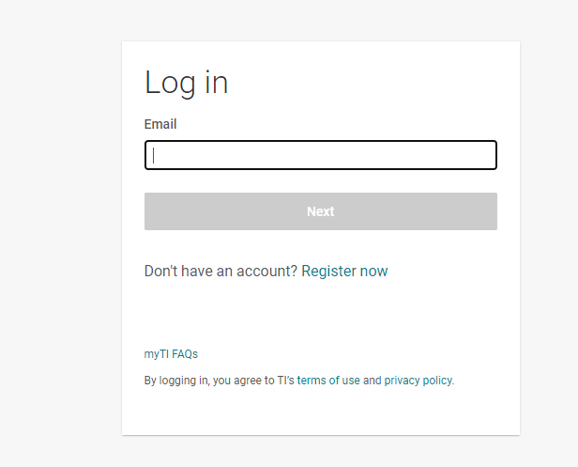

#### Install Uniflash

1. Download Uniflash v3 from

<https://software-dl.ti.com/ccs/esd/uniflash/docs/uniflash.html>

https://software-dl.ti.com/ccs/esd/uniflash/docs/v3_4/uniflash-v3.4.1_release_notes.html

1. Extract the downloaded .zip archive to a temporary folder.
2. Execute the Uniflash Setup program, uniflash_setup_3.4.1.00012.exe

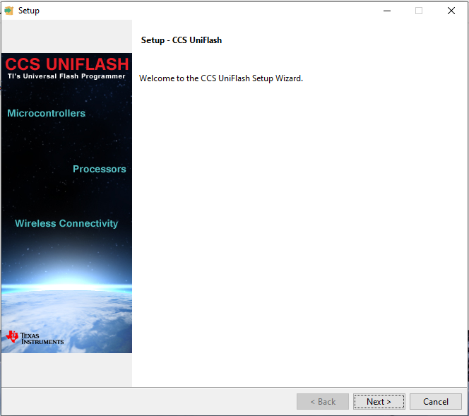

1. Select Next on the above screen
2. Select “I accept the agreement” and Click **Next**

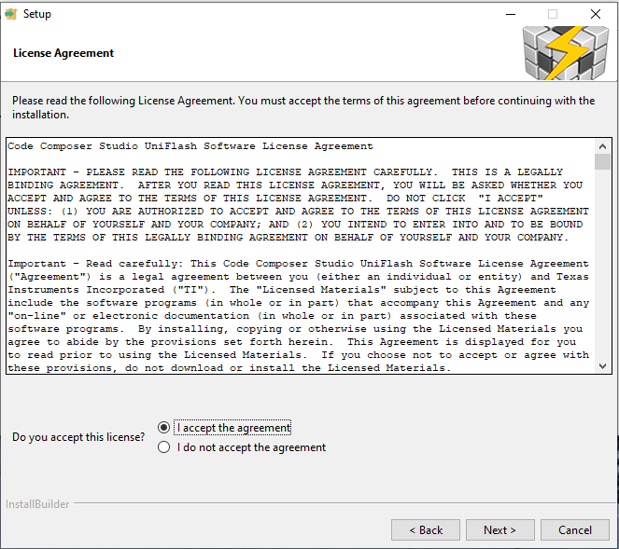

1. Click **Next** to install into the default Installation directory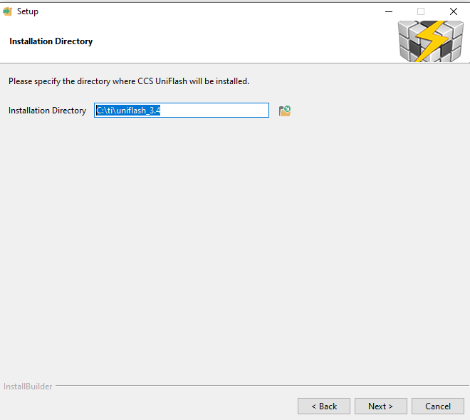
2. Click Next on the following screen

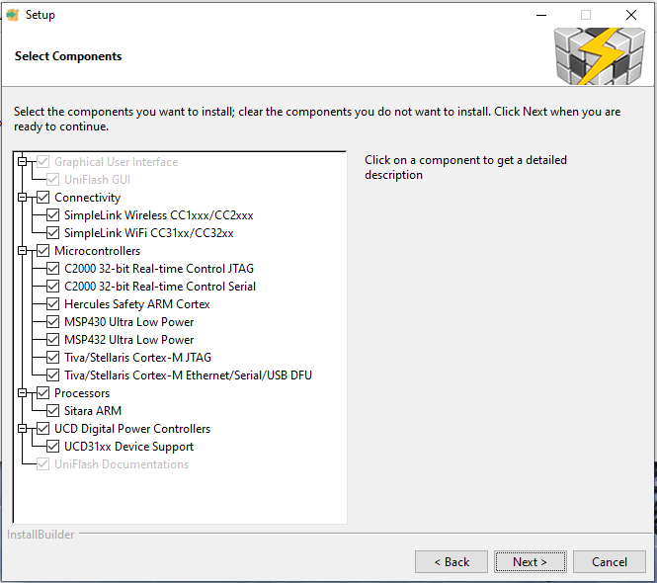

1. Click Next on the following screen

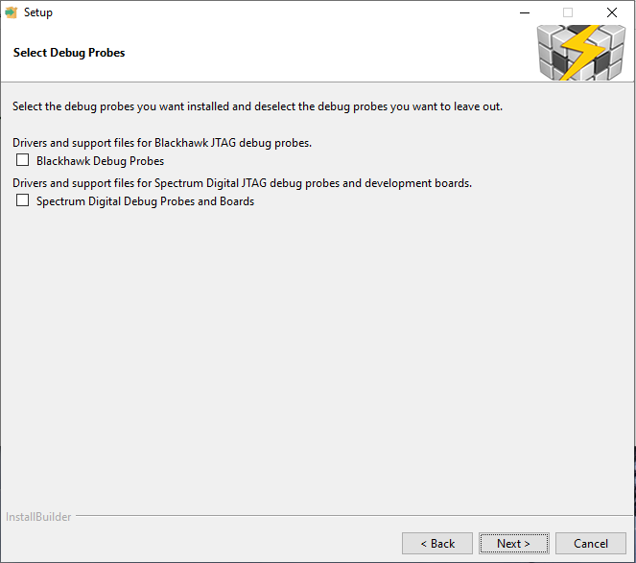

1. Click Next on the following screen

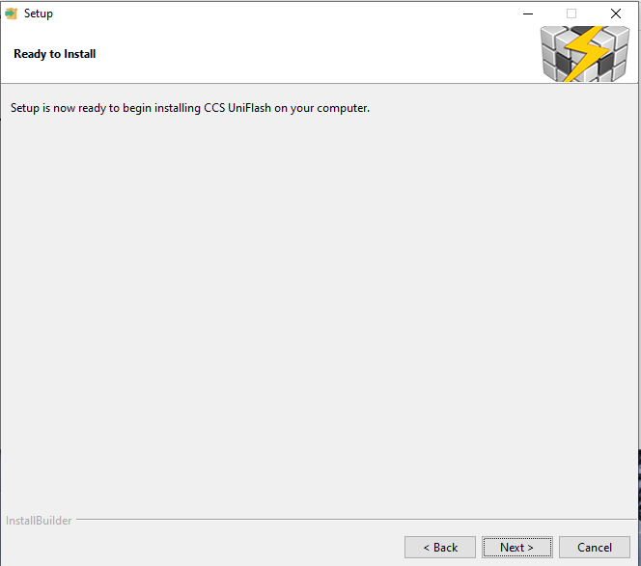

1. Wait for the installation to finish and then Click Next on the following screen

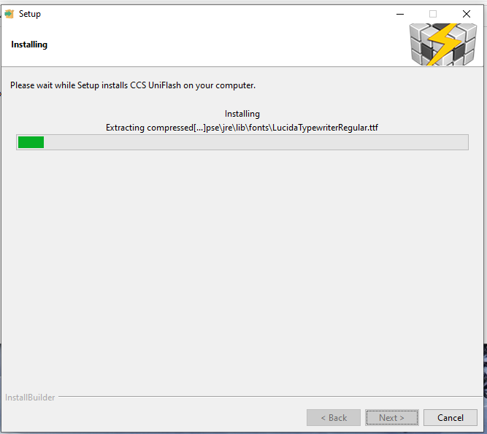

1. Click Finish on the following screen

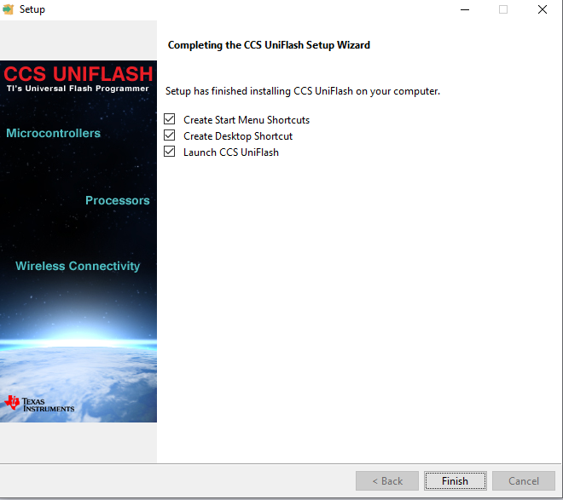

1. Uniflash is now installed and you should see something like this:

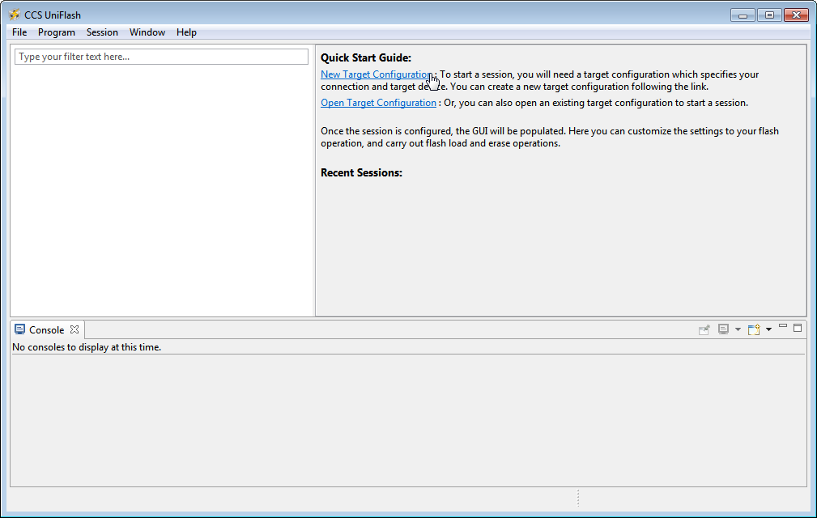

#### Preparing to Flash a Target Board

Now that Uniflash is installed. It needs to know where the files needed to flash to the LM1 device are located and how to send them to the target via either USB or Ethernet.

The following files to be served by the host PC to the target board must be placed in the TFTP home folder directory (C:\AM335x_Flashtool\images).

1. u-boot-spl-restore.bin
2. u-boot-restore.img
3. zImage
4. am335x-lm1.dtb
5. upgrade.tar.xz
6. boot_partition.tar.gz
7. Clean-TraceSyncInstall_Ver1.6.0.58.exe
8. TraceHygieneManagementInstallWizard_Ver1.6.0.48.exe

#### Folder Creation in Windows

1. Create folder “*AM335x_Flashtool*” in C:\ drive
2. Create folder “*images*” inside C:\AM335x_Flashtool
3. Copy the files from folder “***eMMC_Production_Image_Release_Package*** ” to windows folder “C:*AM335x_Flashtool\images*\”

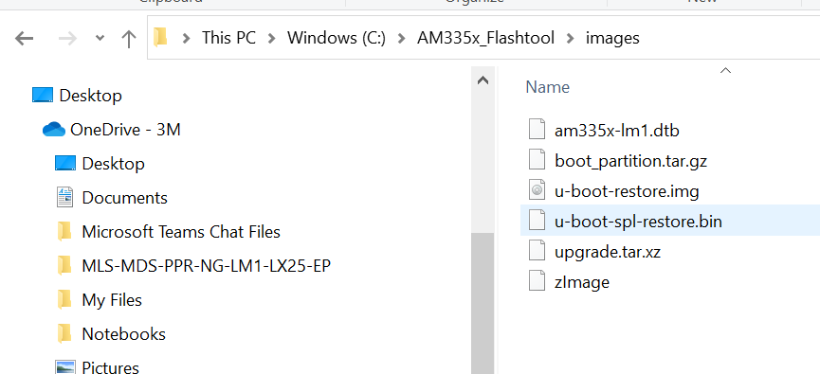

## Windows Tera Term Setup

1. Power on LM1 and Connect the LM1 to Windows PC
2. Open Tera Term, select Serial option and a COM port in dropdown list. Usually it is the last(third) line item in dropdown list

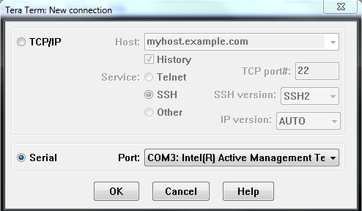

1. Make changes in the baud rate and other setting as shown in below snapshot. Select “Setup” and then “Serial Port”

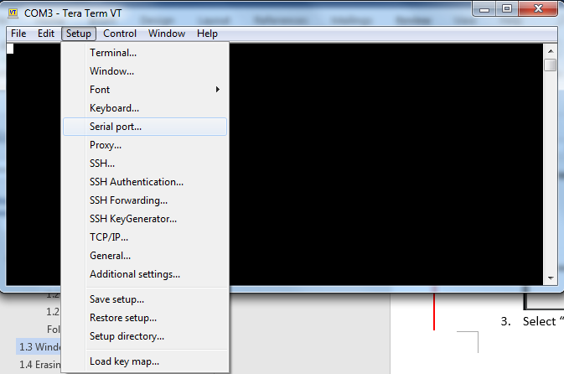

NOTE: COM port (COMxx) is dependent on user PC. User should select the highest COM port from the dropdown menu of “Port”

Set Baud rate to 115200

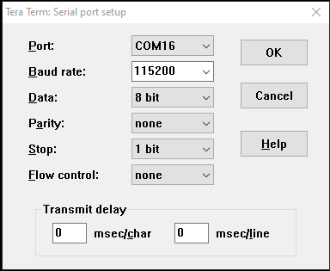

## Erasing eMMC data

1. Configure the Windows Tera Term application as given in **section 1.3- Windows Tera Term Setup**

**Note: Follow step 2 In case of Android to Linux Migration. Skip to step 3 in case of Linux to Linux migration.**

1. Set the current Active Window to Tera Term (By clicking left mouse button in the middle of the Tera Term window).

Shut down the LM1. Keep Enter key pressed on the keyboard and turn On LM1 to stop LM1 in bootloader. Once you see a string of “U-Boot#” then you are in the bootloader and can release the Enter key.

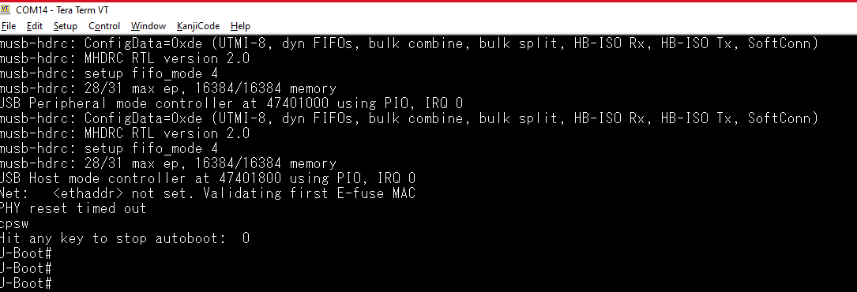

1. Set the current Active Window to Tera Term (By clicking left mouse button in the middle of the Tera Term window).

If the LM1 is having Linux, then Power On LM1. Let it turn On completely until the LM1 app is seen on Luminometer. Keep Enter key pressed on the keyboard with one hand and long press the power button of LM1 until you see the options to “Restart” and “Power Down” the LM1. Keep enter key pressed on the keyboard and select “Restart” option on LM1. Once you see a string of “=>” on the Tera term, then you are in the bootloader and can release the Enter key.

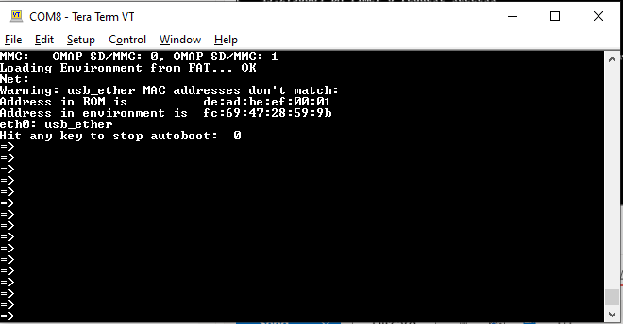

1. Execute the MMC commands in sequence mentioned below on Tera Term Terminal

*mmc dev 1 (hit Enter key after typing this command)*

*mmc erase 0 15106047 (hit Enter key after typing this command)*

Data in eMMC is now successfully erased as seen below (below screen shot is when the original OS in LM1 is android - Android to Linux migration)

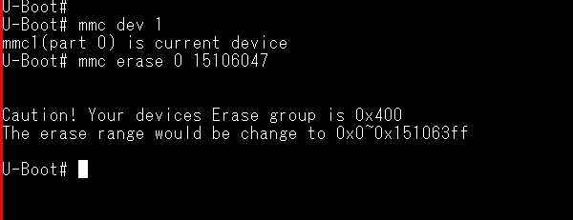

If the original OS in LM1 is Linux then the screen shot after erasing emmc will be as below (Linux to Linux migration)

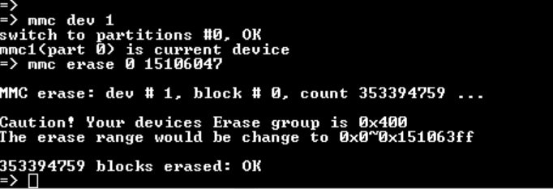

## LM1 Migration steps

|  |  |
| --- | --- |
| **Sr.No** | **Software Package** |
| 1 | *eMMC_Production_Image_Release_Package* copied on Windows PC |

### Flash eMMC Production Image on LM1

**Steps**

#### Flashing a Board using USB

1. If Uniflash is not already running on the host PC, start it.
2. **Click** on **New Target Configuration**



1. Set **Connection** to **Sitara Flash Connections** and **Board or Device** to **Sitara Flash Devices**. Click **OK**.

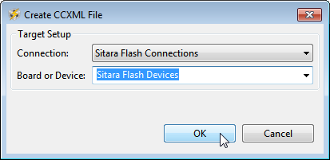

1. Make sure the **Flash Server Configuration** is set up properly. Please refer below image

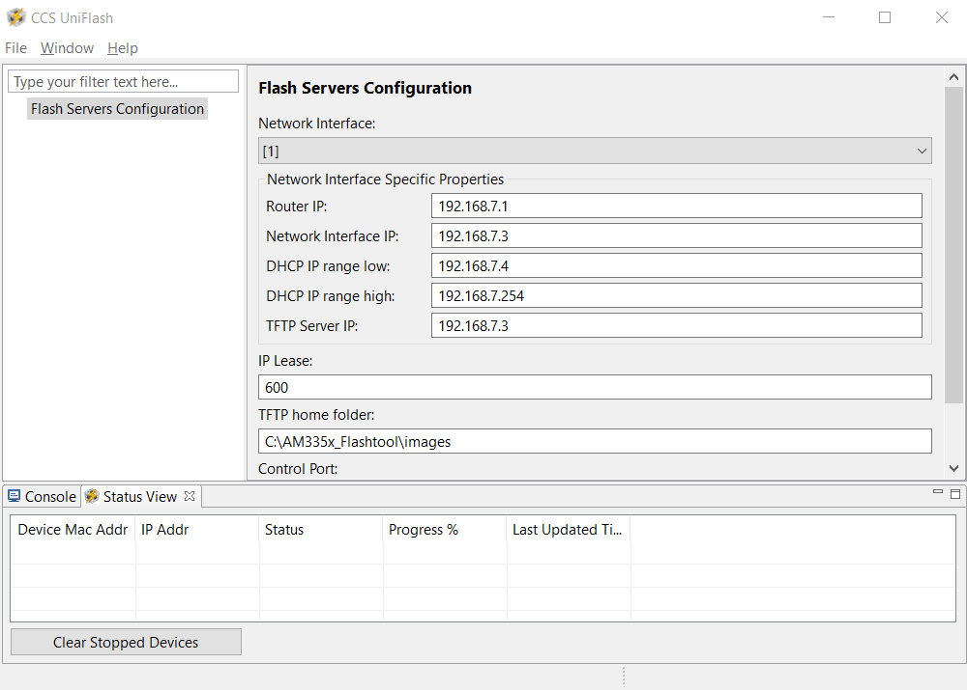

1. Power down the LM1 by Hard pressing Power button for 10 seconds.
2. Now turn device back on by pressing the power button for 1 second. You should hear a faint click and the screen might flicker, but the screen will remain black for the next steps.
3. After restart make sure there is "Linux USB Ethernet/RNDIS Gadget" under Network Adapters, in Device manager.

- If this does not show up in Network Adapters, try restarting the LM1 a couple times and check to see if "Linux USB Ethernet/RNDIS Gadget" shows up under Network Adapters.

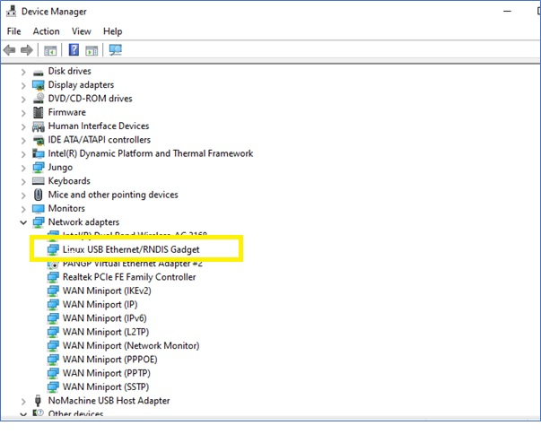

7.1 If LM1 does not appear as “Linux USB Ethernet/RNDIS Gadget” under Network adapters but displayed as RNDIS under “Other Devices” then follow the steps mentioned below. Otherwise, skip to Step # 8 below

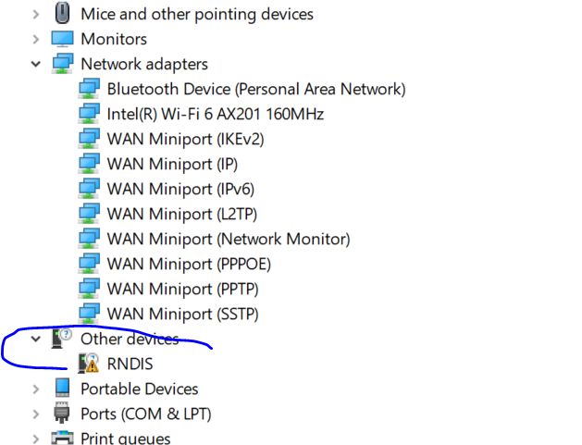

1. Right click on the RNDIS driver shown on Device Manager and select Update driver

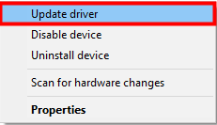

1. Select "Browse my computer for driver software"

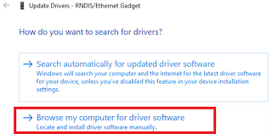

1. Select "Let me pick  from a list of device drivers on my computer"

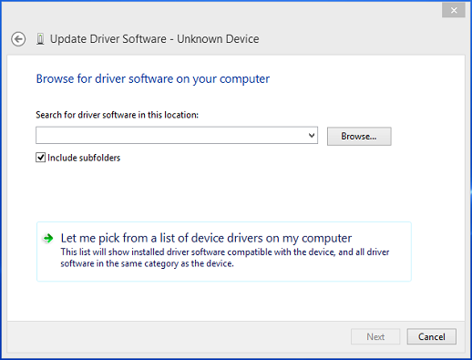

1. Select Network adapters

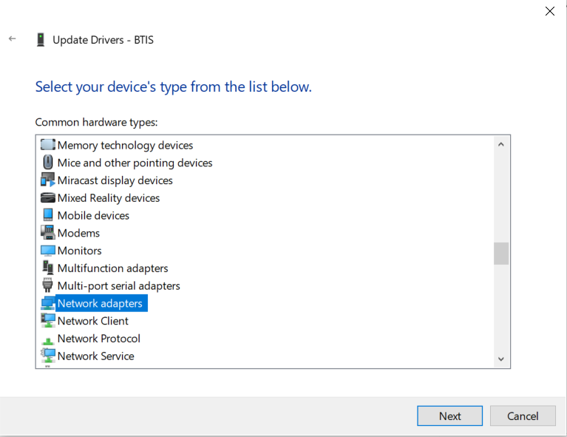

1. Select Linux Developer Community and select RNDIS Driver

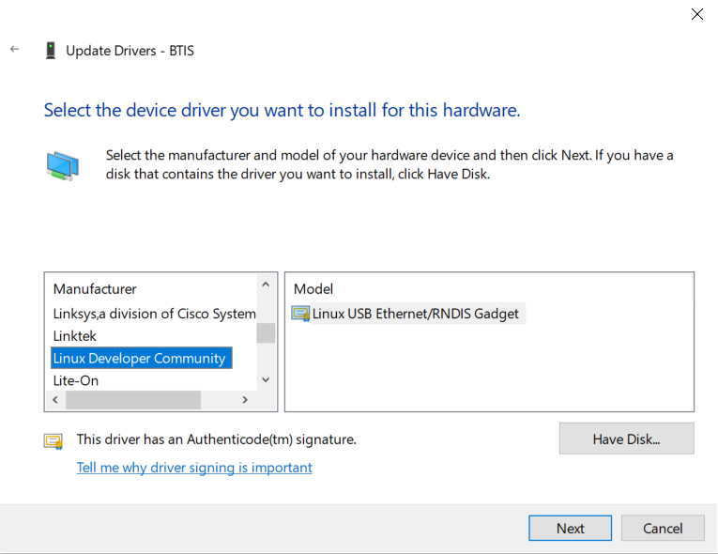

1. Click Next
2. Click Yes

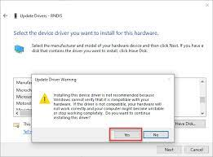

1. This new interface needs to be configured with a static IP address. **Right Mouse** **Click** on the Networking icon in the toolbar, and open “Network & Internet settings”.

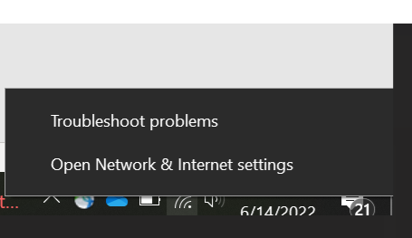

and then click on the “**Change adapter options”** link.

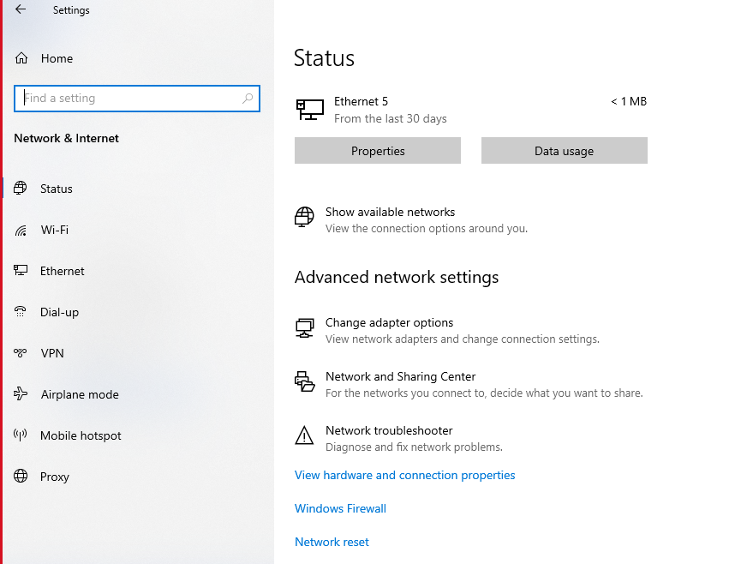

1. Double click Network adapter “**Linux USB Ethernet/RNDIS Gadget**”. Refer the image below

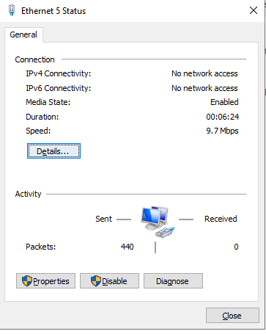

1. In the Connection Dialog, **Click** on **Properties** and below window will open

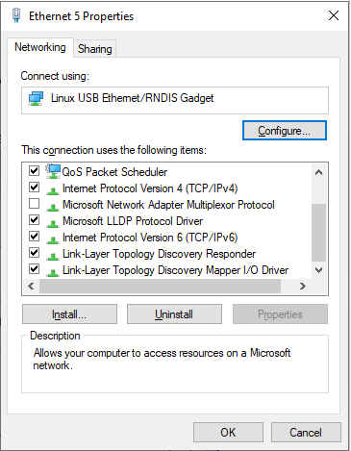

1. Select **Internet Protocol Version 4 (TCP/IPv4)** and choose **Properties**.
2. Set the port to use a Static IP Address by selecting **Use the following IP Address:** and changing the **IP Address:** to 192.168.7.3. This setting should correspond to the **Network Interface IP** setting in Uniflash. Verify that the **Subnet Mask** is set to 255.255.255.0 and click **OK**.

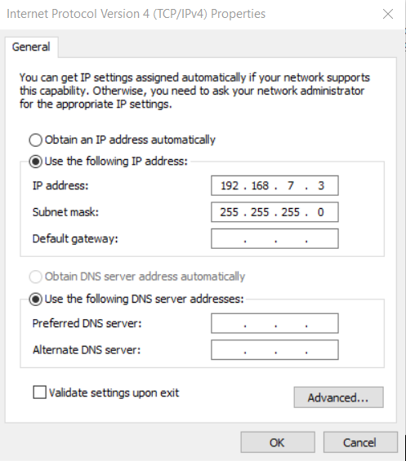

1. Click OK
2. In Uniflash, enable the flashing capability by clicking on **Start Flashing**.

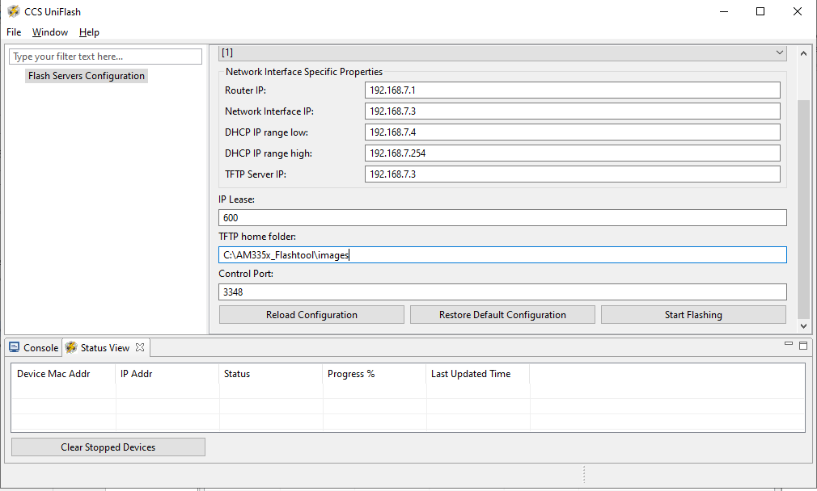

1. Depending on your Windows Firewall settings, you may get the below two warnings for the servers being used (opendhcp and opentftp). If so, please click **Allow access**.

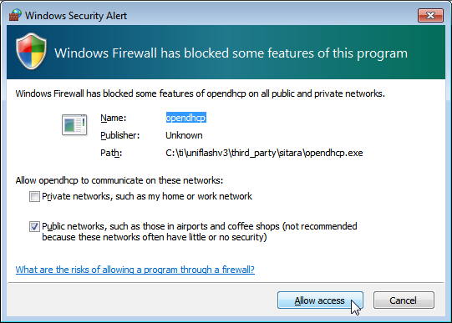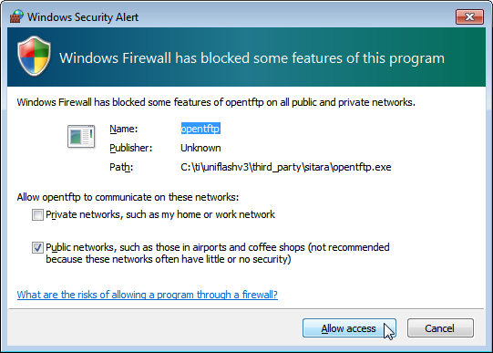

1. Power down the LM1 by Hard pressing Power button for 10 seconds. Now turn device back on by pressing the power button for 1 second. You should hear a faint click and the screen might flicker, but the screen will remain black for the next steps.
2. After LM1 is turned ON, Ensure that in “Network Adapters” as “Linux USB Ethernet/RNDIS Gadget” is present in the device manager windows of Windows

In case of DHCP and TFTP ports (67 and 68) are blocked, no file transfer progress will be observed.

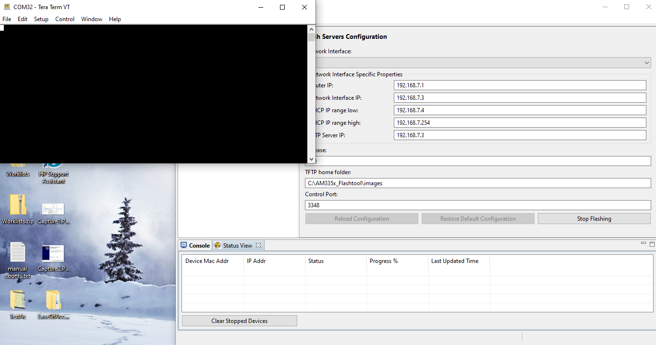

If case of DHCP and TFTP ports (67 and 68) are not blocked then the progress will be as shown below

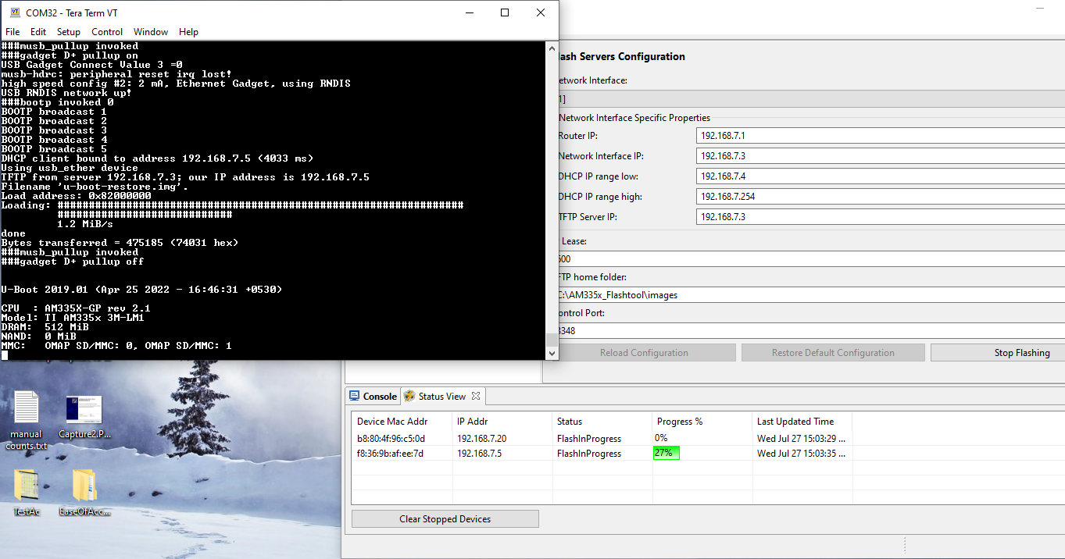

1. Now, the SPL and the u-boot.img will be successfully flashed, LM1 will restart automatically.
2. If the message shows up asking to format the disk before you can use it. The user should select Cancel.

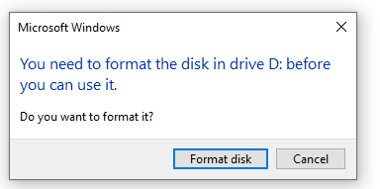

1. Follow steps mentioned in the section “flashing eMMC Production Image” below.

#### Flashing eMMC Production Image

1. Once the LM1 starts booting, the eMMC production images (kernel image,dtb,scripts ) will start flashing automatically during the boot process
2. When the below logs are observed on Tera Term Screen, the RNDIS IP address should be configured manually as mentioned in the steps below

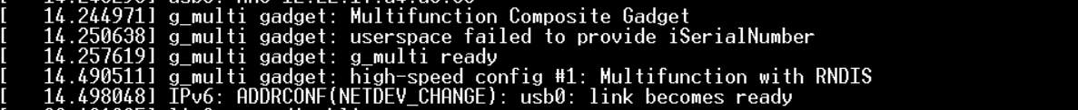

1. The USB RNDIS network interface is detected as shown below when the log mentioned in above image are observed on the console.



1. This new interface needs to be re-configured with a static IP address. **Click** on the Networking icon in the toolbar, and then click on the “**Change adapter options”** link.



1. Double click Network adapter “**Linux USB Ethernet/RNDIS Gadget**”. Refer the image below



1. In the Connection Dialog, **Click** on **Properties** and below window will open



1. Select **Internet Protocol Version 4 (TCP/IPv4)** and choose **Properties**.
2. Set the port to use a Static IP Address by selecting **Use the following IP Address:** and changing the **IP Address:** to 192.168.7.3. This setting should correspond to the **Network Interface IP** setting in Uniflash. Verify that the **Subnet Mask** is set to 255.255.255.0 and click **OK**.



1. Click Ok
2. Wait for the eMMC production image to complete the flash operation. This process will take about 25-30 minutes (No progress will be visible on the screen). Wait until you see the Root Login prompt on Teraterm to indicate that it is completed.
3. During **OS migration process after the OS file is flashed through the CCS Uniflash tool don’t reboot the device**. A login prompt as shown in below image will appear  
   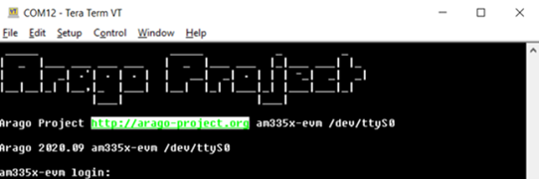
4. Login to this login prompt by typing “root”
5. Run below command to transfer the installers. Wait until you see “root@am335x-evm:~#” on the prompt. File transfer is in progress.

./receive_installer.sh Clean-TraceSyncInstall_Ver1.6.0.58.exe

1. Run below command, Wait until you see “root@am335x-evm:~#” on the prompt. File transfer is in progress.

./receive_installer.sh 3MClean-TraceHygieneManagementInstallWizard_Ver1.6.0.48.exe

Expected output after running both the commands is as below,  
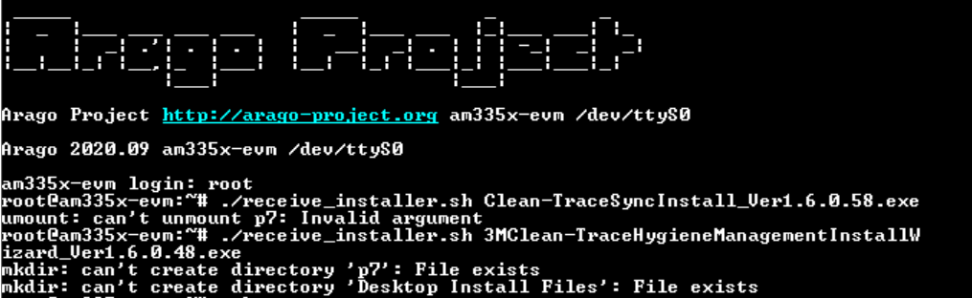

1. After successful copy when you see root@am335x-evm:~# , execute “reboot” command. Wait for the reboot to finish, unplug the unit and the migration is completed.

