After build application using Release configuration:

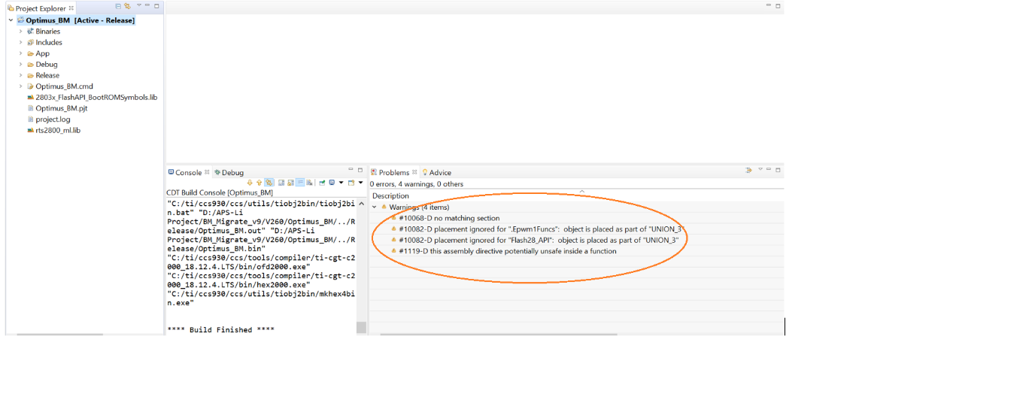

To fix above warnings linker file is modified as below:

Before After

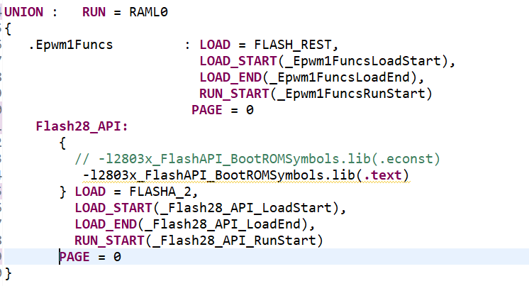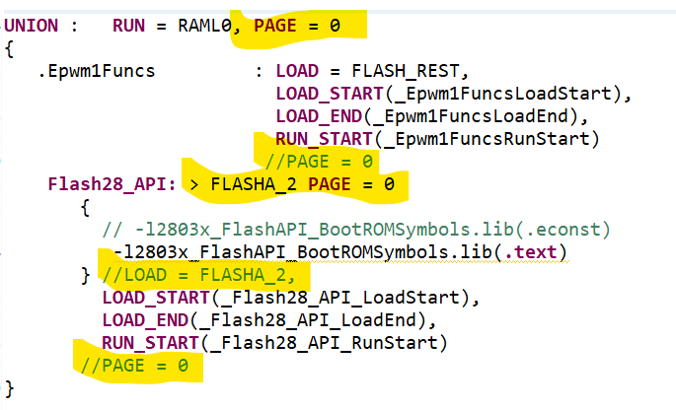

After making above changes and Rebuild still getting following warnings:

Below lines in the linker script shows above warning:

Below lines in the application code shows above warning:

