The XDS510USB to the target board connection diagram

14 pin cable
USB Cable
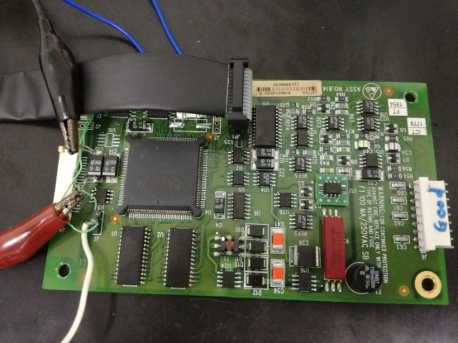
+5V
XDS510 USB
PC
TMS320F240

Follow the step:
--Click “Configuration---> Verify”
--Click “Emulator--->Reset”
--Click “Emulator--->Test”
After that, open the Setup CCStudio v3.3 to setup the detail and open the CCStudio v3.3
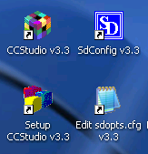
In the CCS v3.3, the software finally show the connection to the target
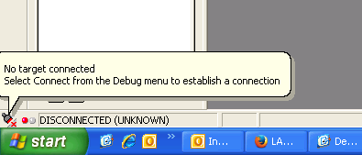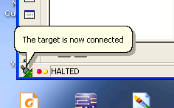

Now the situation is we can save the program and data, but can’t load the program and the data inside the TMS320F240. After load the program and data, the CCS v3.3 software will show as below.
