The next figure shows the result when I execute build. The program is show in the main.c window

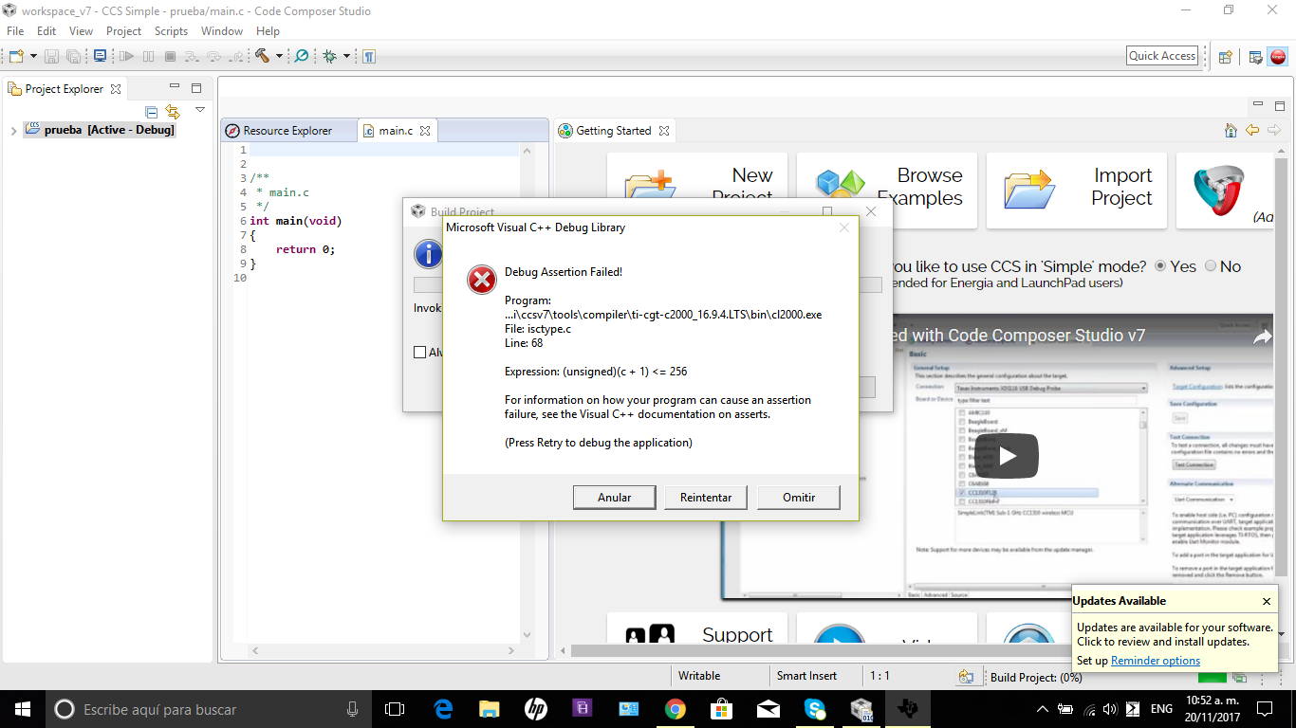

The following screen shot shows the result when Iclick on retry

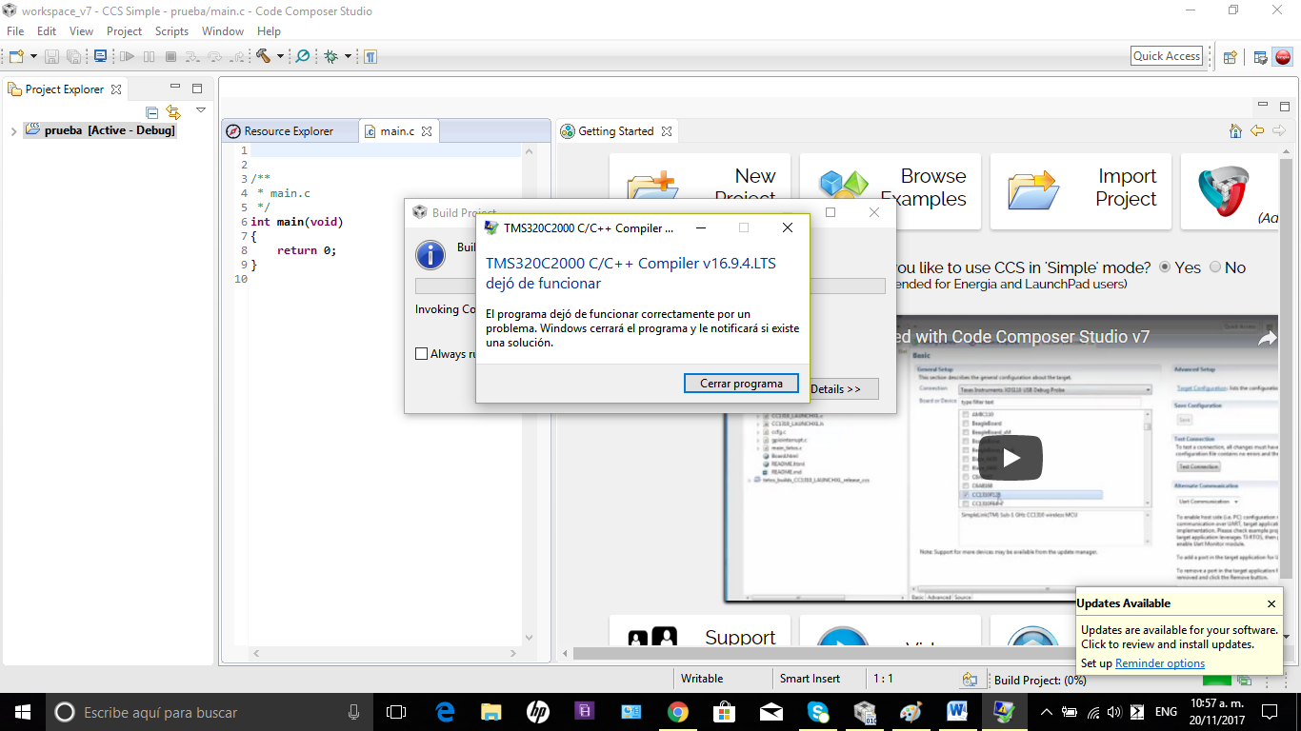

The next screen shot shows when I execute dubug tool

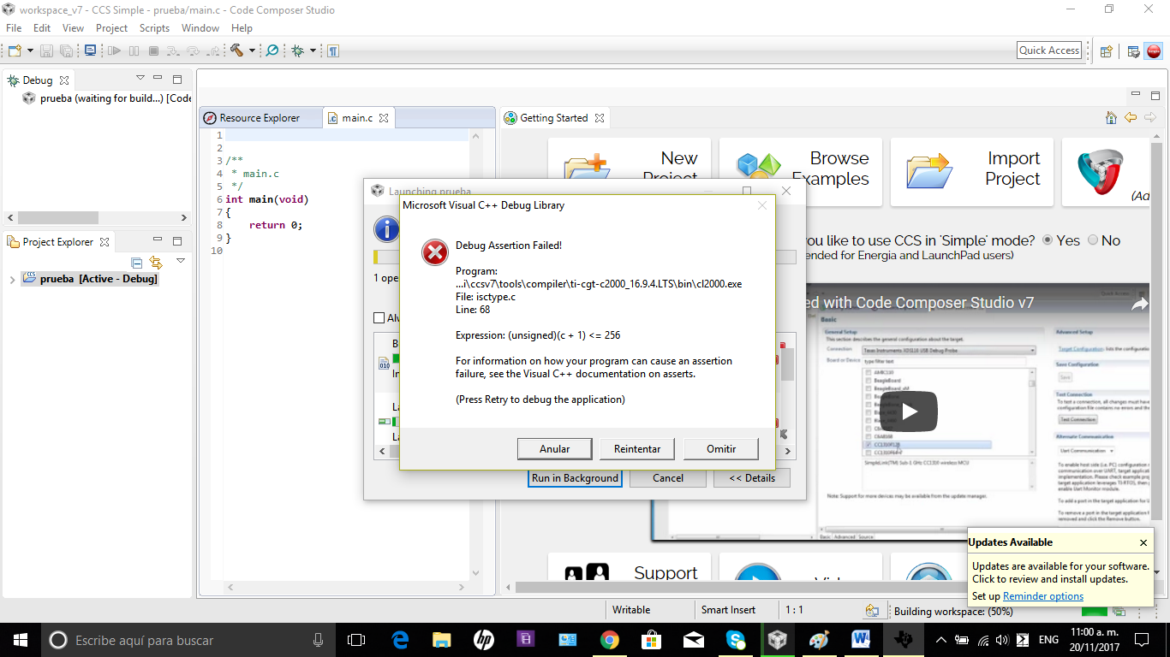

Afetr of several minuts the screen is

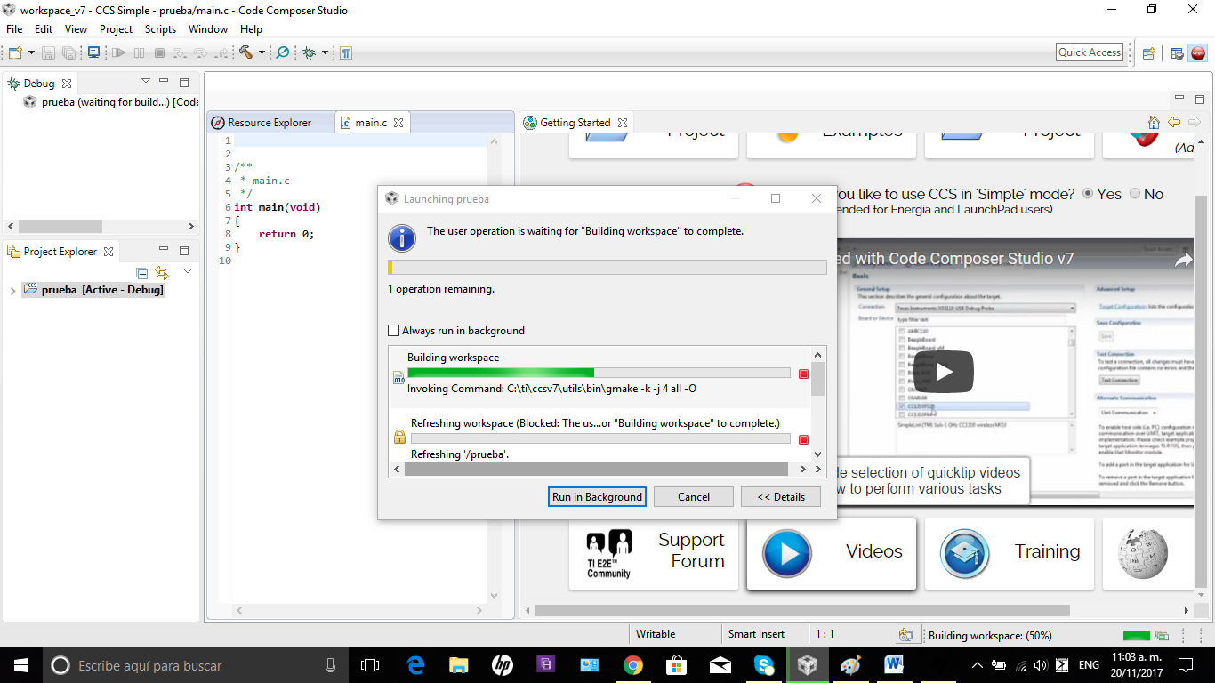

After of ten minuts the screen does not change

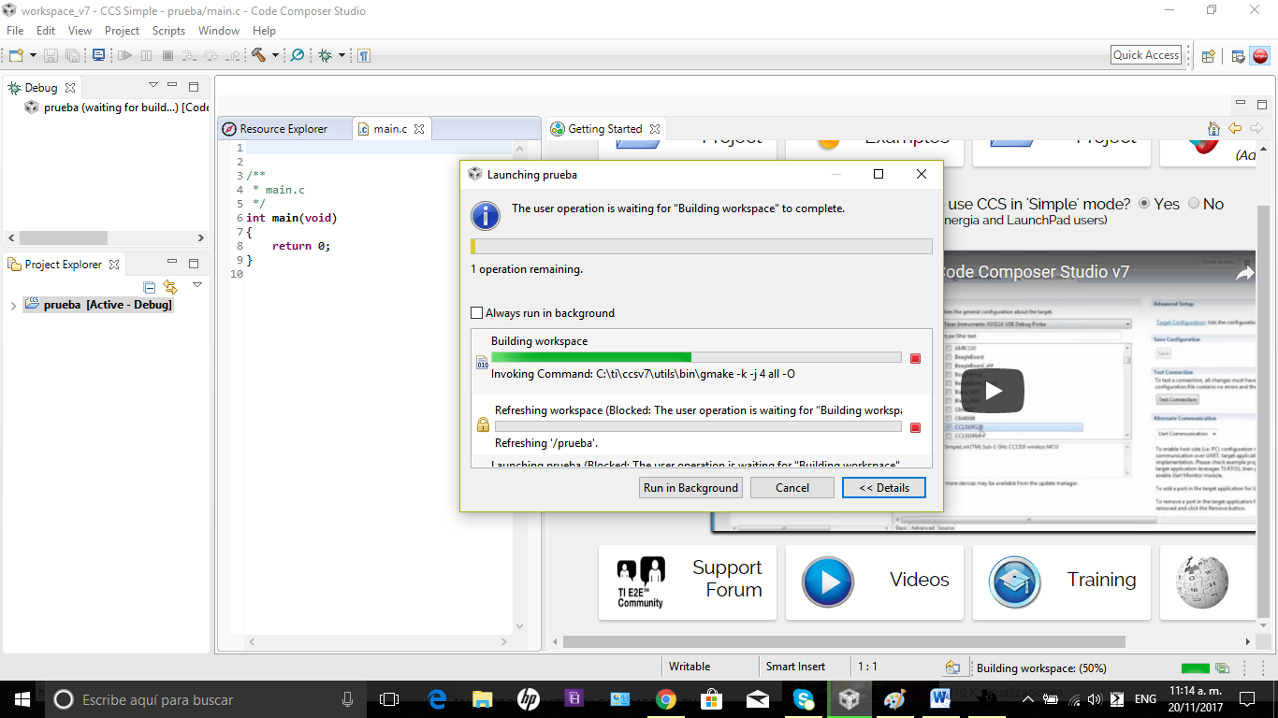

Tried execute, for second time, the debugger, now the process is the show in the screen shot.

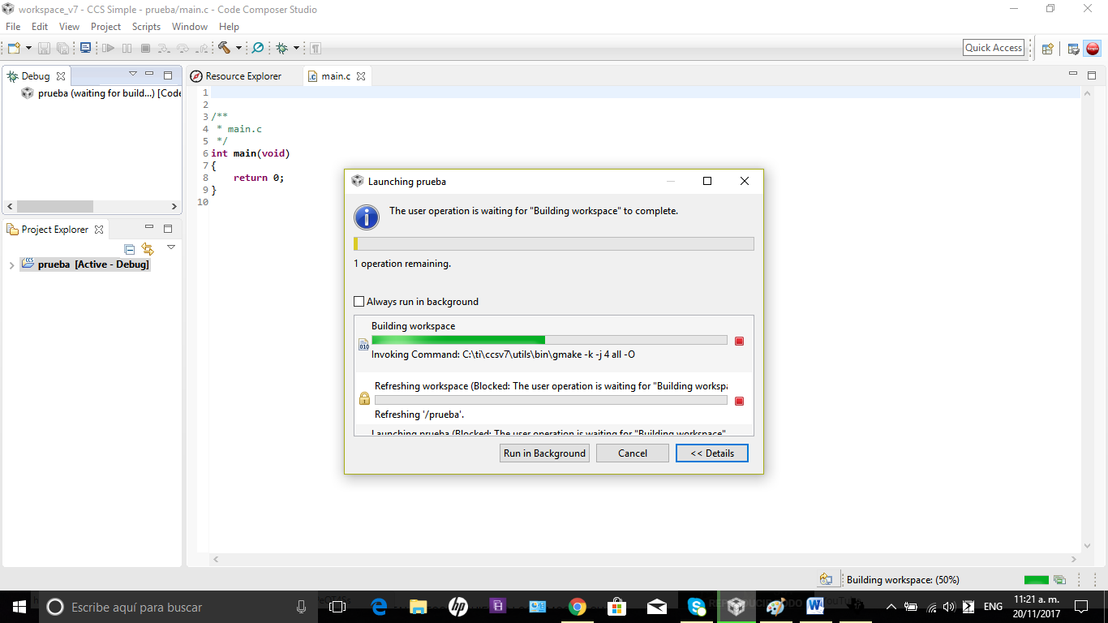

After of exit of CCSv7, I can`t to exit the of progress information window. I need to restart my computer.

