Importing firmware from CCSv3.3 to CCSv9:

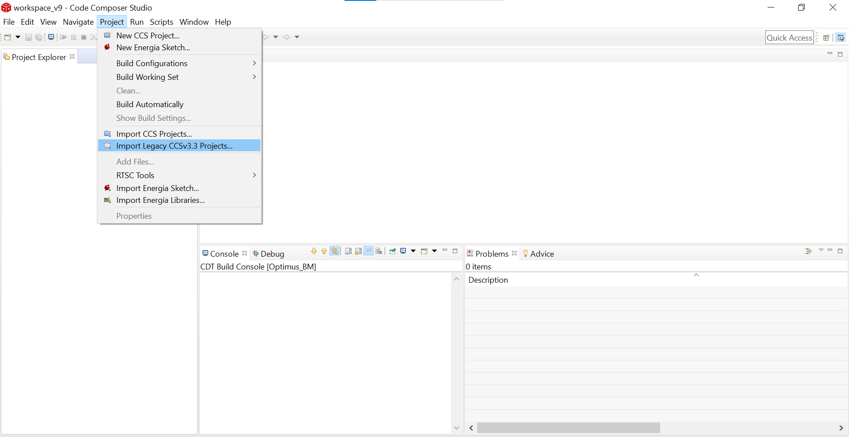

Selected (.pjt) of CCSv3.3 firmware:

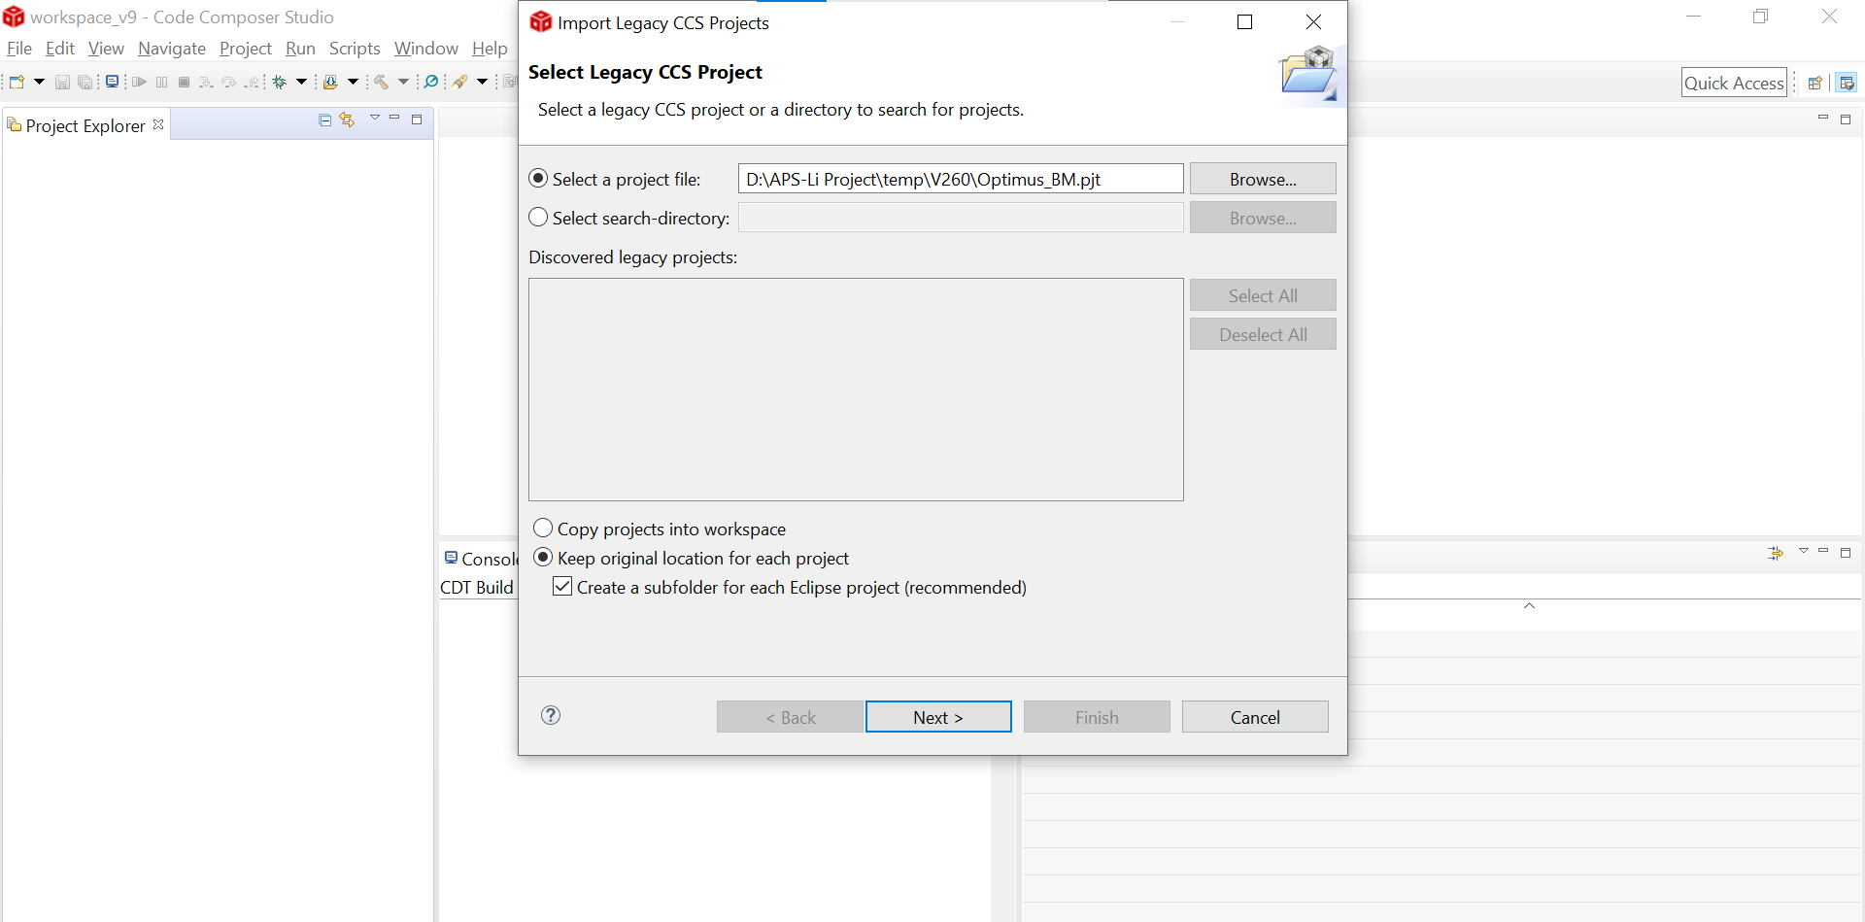

Default Device family and compiler version selected:

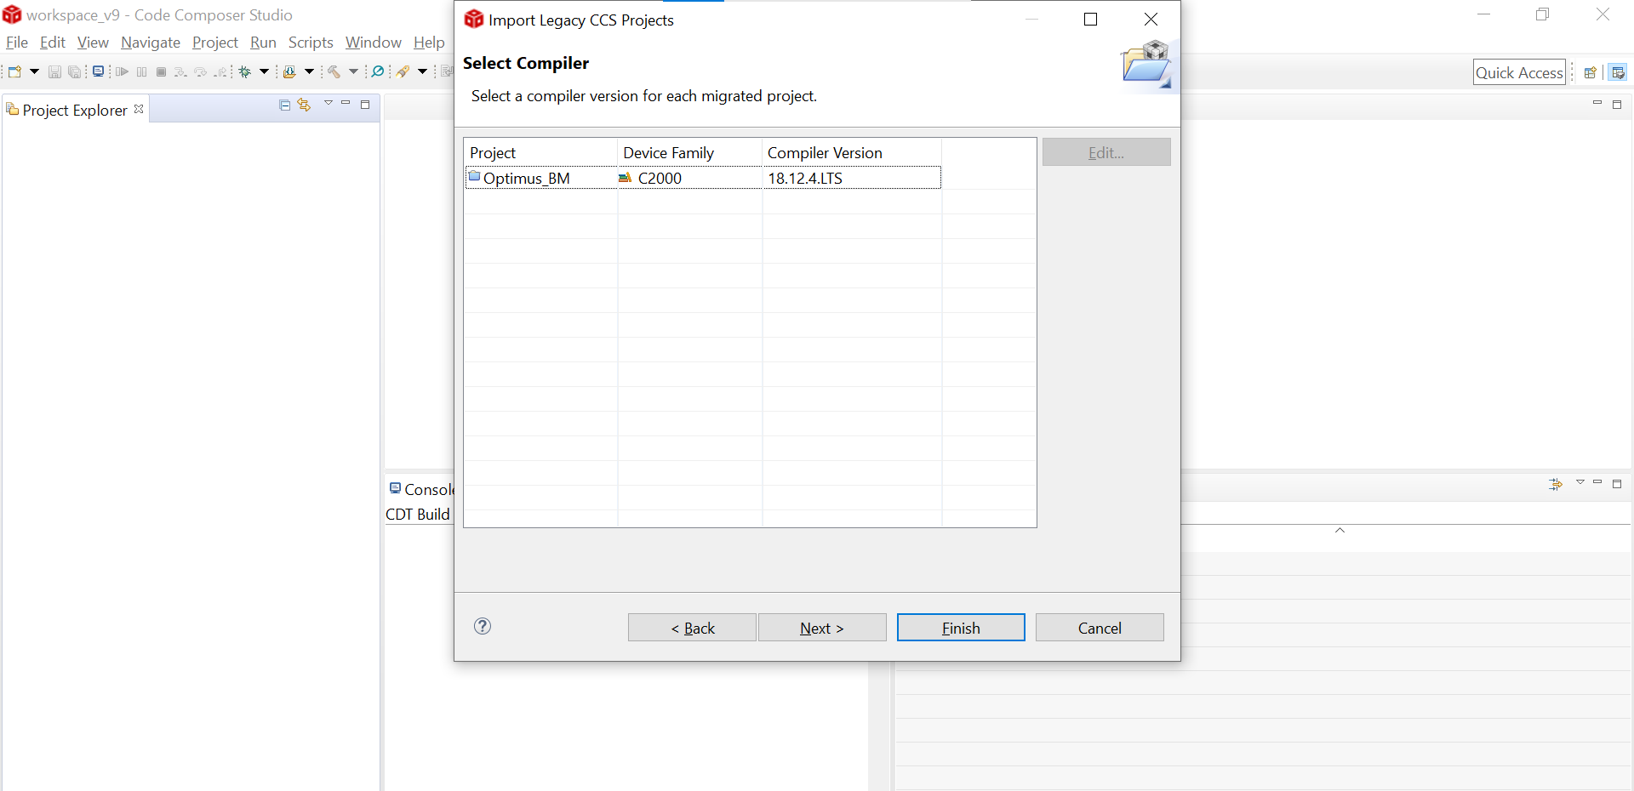

After build: Debug configuration

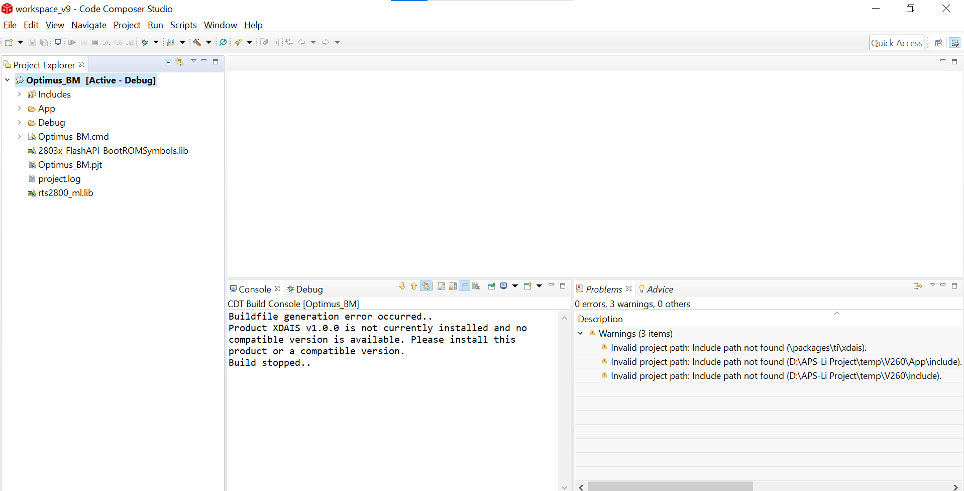

After build: Release configuration

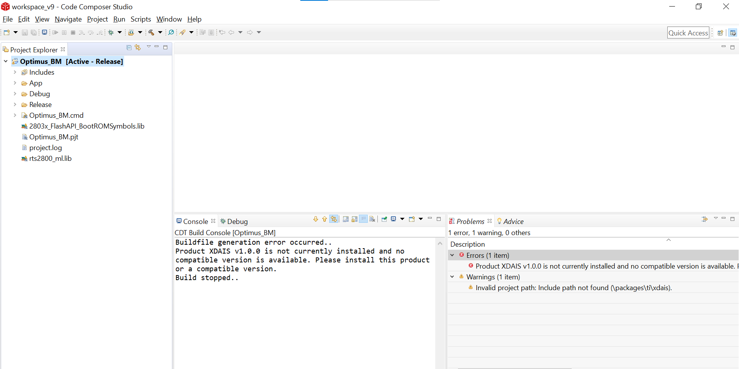

Remove option not available so we used to Deselect all:

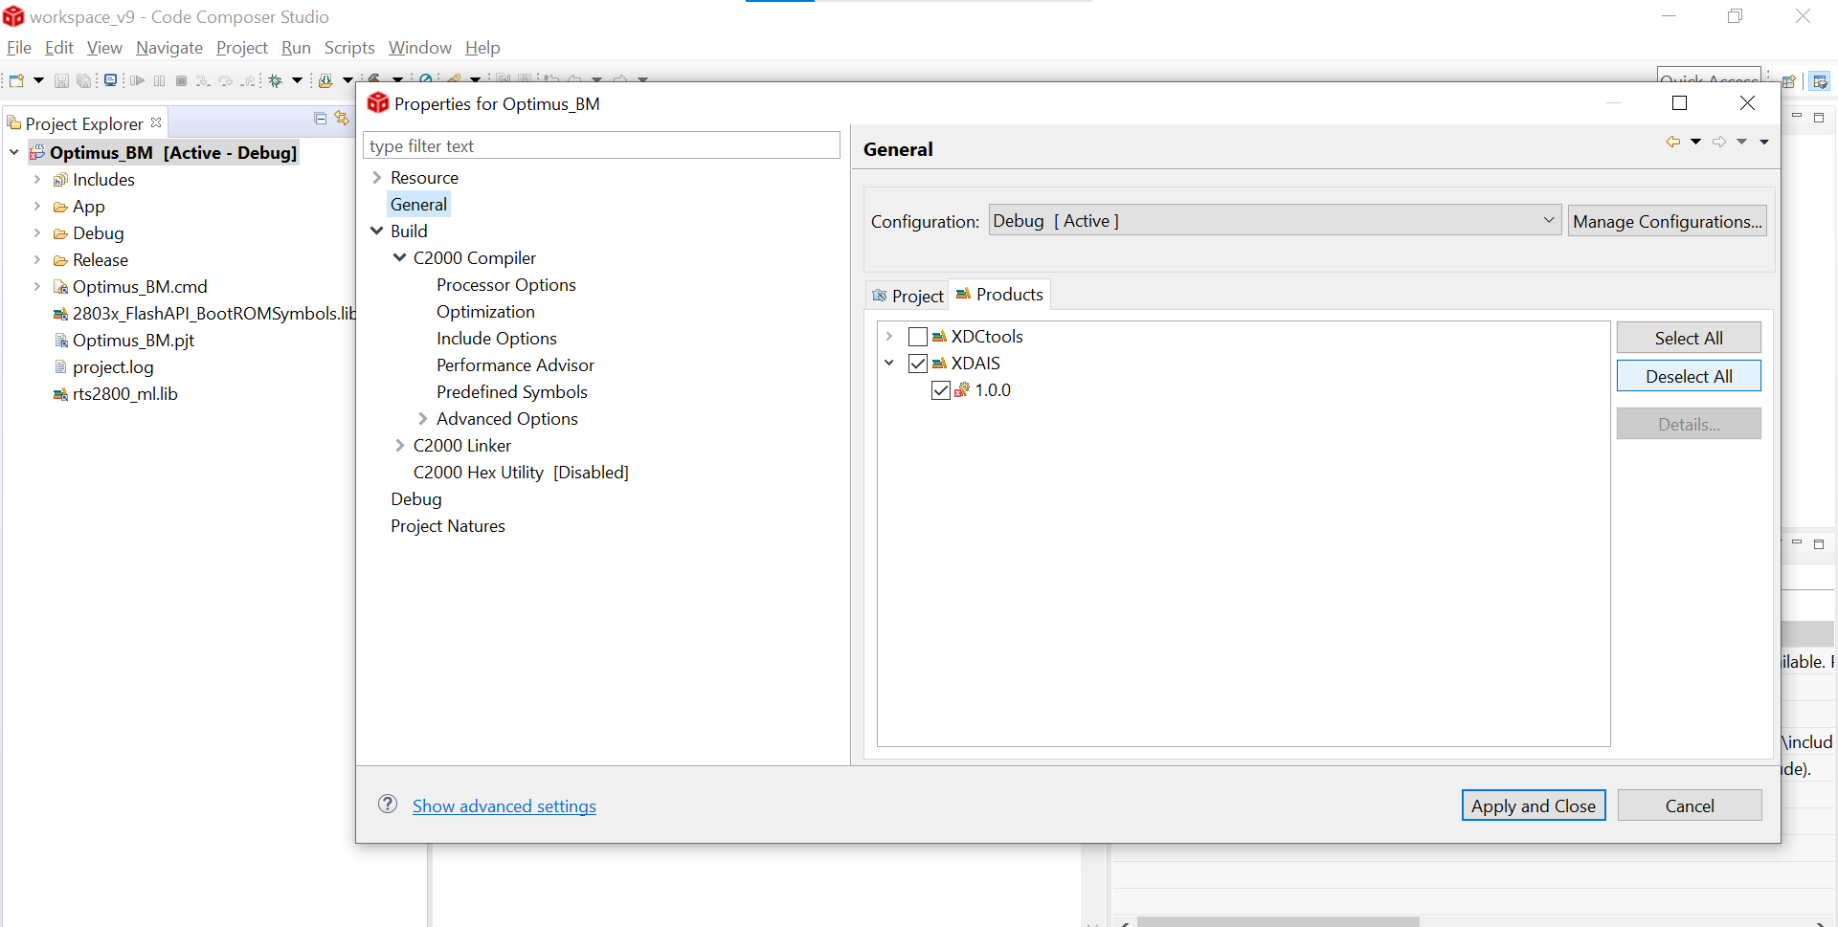

After Deselect All:

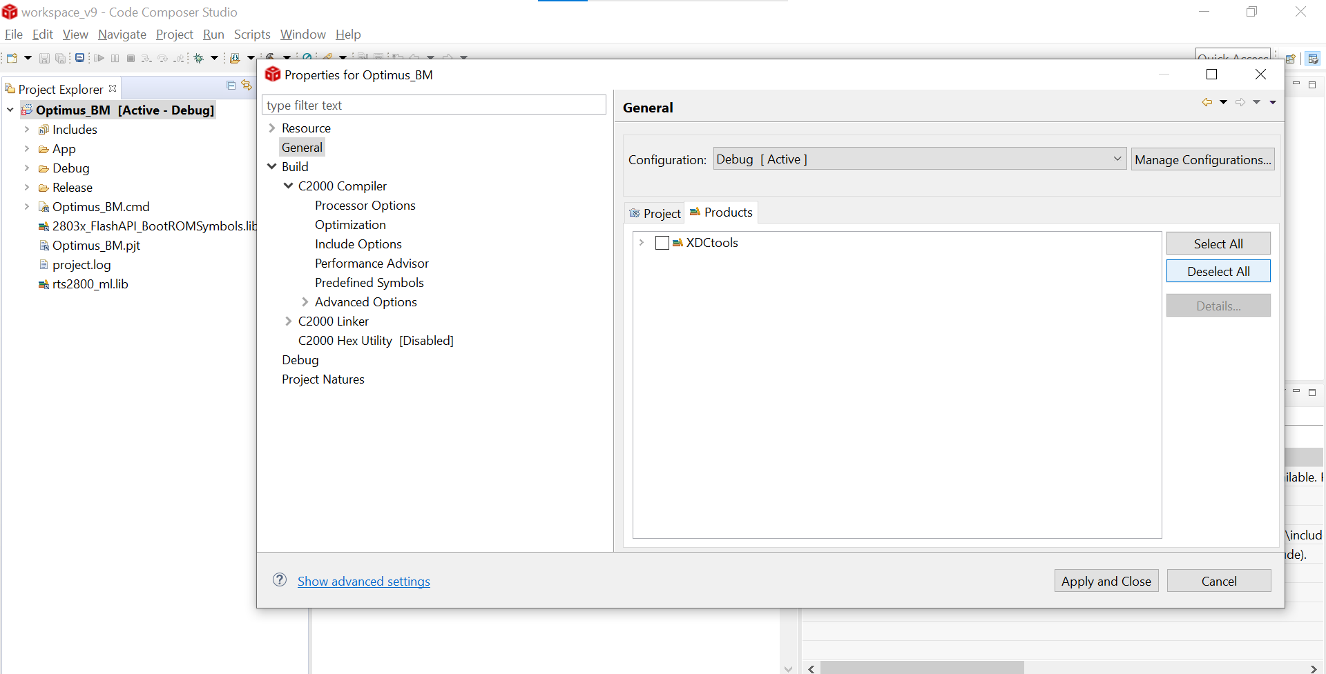

Map file permission denied Error:

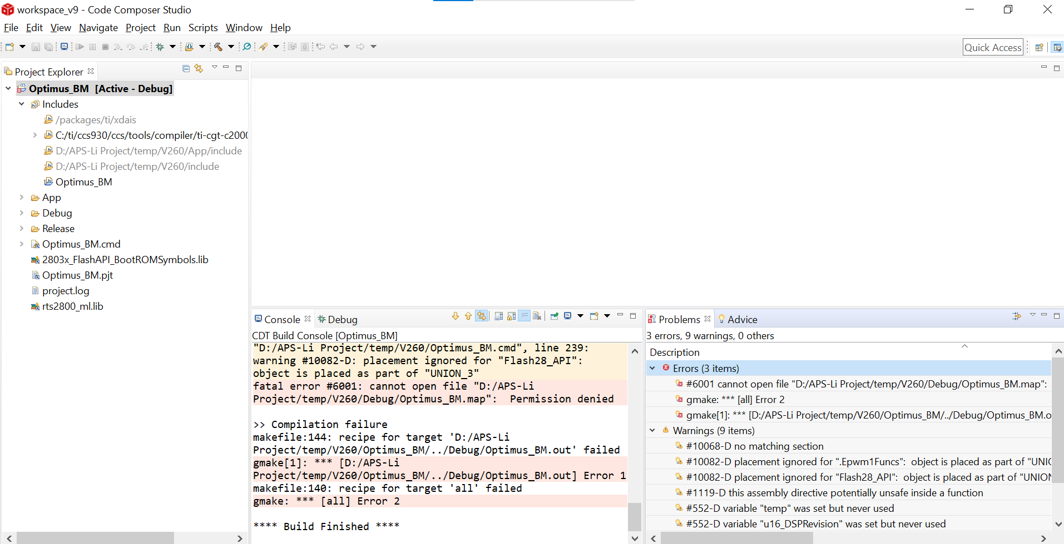

By default, firmware is Read only for map file:

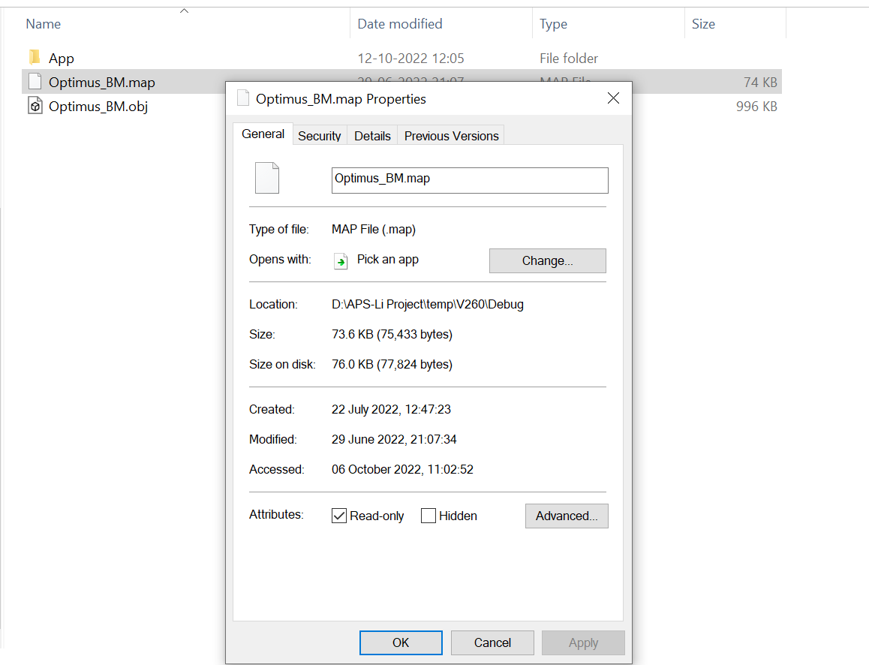

Read only removed for map file: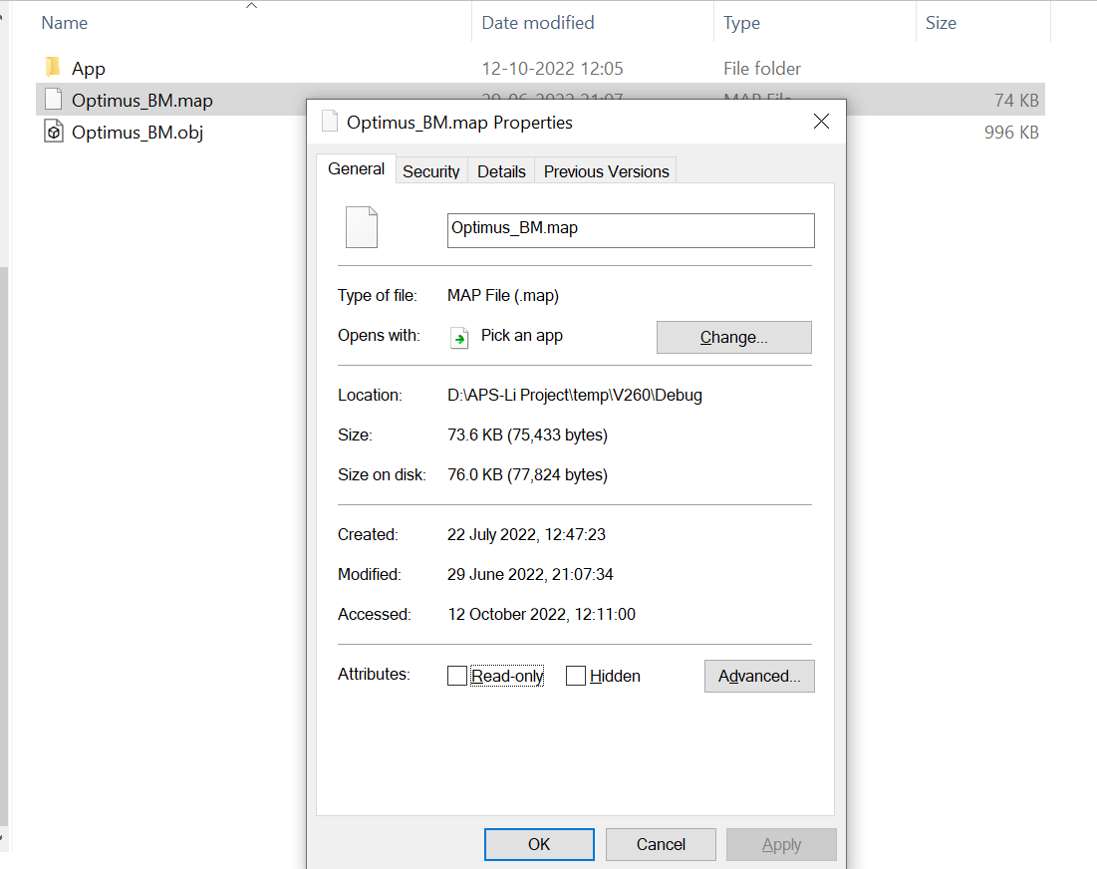

After Rebuild in Debug Configuration : Error gone for map file permission denied

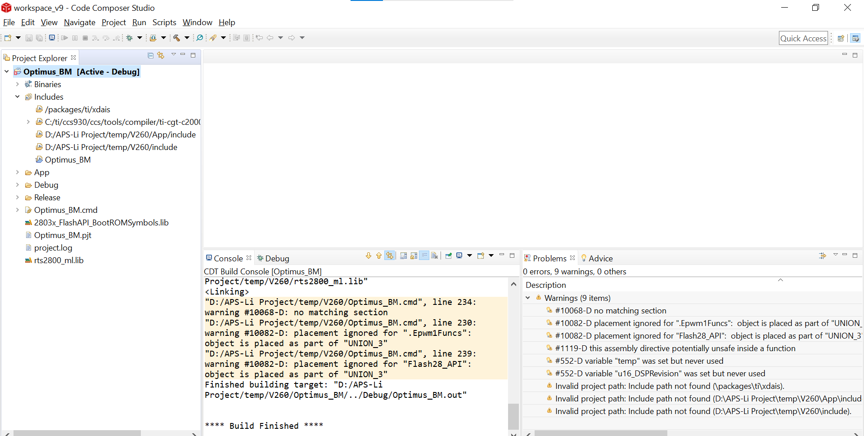

These errors do not occur: We skipped this step

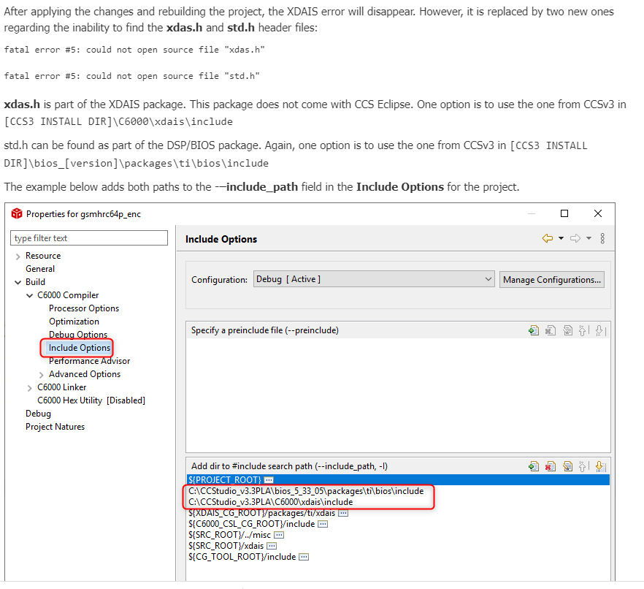

This warning does not encounter: We skipped this step

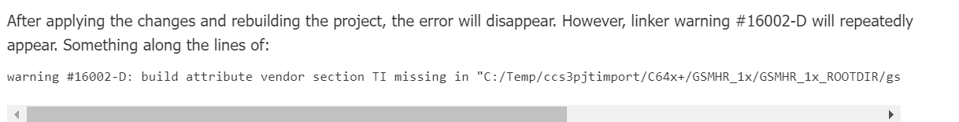

After deselecting XDAIS package and Release Configuration Rebuild :

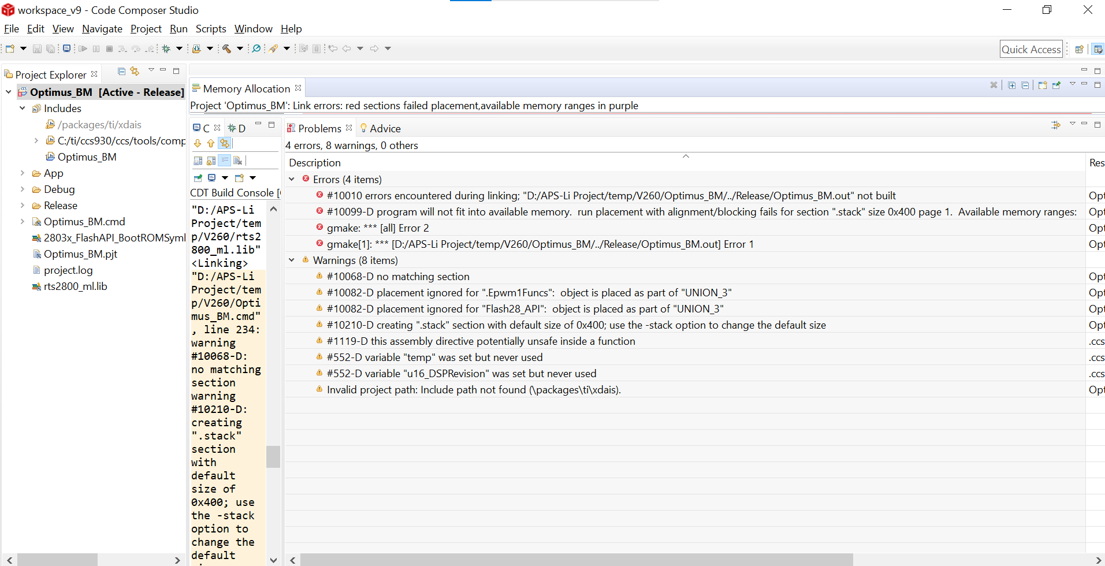

Above error was not in Debug Configuration build.

Default device variant or target was chosen for above error:

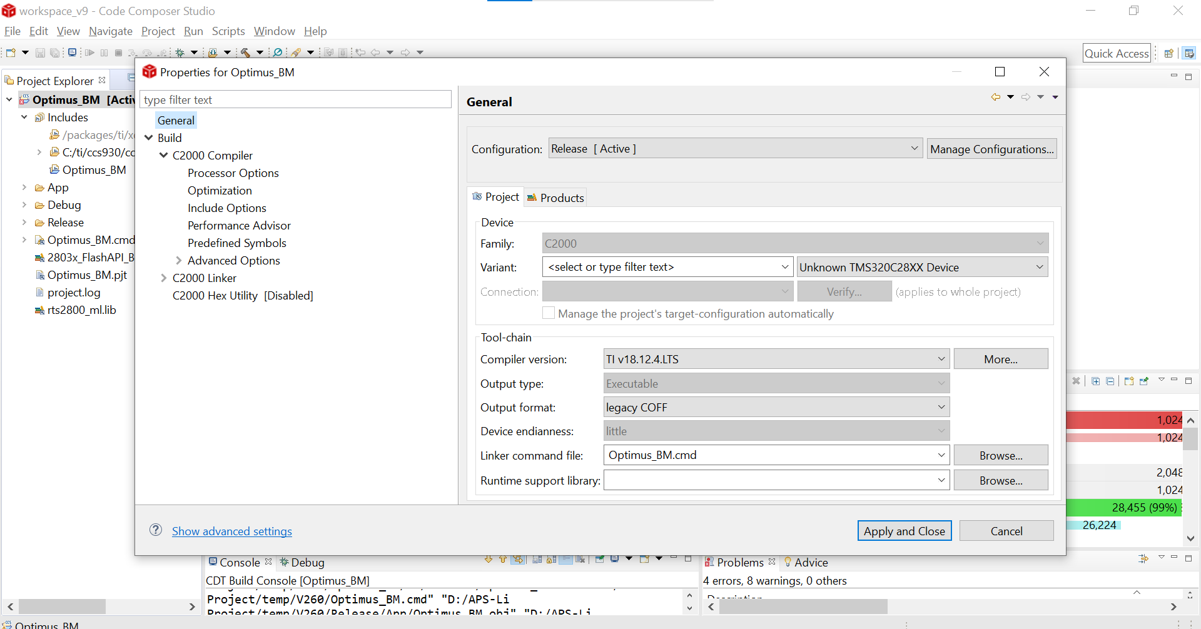

Device variant or target chosen now is TMS320F28033. Still stack size issue came.

Current Default Stack size after migration is as shown:

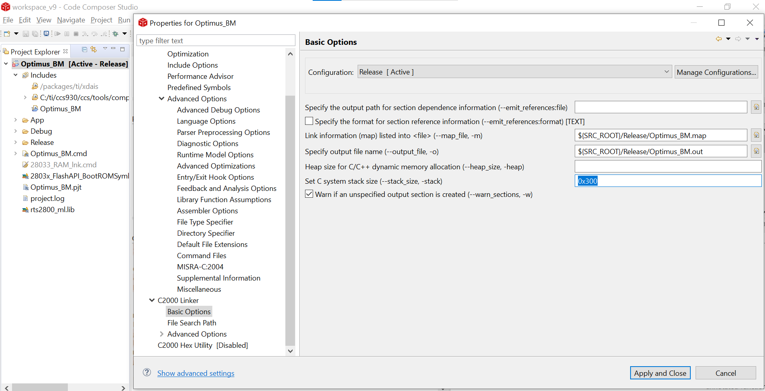

After changing stack size to 0x200 errors got resolved but warnings are there:

