Hi guys,
I have encountered some issues when using uart with lld and dma mode.
1: condition
ccs version is 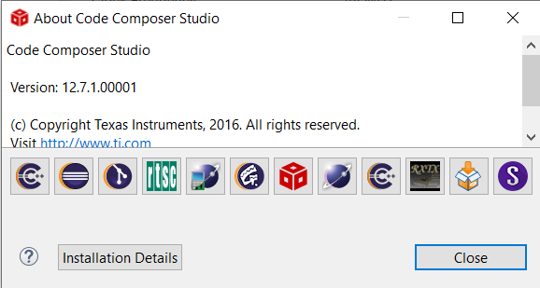
sysconfig and SDK version is 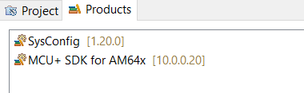
2. phenomenon：
when I add three Uart peripherals, and just the first use DMA mode shown as follows:
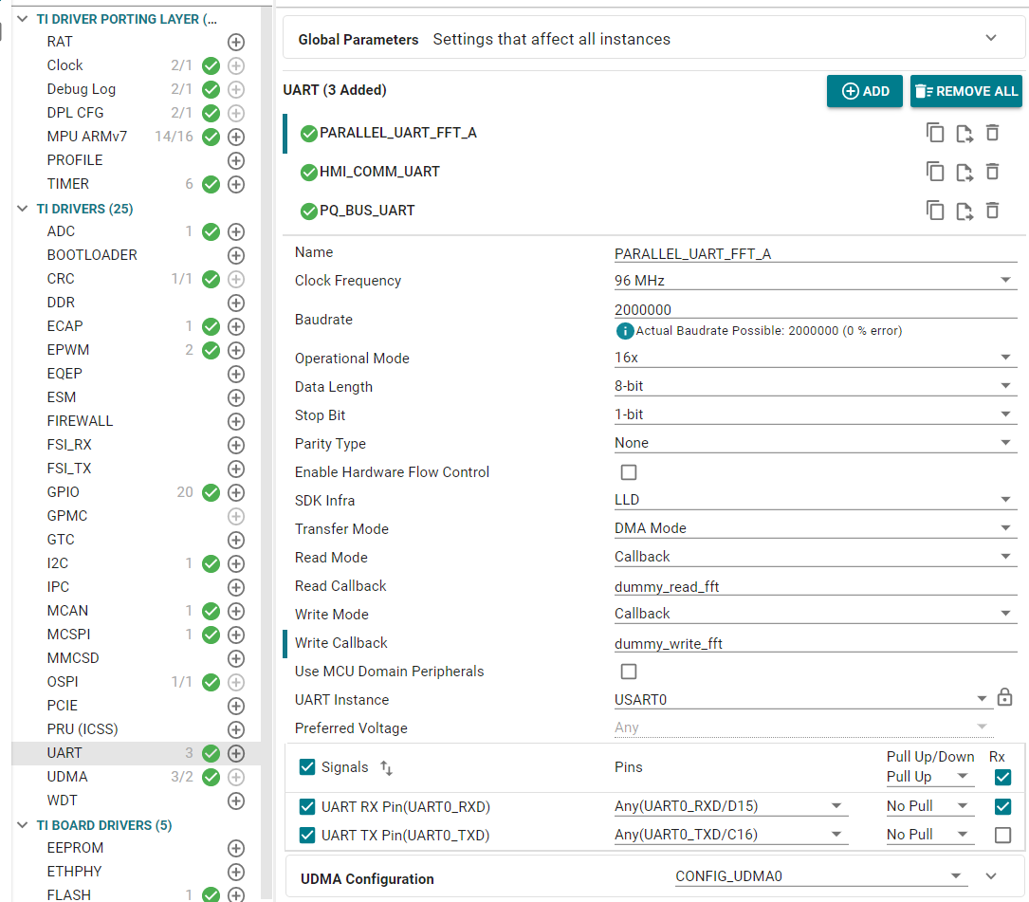
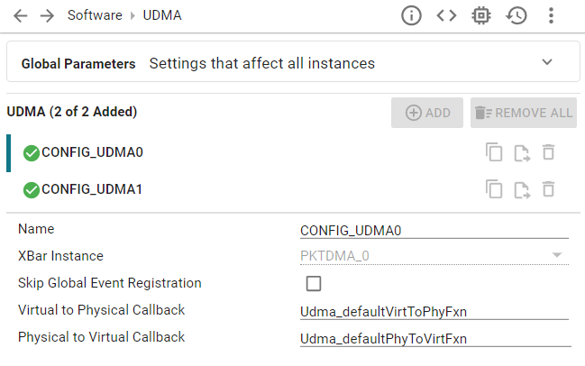
build the project, and there is an error shown as follows:
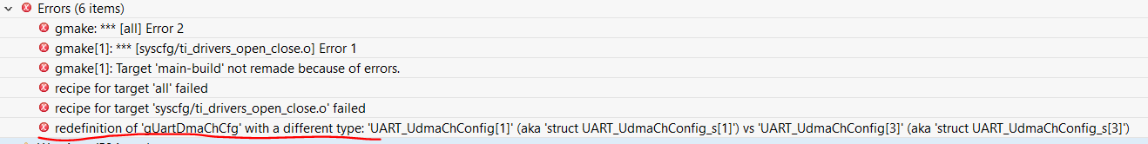
and I find that the "gUartDmaChCfg" in ti_drivers_open_close.h and ti_drivers_open_close.c are different shown as follow:
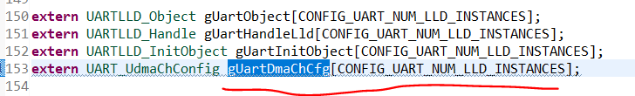
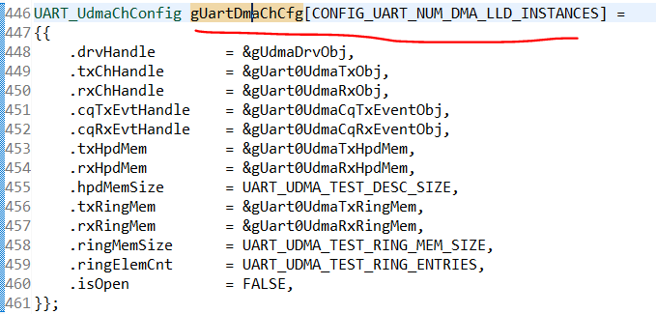
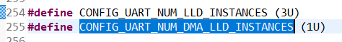
3. you can test based on the following examples: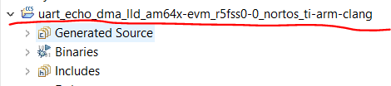

in conclusion, can you help me find the reason and tell my the solution?
thank you!

