Am3352 USB1 port connect to 4G Modem（USB Host Mode, use USB cable）problem（Anti-interference）

Hi, all:

In our application, we use Am3352 USB1 port connect to 4G modem through USB cable. Because the product is used in the base station, the electromagnetic interference on site is relatively strong, we found that the driver（option.ko）of 4G modem can’t load normally, sometimes attached, sometimes disconnected, continued, as follows:

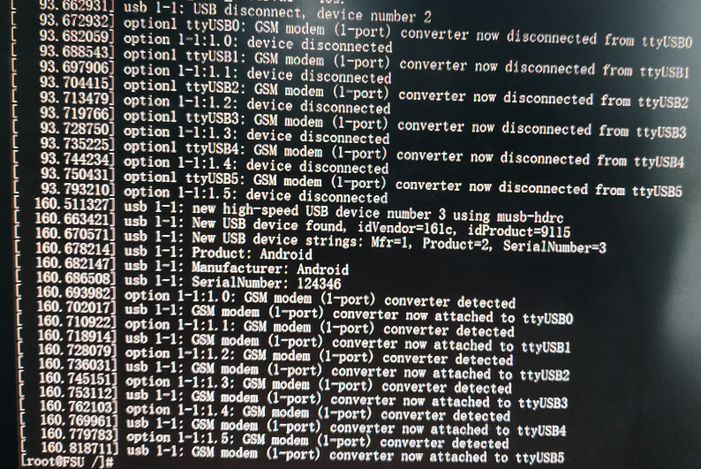

We think it may be caused by interference of USB cable, replace another USB cable for experiment, the result is more serious, the USB message of the kernel prompts an error, as follows:

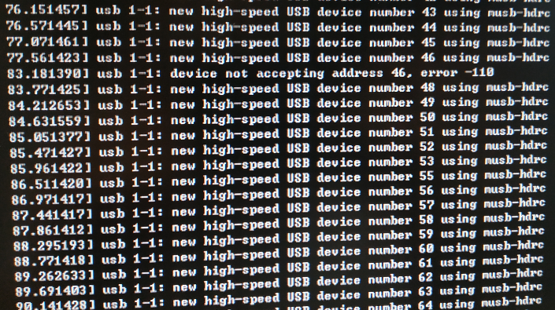

Since the 4G modem is a high speed device, the driver recognizes the high speed device when loading, which is more vulnerable to interference, so we consider forcing the USB1 port of am3352 into full speed mode, modified /drivers/usb/musb/musb-core.c, as follows:

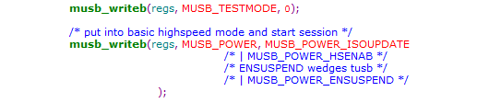

In the field test, it has obvious effect and the drive（options.ko） can be loaded normally, and the product works normall.

However, after running for a period of time, the 4G modem's network is disconnected, check the cause, and find the USB printing information prompt error of the kernel, as follows:

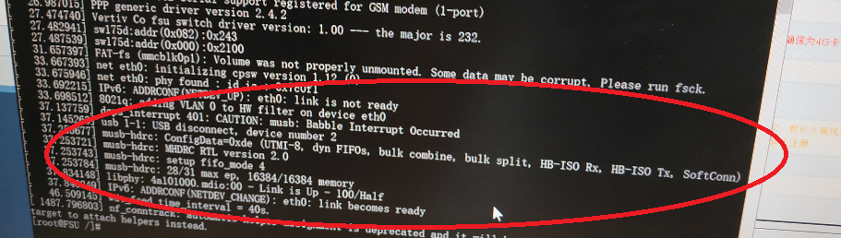

Prompt "Babble Interrupt Occurred usb1-1: USB disconnect, device number 2" error messages, and it can not be restored to normal, only restart the product.

We don't know the cause of the problem, the site can't be recovered, and the customer complains.

We now have two questions:

1. We use SDK7, how to modify the software of kernel to force the USB1 port of Am3352 to work in Full-Speed mode? Is the current modification method correct?

2. Why does “Babble Interrupt Occurred” error occur? How to modify the software of kernel to solve this problem?