I'm using the TMS570LS0432 and EM1402 for the battery active balancing. I've connected 16 Cells to the cell channels on the evaluation board.

The launchpad and the 1402EVM are connected via UART, I have some problems about the communication.

1. When I connect EM1402 directly to PC, the GUI is able to open, and the TX and RX on the EM1402 board have signals.

Then I connected EM1402 to TMS570 board, and run the example code on code composer studio, the program is able to run, but the program does not receive any signal from the board.

1. I downloaded the demo code tms570bms-1.0 from the web . During the running time, the code would be stuck in the while as shown in the following picture.

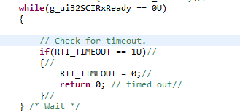

I noticed that the RXRDY and TXRDY are set in the notification.c shown below.

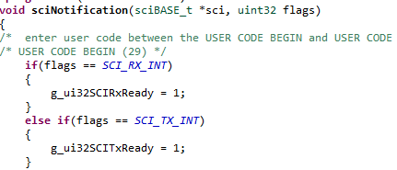

However, the RXRDY would never be set and maintain 0.

With regard to the function ‘sciNotification’, I confused that when and how would the function be executed.

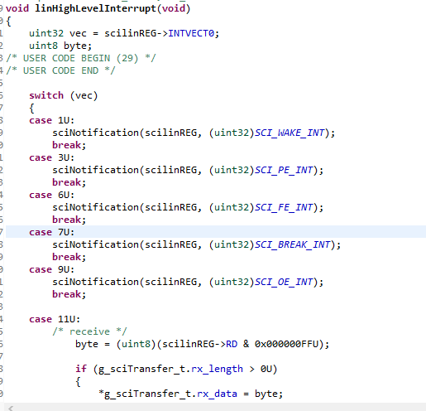

I don’t find any other information in the code about the INTVECT0 , so I was confused that what’s the condition that the INTVECT0 would be set at value 11, so the RXRDY can be set 1.

3. By masking the while, the RX pin would response the signal.

This is the part where I communicate with the PL455 chip:

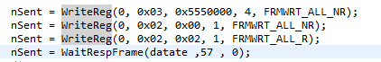

And I got the results shown below:

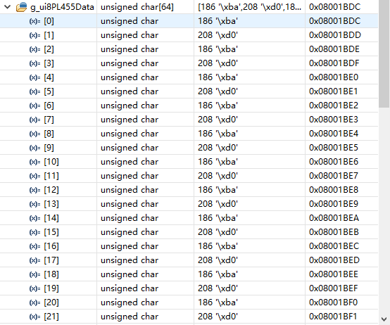I thought this results were not right, because the the file bq76PL455A-Q1 Software Design Reference (slva617a.pdf) have illustrated the meaning of the first byte is the length of data.

