Hello,

After the study of NHET module, Is hetpin can able to generate (25-27)MHz ?.
HR prescalar output i.e HR clock is going to IO Control module which I have shown below,

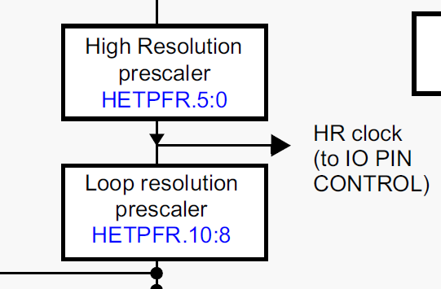

Below is the IO PIN Control module, HR clock is given to HR block.

