Halcogen setup:
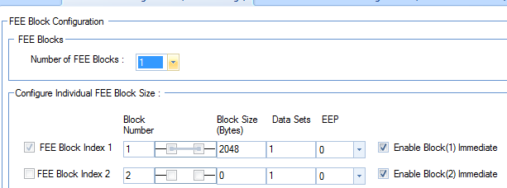
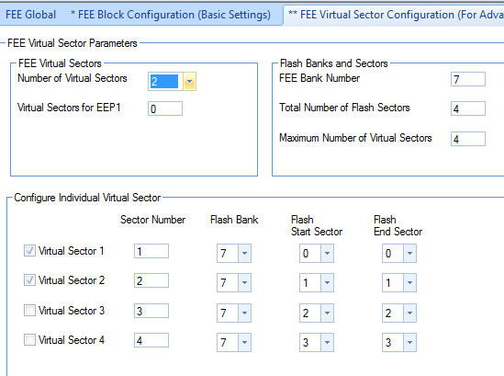

Initialization seems to execute fine:
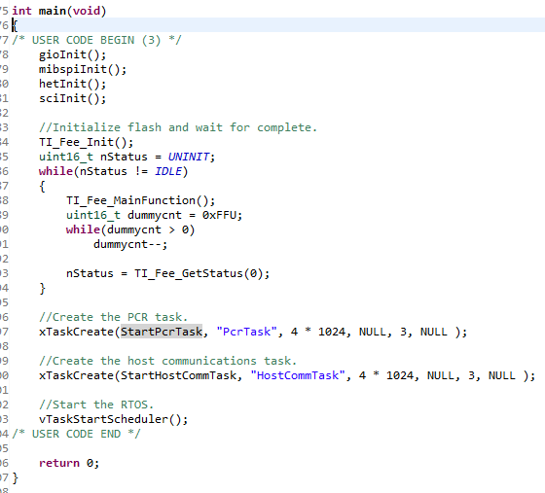

In the GetInstance method, my call to ReadFromFlash returns false. Because of this return value, I call WriteToFlash.:
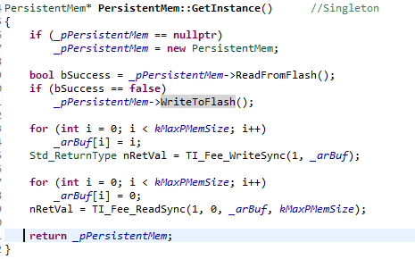
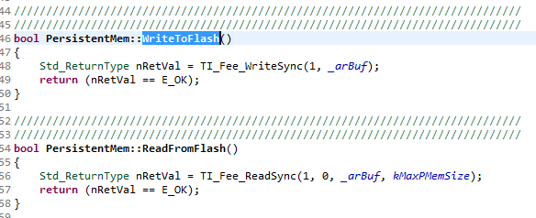

Eventually, the call to WriteToFlash results in a call to Fapi_doBlankCheck. The program hangs in the Fapi_doBlankCheck routine.
