**DSSM Mass Erase and Factory Reset**

1. Open Target Configurations  
   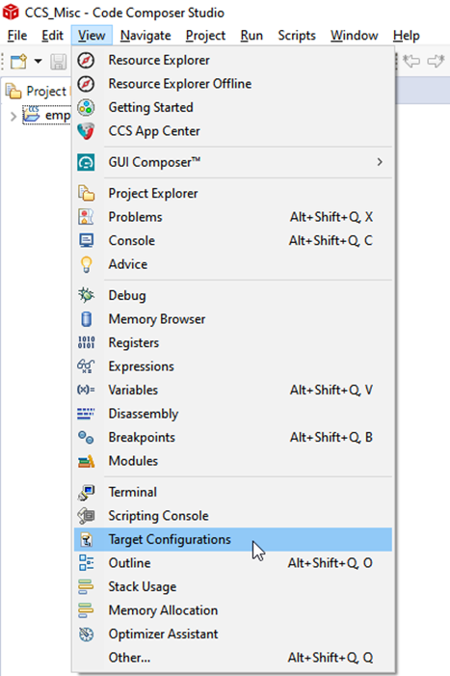
2. In the *Target Configurations* window, find your current MSPM0 project and expand the folders to find the .ccxml file:  
   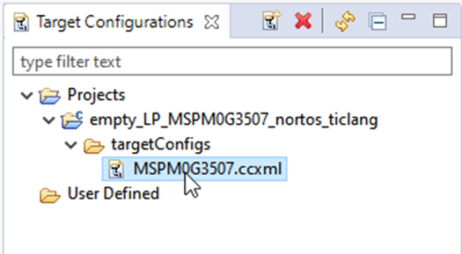
3. Right-click the .ccxml file and click on *Launch Selected Configuration*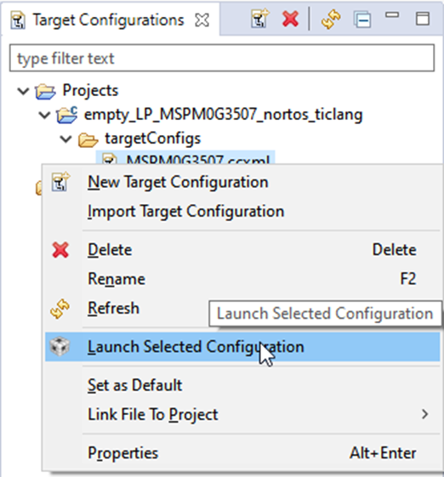
4. Click on Scripts→ MSPM0G3507 Commands → MSPM0_Mailbox_FactoryReset_Auto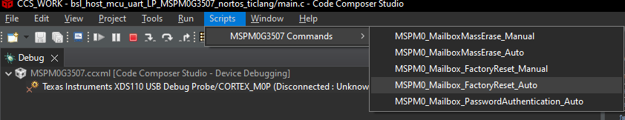
5. the Console will show the following:  
   