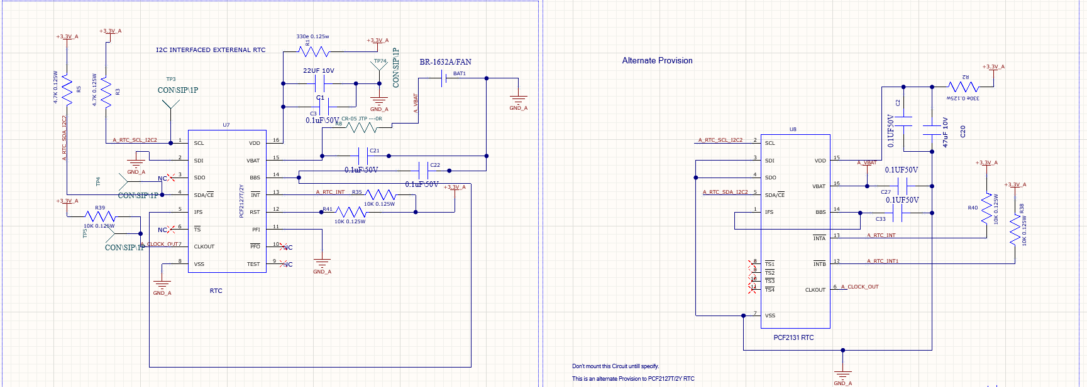

PCF2131 is mounted on the card PCF 2127T is the alternative for PCF2131 RTC.
We are unable to capture the failed transactions because the failure is very random, we are facing I2C bus hang after 2hrs sometimes sometimes after 1hr because of this hang sometimes entire controller is getting hanged.
We used I2C for communicating with another am2634 controller through ISO1640BQDRQ1 IC for isolated communication between two controllers in that also the bus is getting hanged.
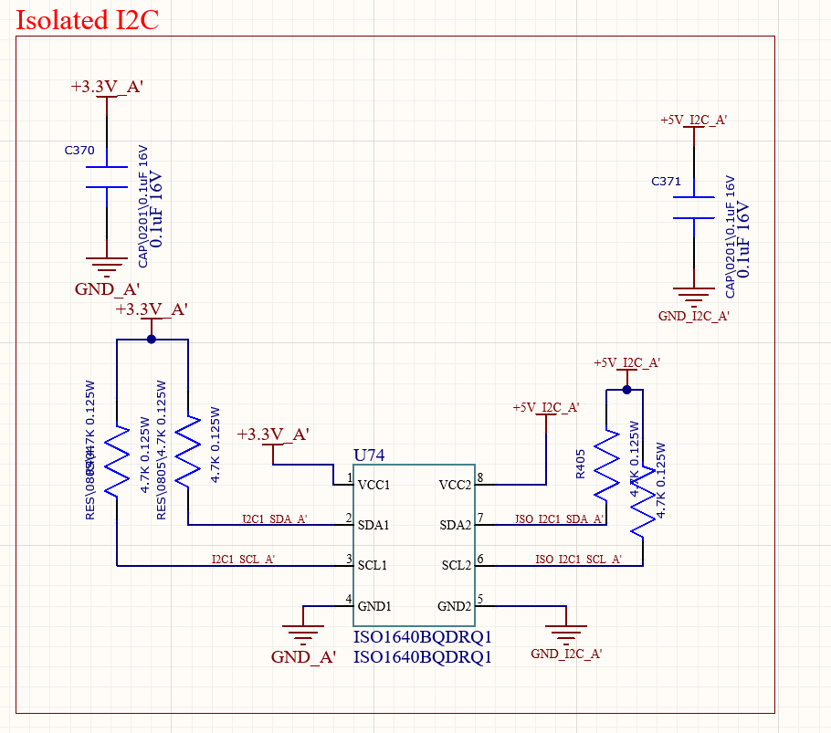

Below are the wave forms with 4.7k pullup on SDA and SCL
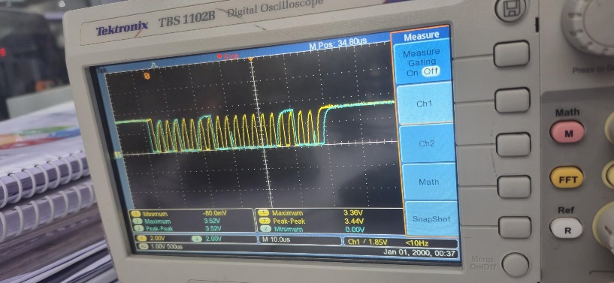
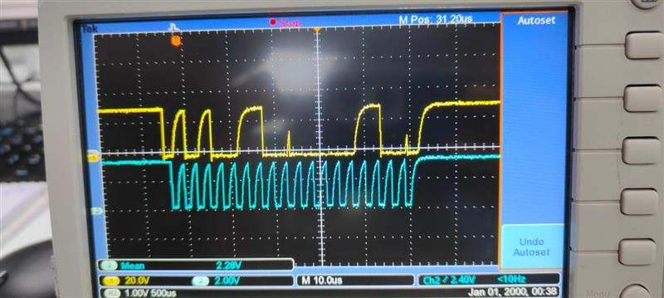
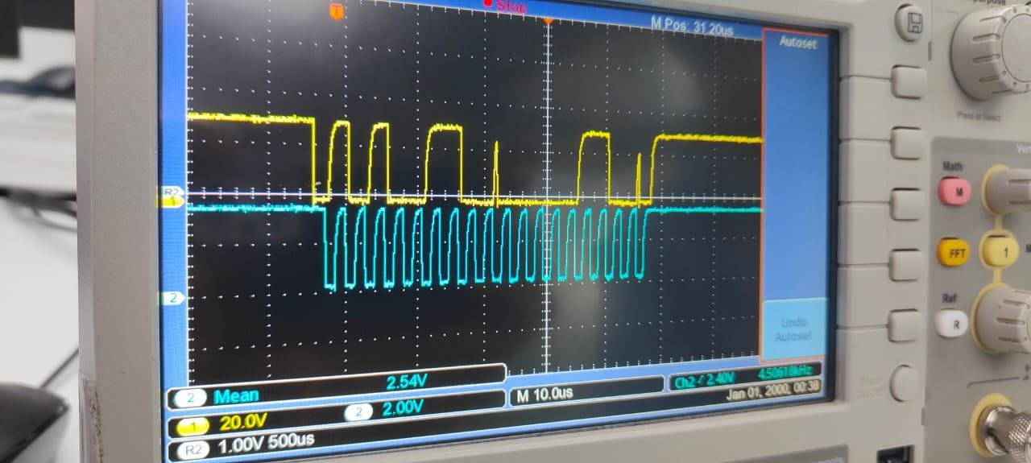
Below are the wave forms with 1.5K pullup on SDA and SCL
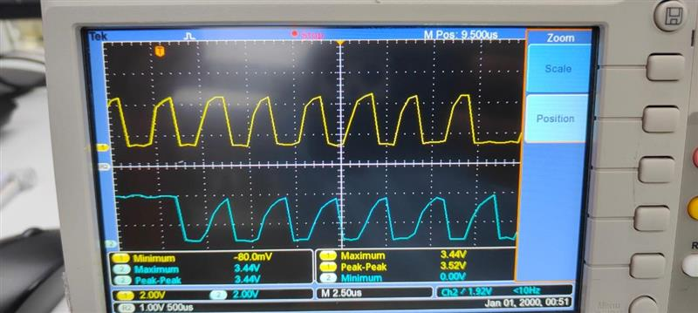

Routing of I2C for two different controllers