Question Description:

In TMS570LC4357 project configuration: while choose the TMS570LC43xx, the Runtime support library shown “automatic”, shown as figure 1. While browse to the library which can be chosen, shown as figure 2.

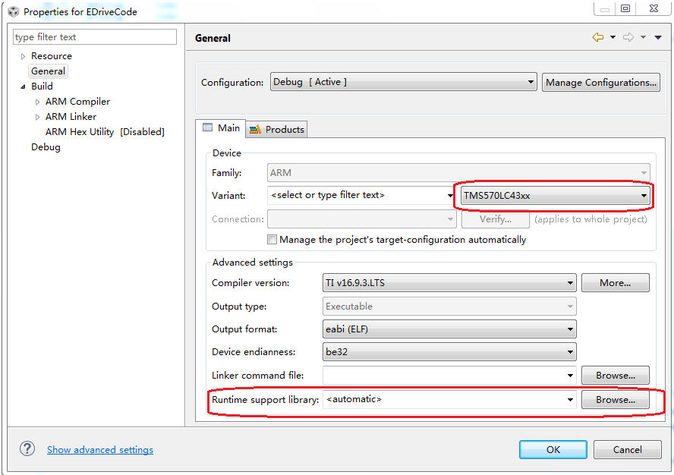

Figure 1: Project configuration

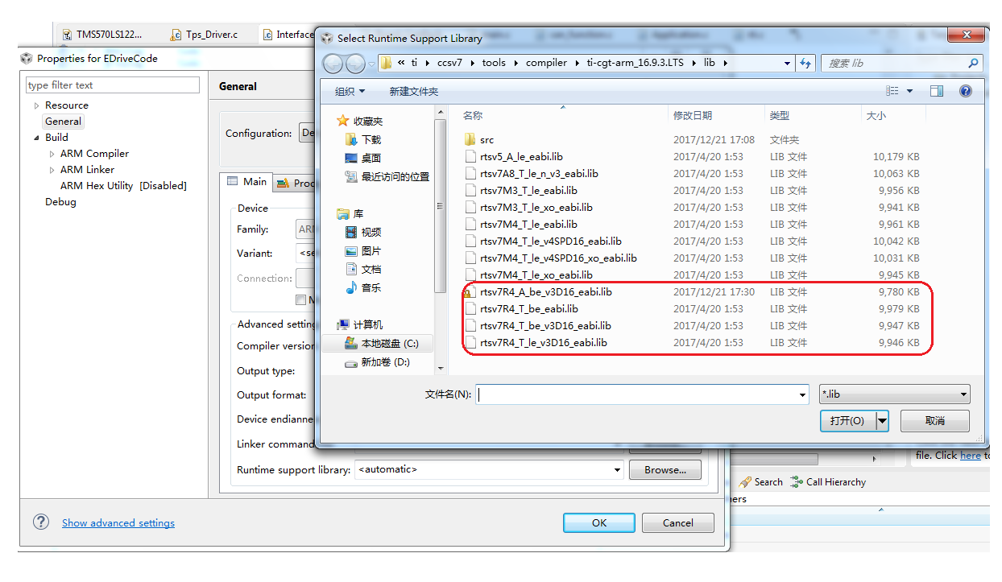

Figure 2: Runtime support library

As there is no R5 core to select which TMS570LC4357 is Cortex-R5 core, customer select “rtsv7R4_T_be_v3D16_eabi.lib”, and customer has concern for the selected library ：

1) Which version of LTS could support R5F core for TMS570LC4357?

  2) Would "rtsv7R4_T_be_v3D16_eabi.lib" affect the code execution of TMS570LC4357 while merge from TMS570LS1227?