**ADC group 1 ch 3**: 0.652 v should be reading (0.652 * 4095) / 3.3 vref ~ 809.

Instead, we are reading 702

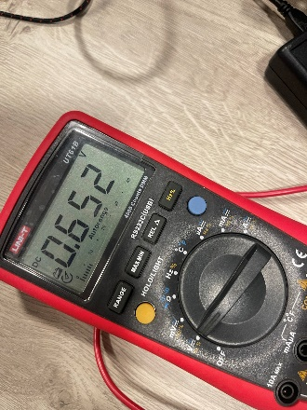

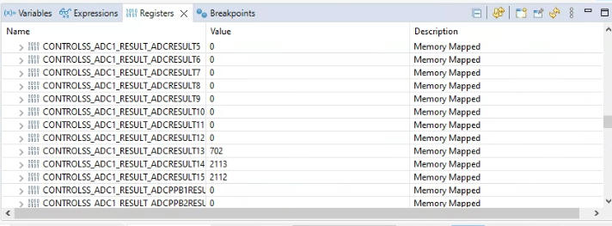

**ADC group 1 ch 3**: 0.938 v should be reading (0.938 * 4095) / 3.3 vref ~ 1164.

Instead, we are reading 1086.

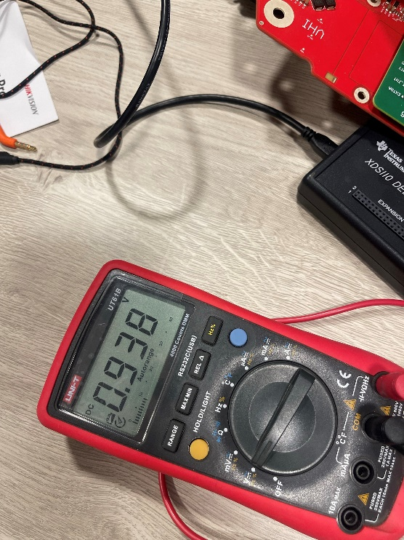

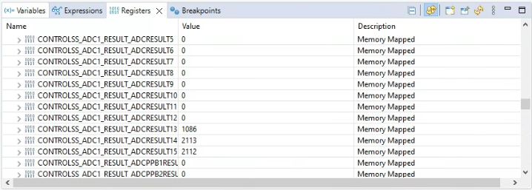

**ADC group 1 ch 3**: 1.226 v should be reading (1.226 * 4095) / 3.3 vref ~ 1521.3.

Instead, we are reading 1470.

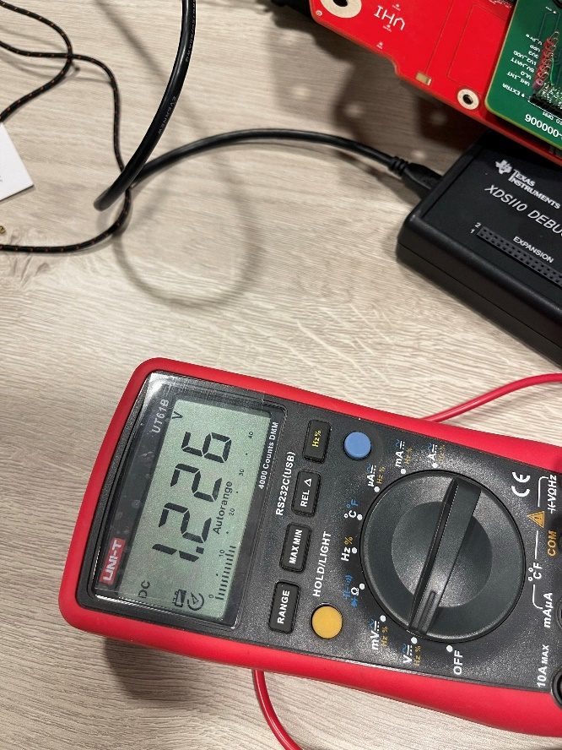

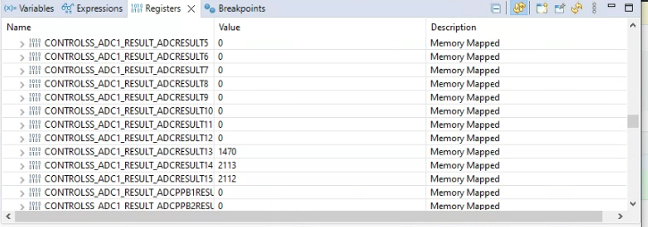

**ADC group 1 ch 3**: 1.523 v should be reading (1.523 * 4095) / 3.3 vref ~ 1888.5.

Instead, we are reading 1726.

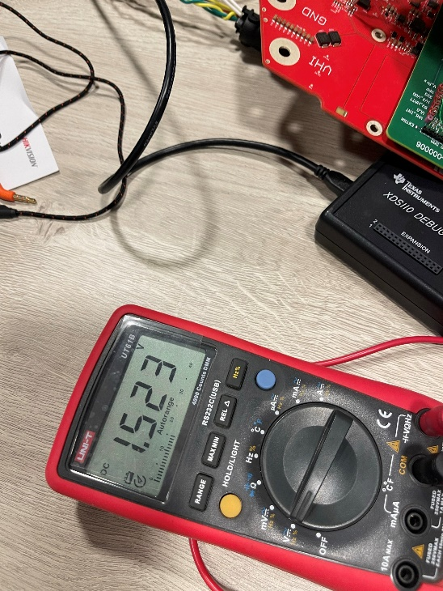

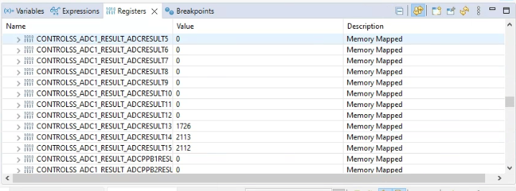

**ADC group 1 ch 3**: 1.809 v should be reading (1.809 * 4095) / 3.3 vref ~ 2244.8.

Instead, we are reading 2272.

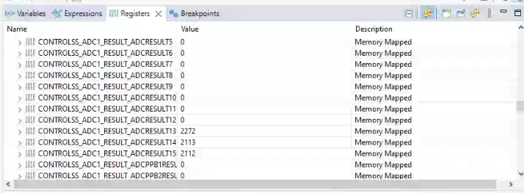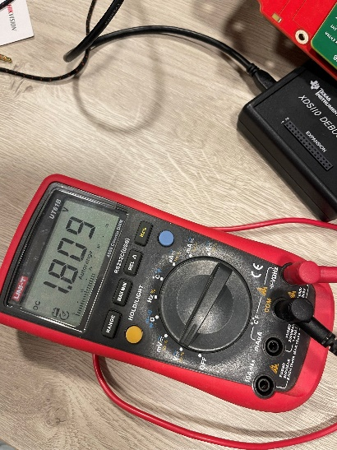

Adc configuration

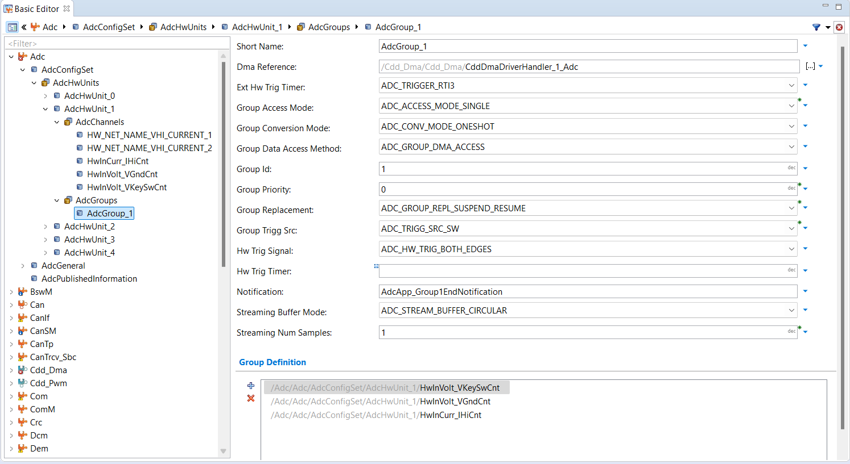Group1 config

