Cannot get the RTSC outline window even when I pull in the empty-min from Resource Explorer.
Updated CCS in the last week of May 2017.
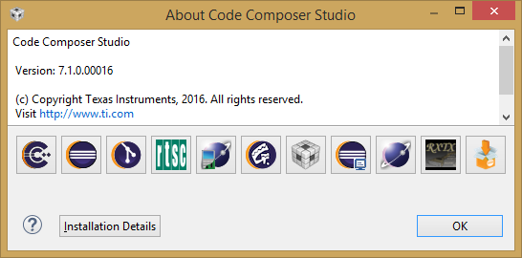
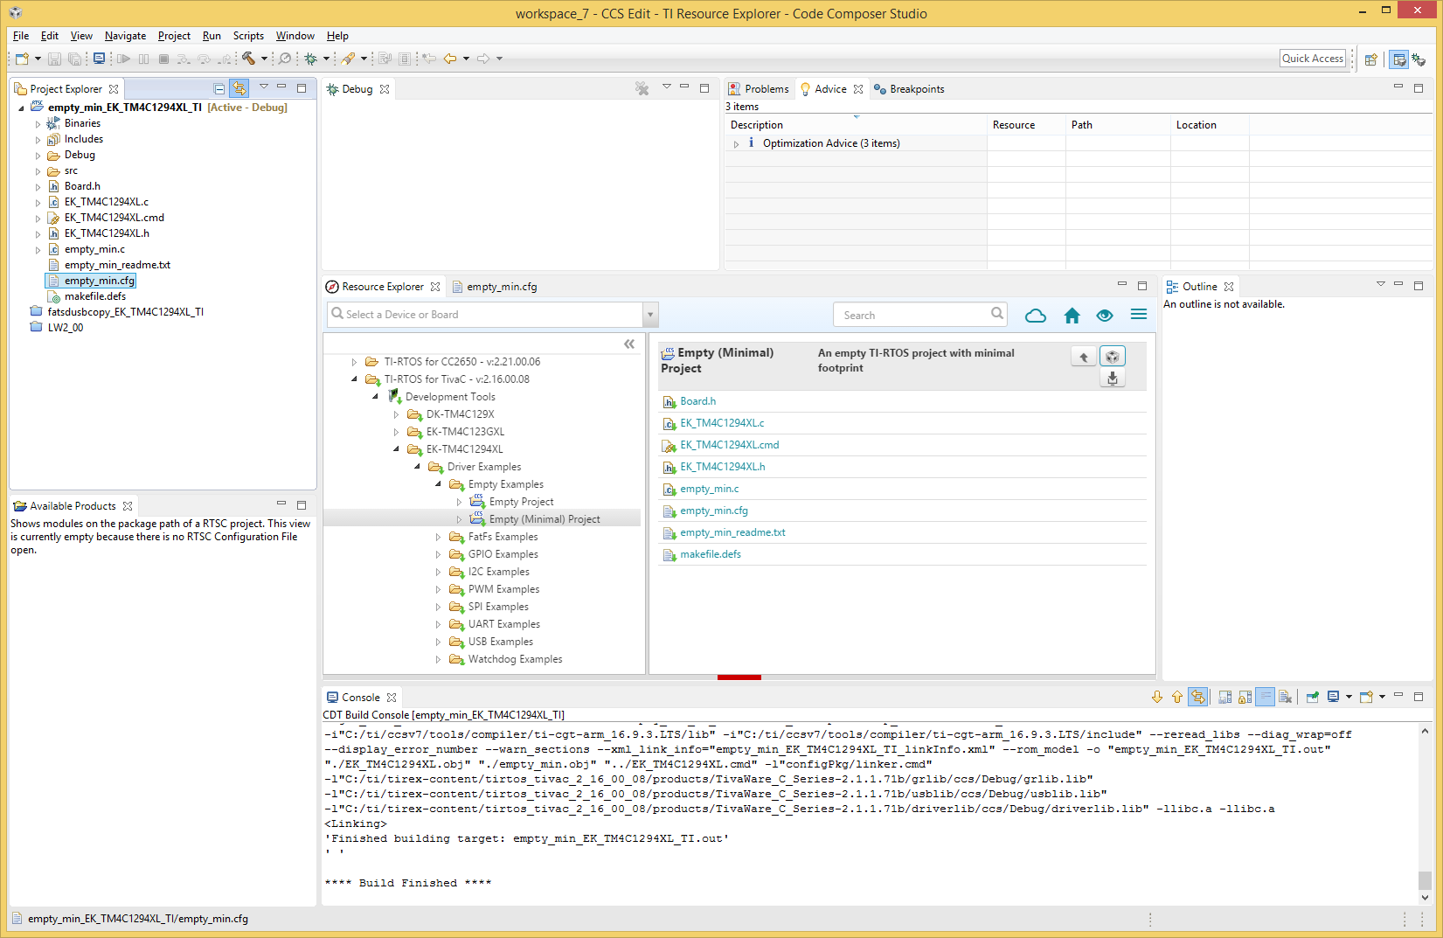
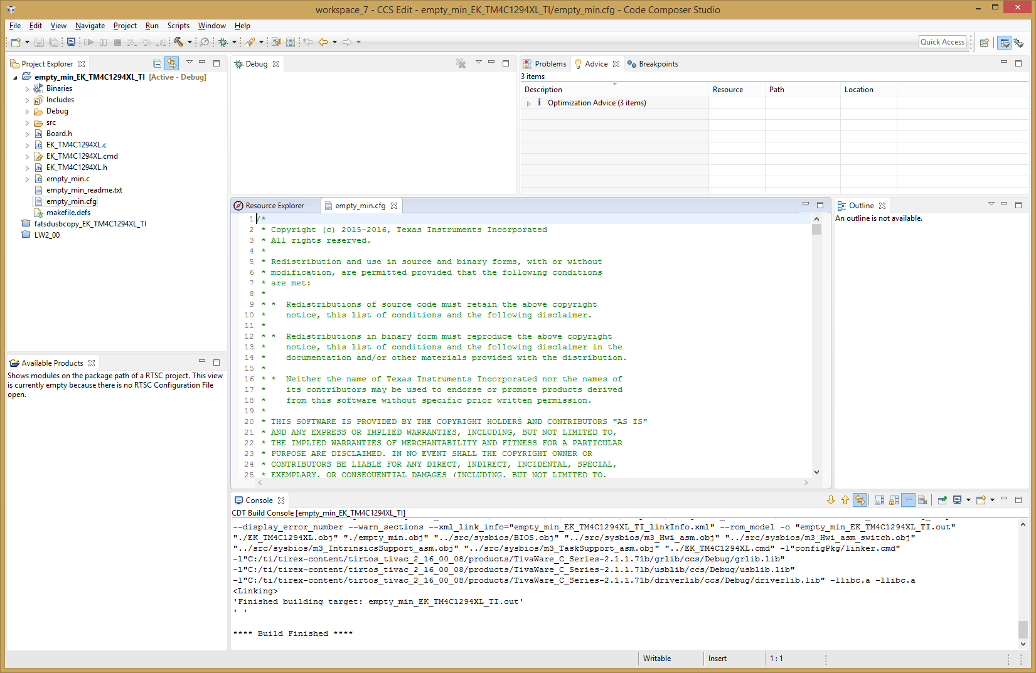
Tried all 3 of the RTSC XDCtools versions.
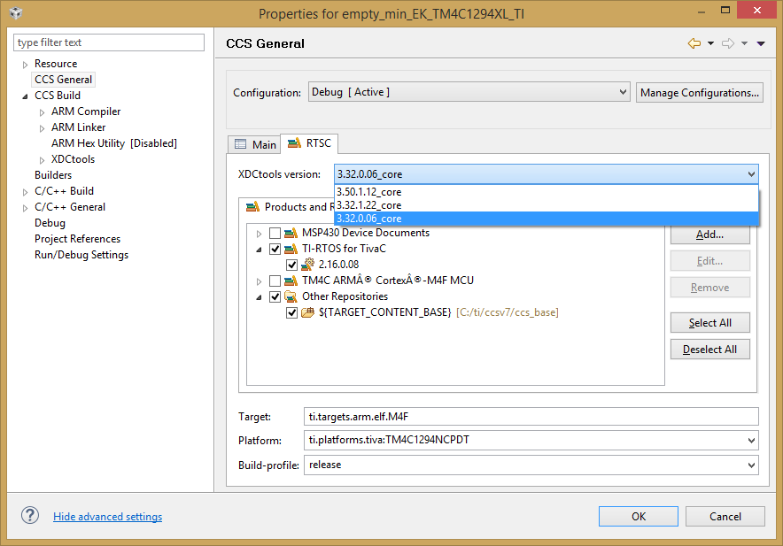
end

