DSSM Mass Erase and Factory Reset
- Open Target Configurations
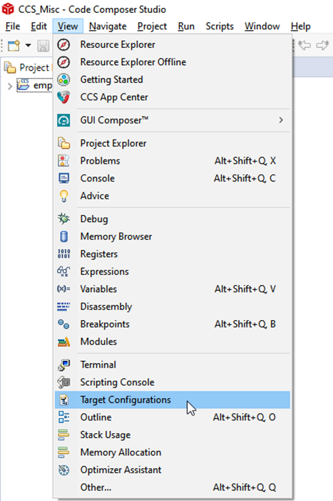
- In the Target Configurations window, find your current MSPM0 project and expand the folders to find the .ccxml file:
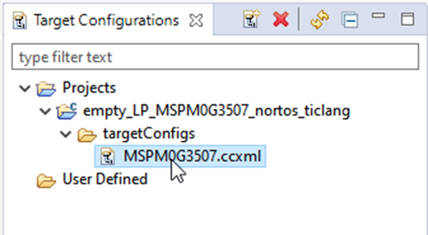
- Right-click the .ccxml file and click on Launch Selected Configuration
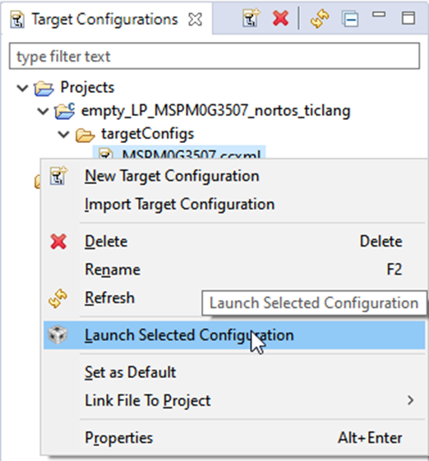
- Click on Scripts→ MSPM0G3507 Commands → MSPM0_Mailbox_FactoryReset_Auto
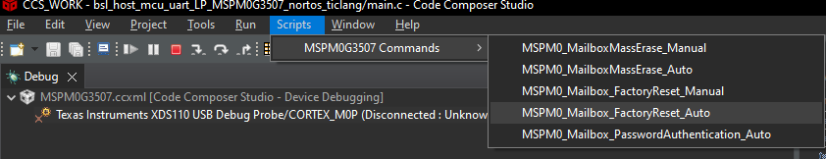
- the Console will show the following:
