Hibernation Details
HW Schematic for hibernation is as given below:

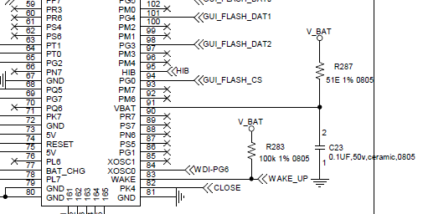

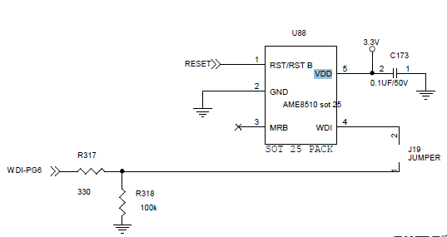

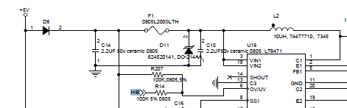
Firmware application code is as mentioned below:
apiHibernate.c -> This file has vfnInitHibernate() and HibEnterWakeExit() function definition.
vfnInitHibernate() is called once in main() and also from my application under HibEnterWakeExit().
HibEnterWakeExit() gets invoked once main power is OFF in my application.
Main.c -> Configured the clock as below:
ui32SysClock = SysCtlClockFreqSet((SYSCTL_XTAL_16MHZ | SYSCTL_OSC_MAIN | SYSCTL_USE_PLL |SYSCTL_CFG_VCO_480),40000000);
void vfnInitHibernate()
{
SysCtlPeripheralEnable(SYSCTL_PERIPH_GPIOL);
GPIOPinTypeGPIOOutput(GPIO_PORTL_BASE, PIN_LOAD_CONTROL);
GPIOPinWrite(GPIO_PORTL_BASE,PIN_LOAD_CONTROL,0);

// START: Configure PQ2 & Pk4 as input for Wake sources with respect to new hibernation board
SysCtlPeripheralEnable(SYSCTL_PERIPH_GPIOQ);
GPIOPinTypeGPIOInput(GPIO_PORTQ_BASE, GPIO_PIN_2); // PQ2 for HANDWHEEL key

SysCtlPeripheralEnable(SYSCTL_PERIPH_GPIOK);
GPIOPinTypeGPIOInput(GPIO_PORTK_BASE, GPIO_PIN_4); // PK4 for CLOSE key
// END: Configure PQ2 & Pk4 as input for Wake sources with respect to new hibernation board

//
// Need to enable the hibernation peripheral after wake/reset, before using
// it.
//
SysCtlPeripheralEnable(SYSCTL_PERIPH_HIBERNATE);
//
// Wait for the Hibernate module to be ready.
//
while(!SysCtlPeripheralReady(SYSCTL_PERIPH_HIBERNATE))
{
}

}
void HibEnterWakeExit()
{
vfnInitHibernate();

//
// Initialize these variables before they are used.
//
ui32Status = 0;
ui32HibernateCount = 0;
ui32RTCWakeCount = 0;
ui32EXTWakeCount = 0;
ui32GPIOWakeCount = 0;
ui32RESETWakeCount = 0;

//
// Check to see if Hibernation module is already active, which could mean
// that the processor is waking from a hibernation.
//
if(HibernateIsActive())
{
//
// Read the status bits to see what caused the wake. Clear the wake
// source so that the device can be put into hibernation again.
//
ui32Status = HibernateIntStatus(0);
HibernateIntClear(ui32Status);

//
// Wake was due to RTC match.
//
if(ui32Status & HIBERNATE_INT_RTC_MATCH_0)
{
ui32RTCWakeCount++;
}

//
// Wake was due to Reset button.
//
else if(ui32Status & HIBERNATE_INT_RESET_WAKE)
{
ui32RESETWakeCount++;
}

//
// Wake was due to the External Wake pin.
//
else if(ui32Status & HIBERNATE_INT_PIN_WAKE)
{
ui32EXTWakeCount++;
}

//
// Wake was due to GPIO wake.
//
else if(ui32Status & HIBERNATE_INT_GPIO_WAKE)
{
ui32GPIOWakeCount++;
}

//
// If the wake is due to any of the configured wake sources, then read
// the first location from the battery backed memory, as the
// hibernation count.
//
if(ui32Status & (HIBERNATE_INT_PIN_WAKE | HIBERNATE_INT_RTC_MATCH_0 |
HIBERNATE_INT_GPIO_WAKE | HIBERNATE_INT_RESET_WAKE))
{
HibernateDataGet(&ui32HibernateCount, 1);
}
}

//
// Configure Hibernate module clock.
//
HibernateEnableExpClk(32768);

//
// If the wake was not due to the above sources, then it was a system
// reset.
//
if(!(ui32Status & (HIBERNATE_INT_PIN_WAKE | HIBERNATE_INT_RTC_MATCH_0 |
HIBERNATE_INT_GPIO_WAKE | HIBERNATE_INT_RESET_WAKE)))
{
//
// Configure the module clock source.
//
HibernateClockConfig(HIBERNATE_OSC_LOWDRIVE);

}

//
// Enable RTC mode.
//
HibernateRTCEnable();

//
// Set the RTC to 0 or an initial value. The RTC can be set once when the
// system is initialized after the cold startup and then left to run. Or
// it can be initialized before every hibernate.
//
HibernateRTCSet(0);

//
// Set the match 0 register for 30 seconds from now.
//
HibernateRTCMatchSet(0, HibernateRTCGet() + MWG_IDLE_DELAY);

//
// Configure GPIOs used as Hibernate wake source - PK4
//
GPIOPadConfigSet(GPIO_PORTK_BASE, 0x10, GPIO_STRENGTH_2MA,
(GPIO_PIN_TYPE_WAKE_LOW | GPIO_PIN_TYPE_STD_WPU));

//
// Enable processor interrupts.
//
IntMasterEnable();

//
// If hibernation count is very large, it may be that there was already
// a value in the hibernate memory, so reset the count.
//
ui32HibernateCount = (ui32HibernateCount > 10000) ? 0 : ui32HibernateCount;

//
// Check if user wants to enter hibernation.
//
if(g_bHibernate == true)
{
//
// Increment the hibernation count, and store it in the battery backed
// memory.
//
ui32HibernateCount++;
HibernateDataSet(&ui32HibernateCount, 1);

//
// Yes - Clear the flag.
//
g_bHibernate = false;

//
// Read and clear any status bits that might have been set since
// last clearing them.
//
ui32Status = HibernateIntStatus(0);
HibernateIntClear(ui32Status);

HibernateGPIORetentionDisable();
HibernateIntClear(HIBERNATE_INT_PIN_WAKE);

//
// Configure Hibernate wake sources.
//
HibernateWakeSet(HIBERNATE_WAKE_PIN | HIBERNATE_WAKE_GPIO |
HIBERNATE_WAKE_RESET | HIBERNATE_WAKE_RTC);

GPIOPinWrite(GPIO_PORTL_BASE,PIN_LOAD_CONTROL,PIN_LOAD_CONTROL);
HibernateGPIORetentionEnable();

//
// Request Hibernation.
//
HibernateRequest();

//
// Wait for a while for hibernate to activate. It should never get
// past this point.
//
SysCtlDelay(100);

//
// Wait here.
//
while(1)
{
}
}
}

Observation

