## **How to Build Existing HALCoGen Project in CCS Theia**

1. First, I will suggest you to copy paste your existing project into the default workspace of CCS.

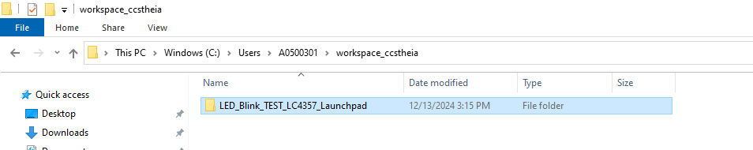

Once you place here you can directly see the project in project Explorer as shown below

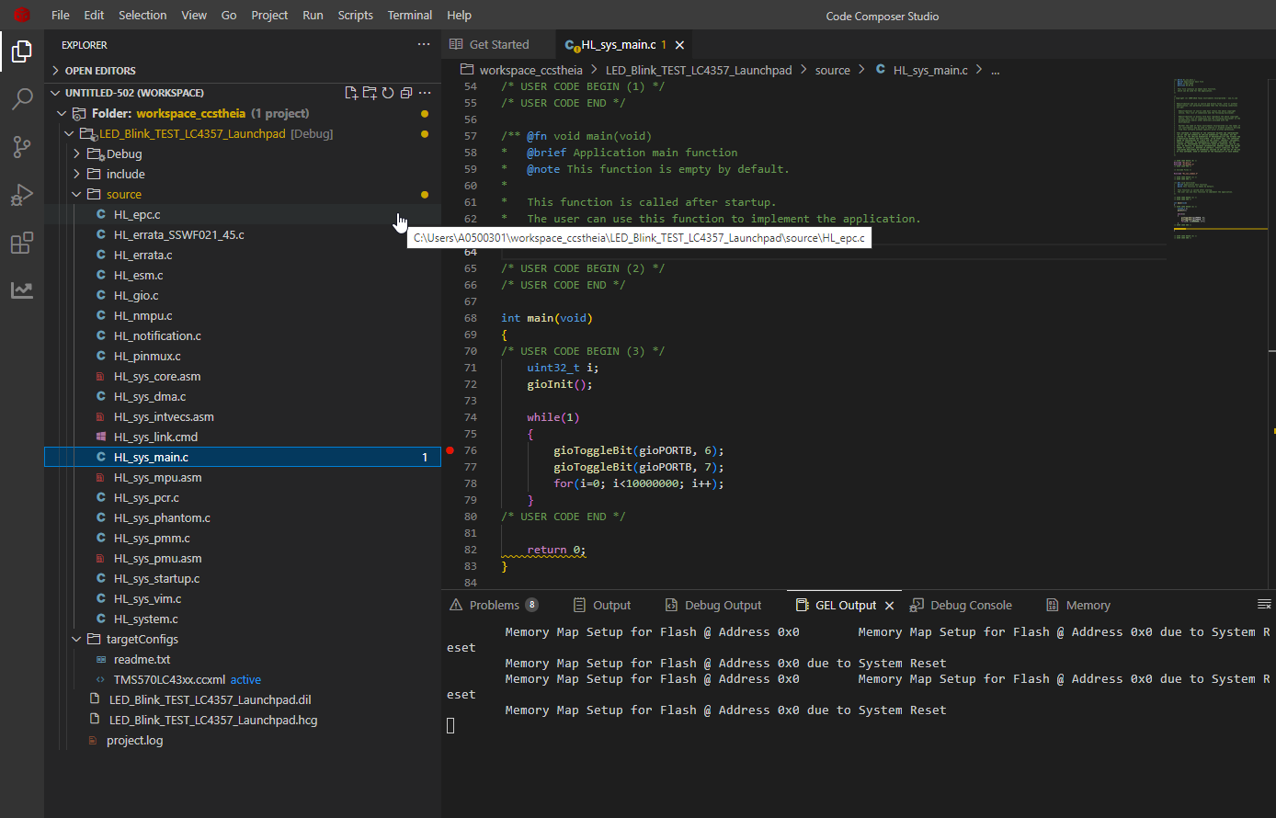

1. Usually all the most of the Hercules project will be build using TI ARM-CGT compiler not on ARM-CGT-CLANG.
2. So first install or copy the ARM-CGT compiler into the compiler folder of the CCS Theia something like below:

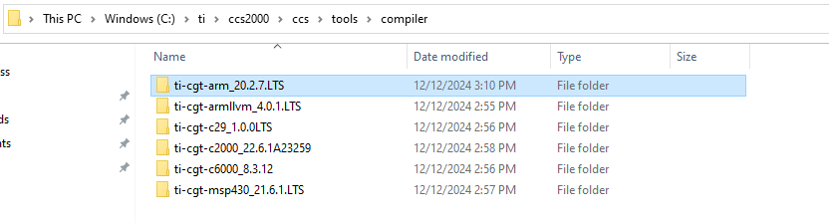

1. Now go to the Code Composer Studio Preferences in Theia like as shown below:

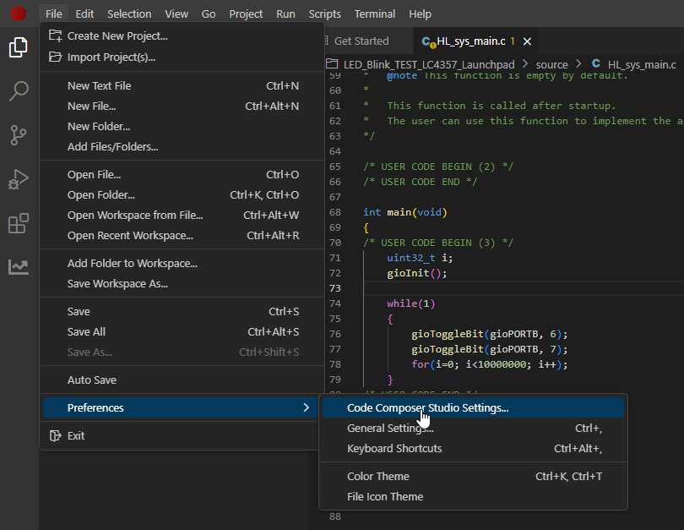

1. Click Refresh button to show the newly added compiler, like below

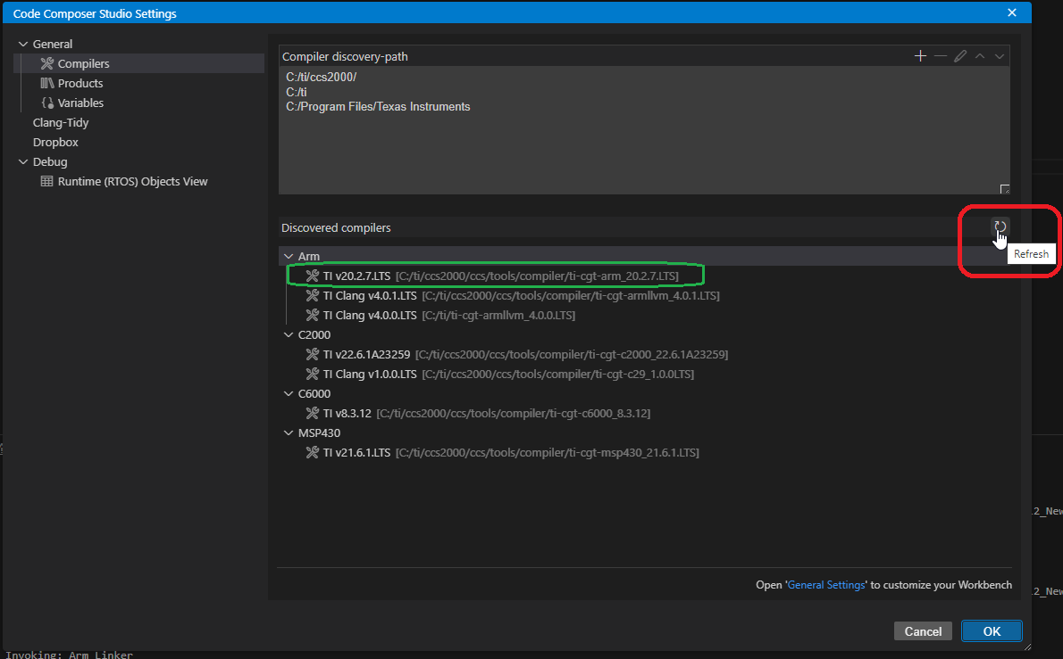

1. Now right click on the project and go to the project properties:

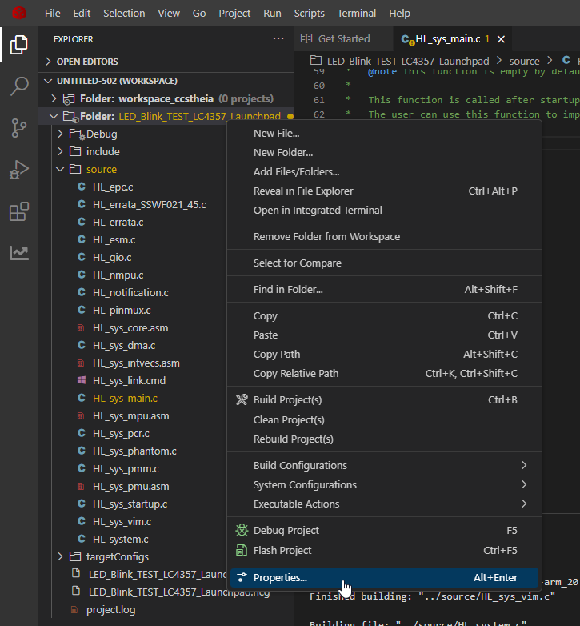

1. Now here select the newly added ARM-CGT compiler

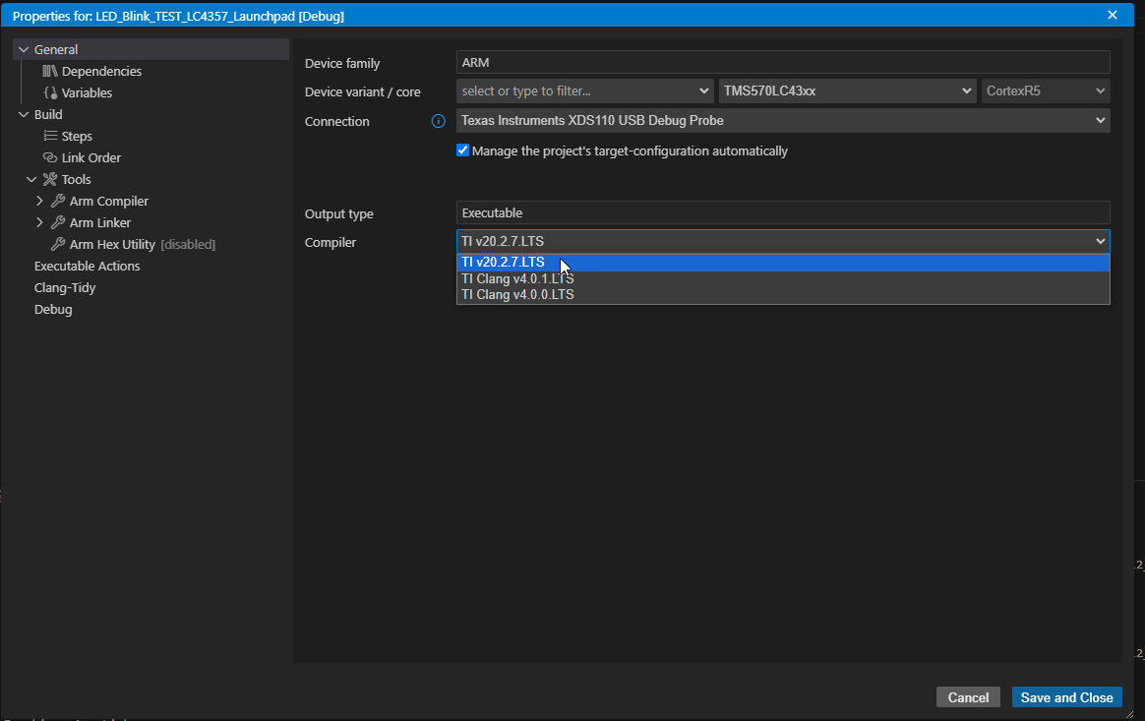

1. Once you select the compiler then you can save and close this window, and then you can build the project:

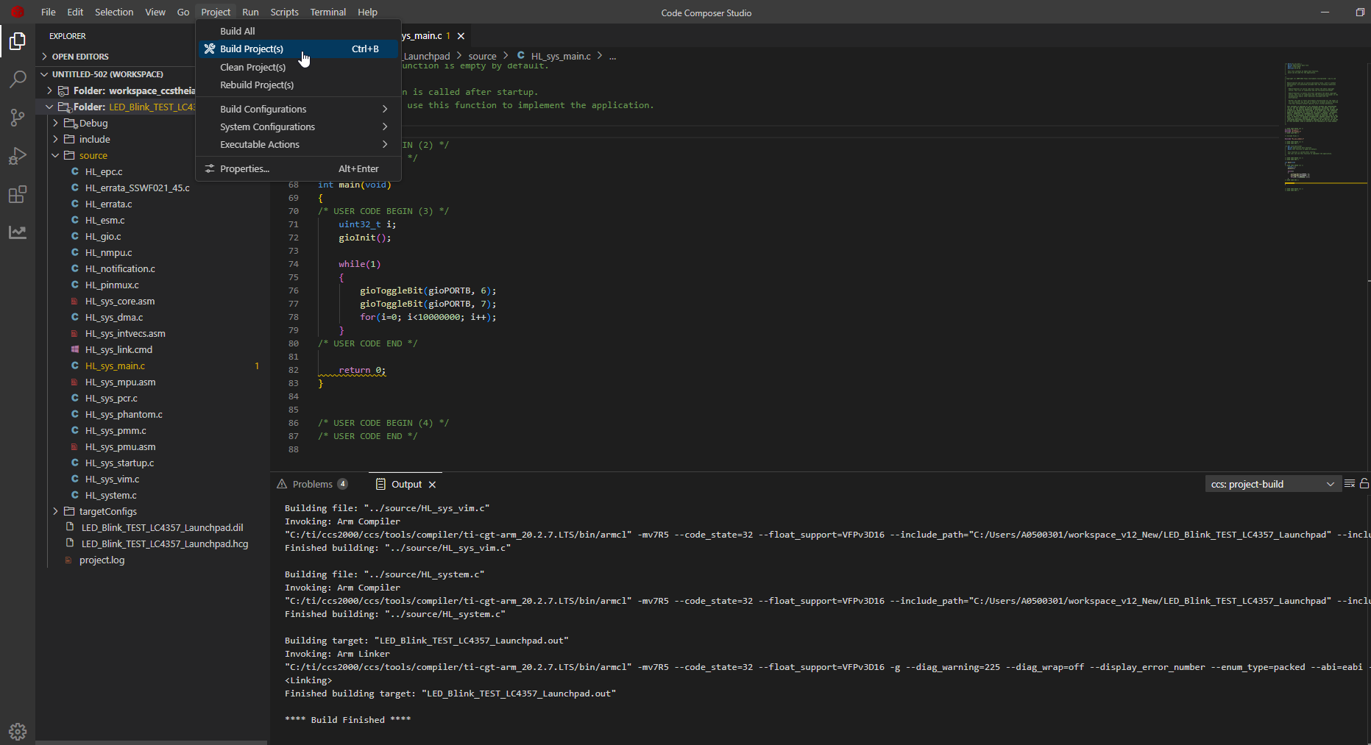

Project should be build without any errors and .out should be generated.

1. Now start debugging your project:

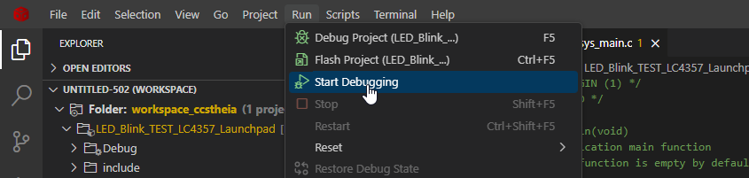

1. Once you click on debugging the code should flash into the controller and debug window should be open.

