Without Commenting Out , when prgm stopped executing

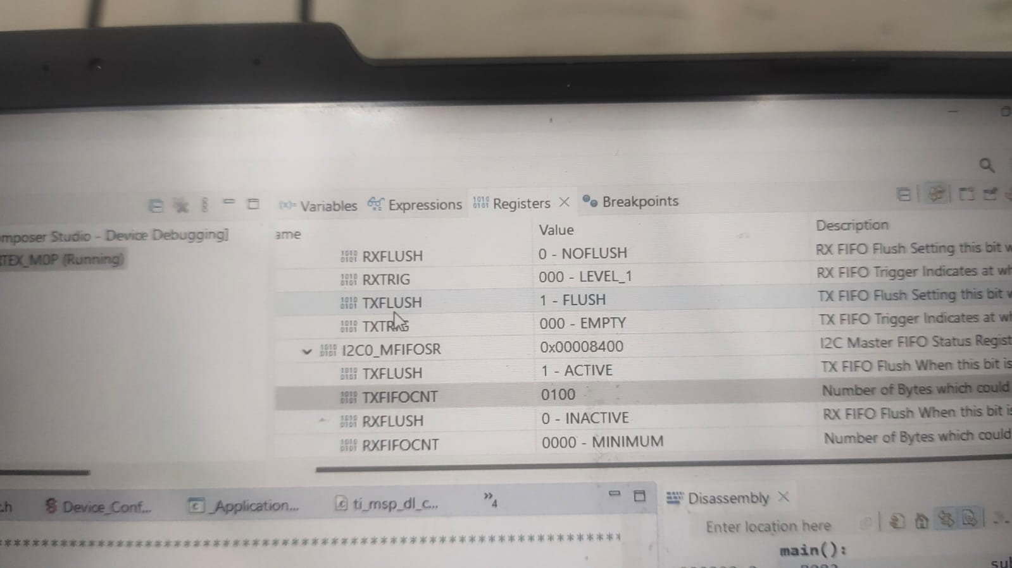

When Customer Comment out the cmd, Timing lines

