SPI_Intr configuration issue for QCA 7006
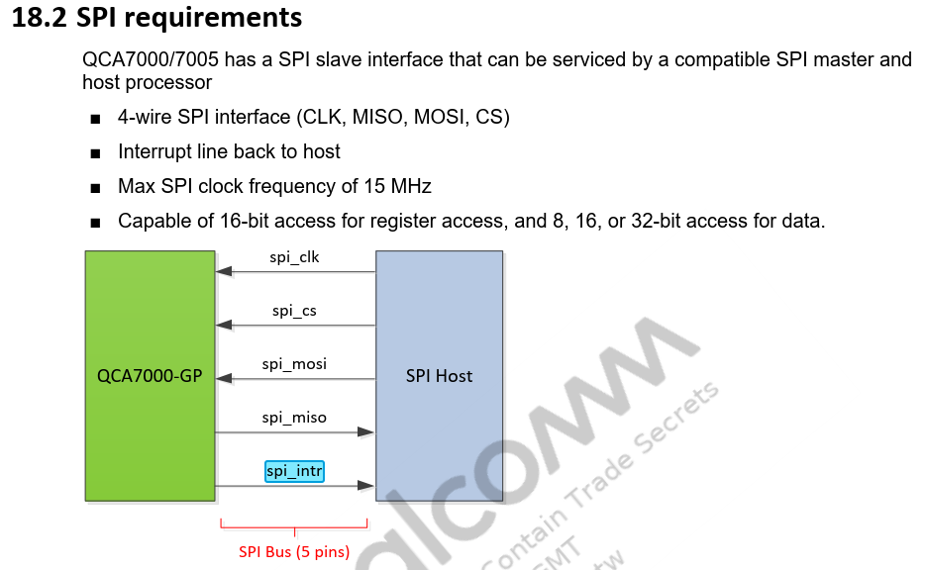
Requirement:
- To receive the interrupt triggered from the PLC Chip on the Spi_Intr line connected to TMS570LS09 using the N2HET1[11]
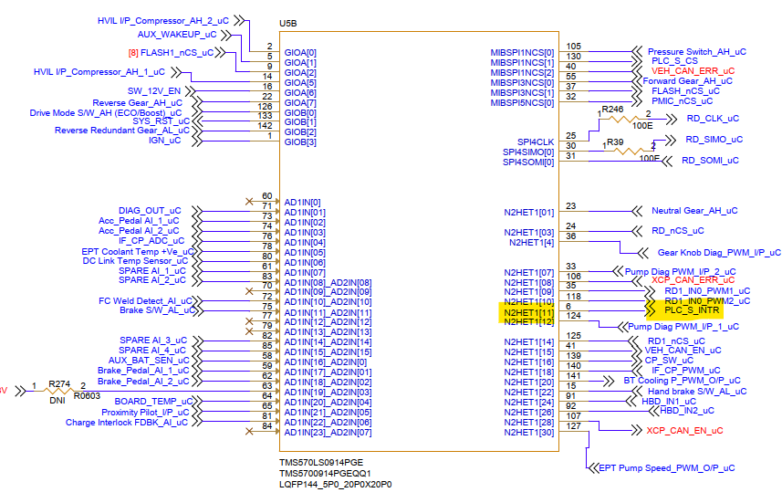
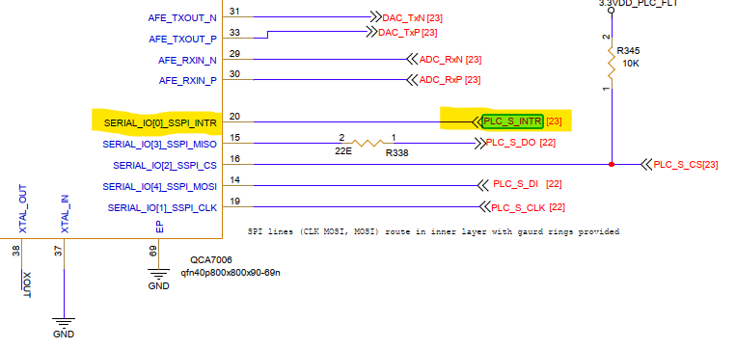
Here in the above snippets it is shown that the SPI_INTR pin of QCA 7006 is connected to N2HET1[11] of the TMS570LS09XX.
- To have the pin number 6(N2HET1[11]) of TMS570LS09 to be used for that purpose, we have configured the ICU and PORT. Please find the configurations of each module in the below snippets
  - PORT: Here the pin 11 of N2HET1 port is configured PORT_PIN_MODE_ICU in the Pin initial mode and Pin mode with the Pin Level value as PORT_PIN_LEVEL_LOW
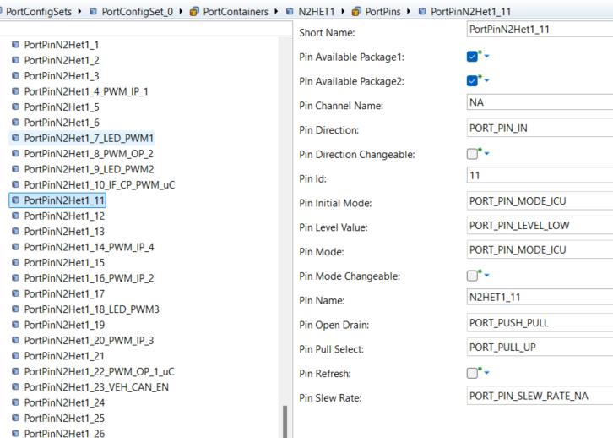
  - ICU: Here we have configured only one ICU channel which refers to N2HET1[11], with the measurement for ICU_MODE_SIGNAL_EDGE_DETECT on ICU_RISING_EDGE.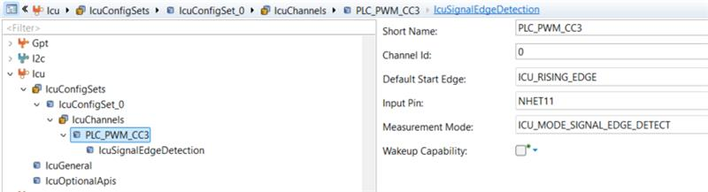
Also, configured the IcuSignalEdgeDetection with the concerned notification function as mentioned below in the snippets

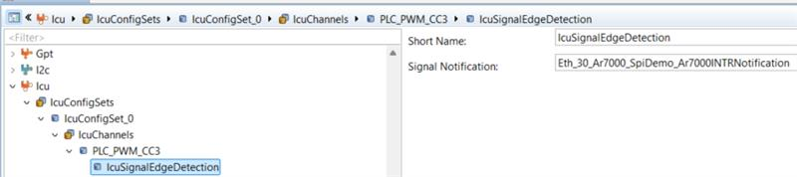
- We have called the Icu_EnableNotification and Icu_SetActivationCondition with the channel id as 0 passed to it.
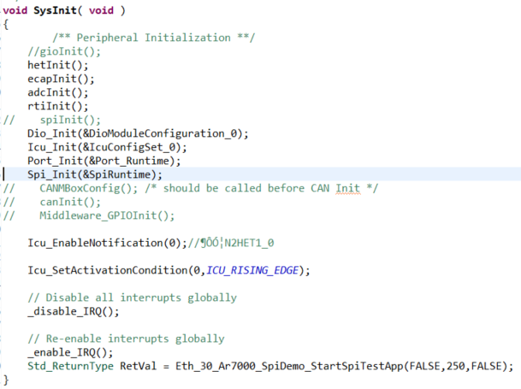

- Also, as per the TMS570LS09 datasheet we have configured the channel 10 for the N2HET1 interrupt in the s_vim_init table.
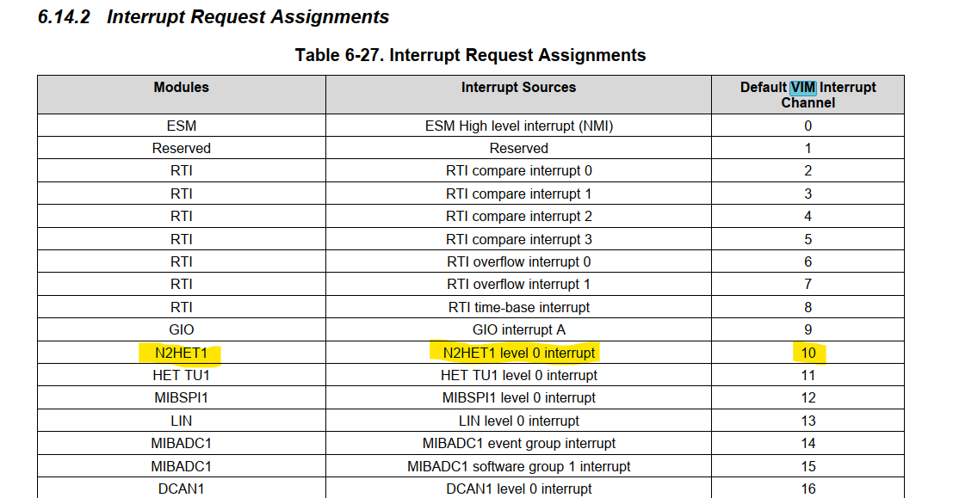
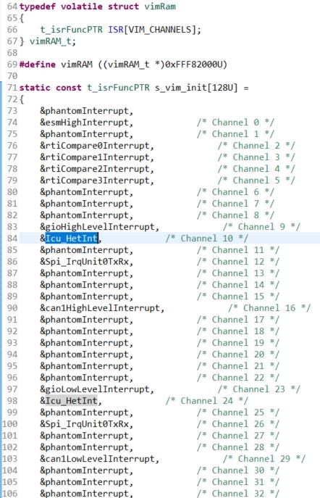
- The below snippet shows the generated table for IcuConfigSet0_HetBlock1_at.
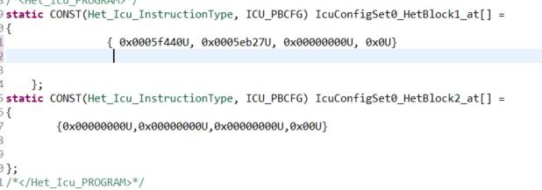

With all the above configurations we are not able to acquire the interrupt from the PLC chip on the channel of ICU configured. Also, we are not able to decrypt the information on the generated IcuConfigSet0_HetBlock1_at to verify it is correctly configured.

SPI configuration issue
As per the configuration present in the VCU_MEML_Spi_ecuc.arxml the attached Spi_cfg and Spi_Pbcg.c are generated. Here below in the snippet I have shared the difference of the Spi_Cfg.h (Generated file– On the right and Manually changed file on the left) file after changing the code manually to make the SPI communication happen successfully.
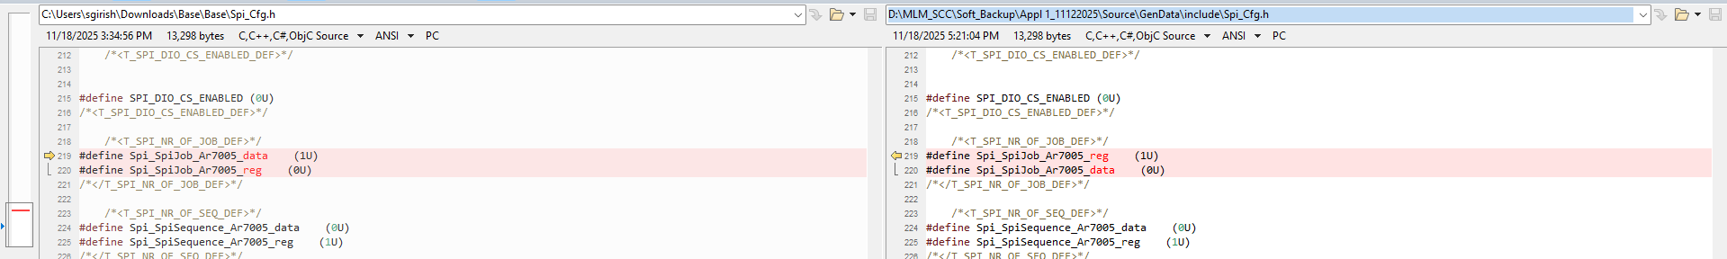
If we are not changing the code then we get the below observations which we discussed yesterday on the call with Shashank.
- The Tx_Buffer for the Register channel is sent as 0xFF, even the TxRegValue is configured as 0x0000
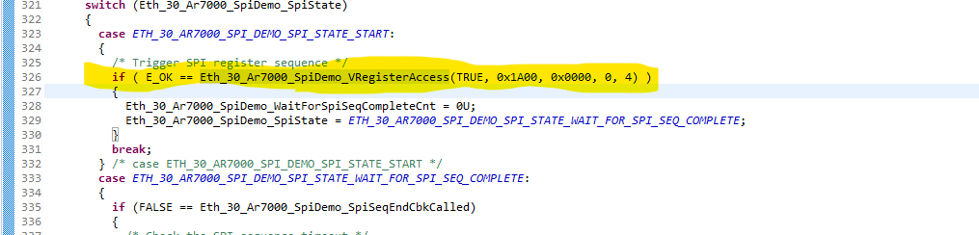
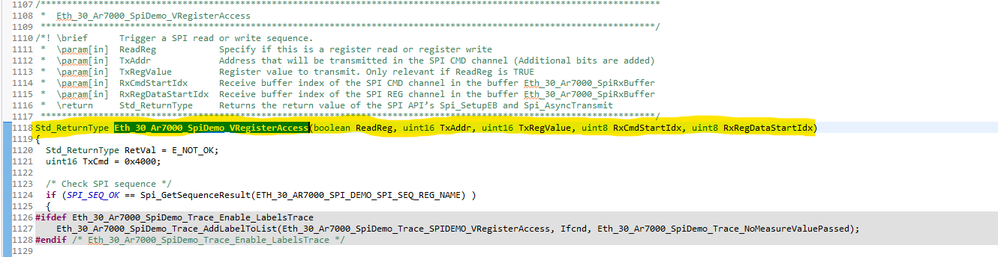
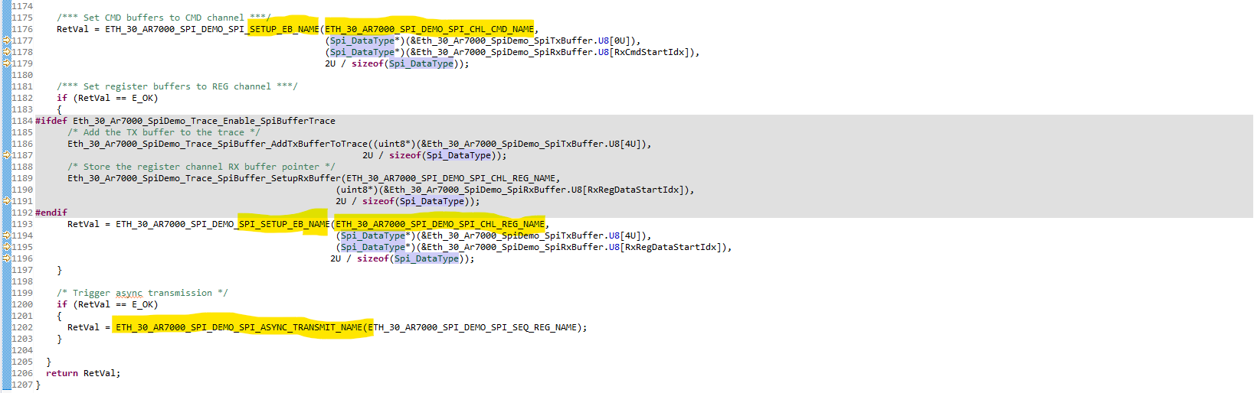
We are able to have this observation only on Mode 2
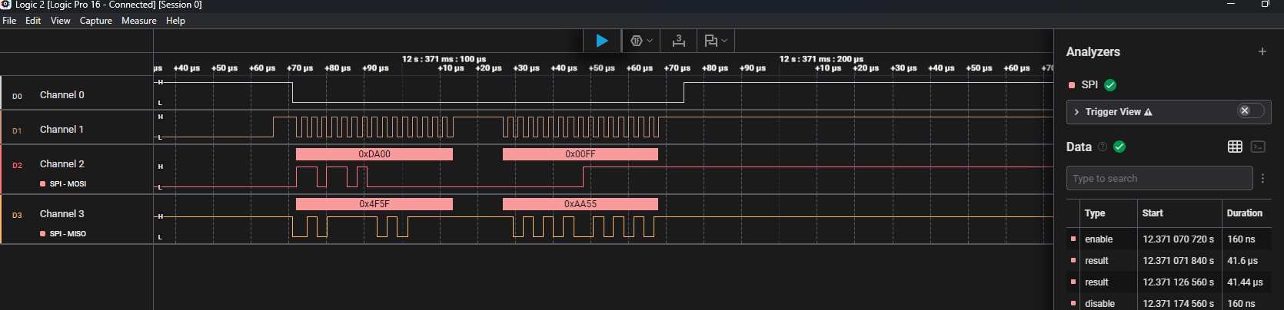
Observation:
- The value 0xFF is getting updated from the DefData_u16 (whose value is 255), when the Spi_Tx_pt is pointing to a NULL_PTR
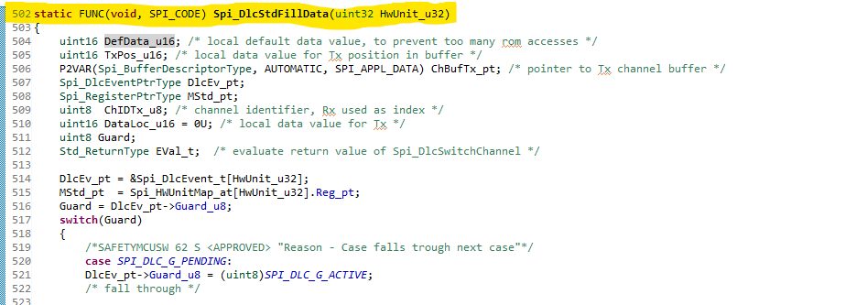
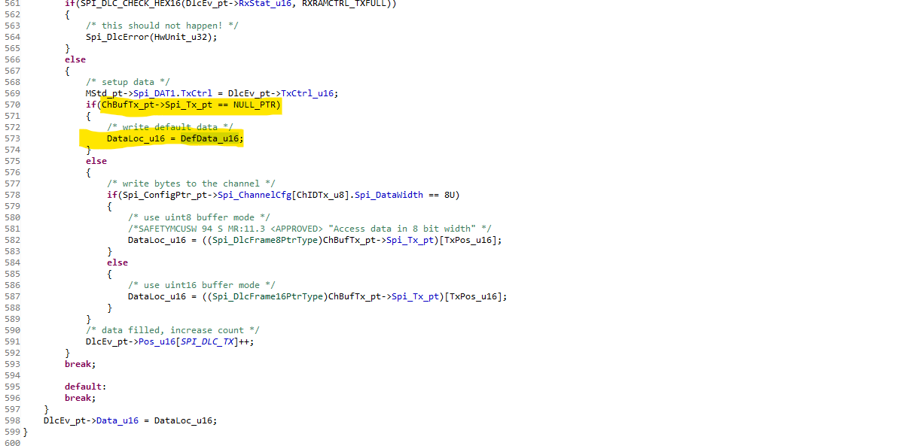
But, as mentioned in the above figure the Spi_Setup_Eb is called with the proper references, and it returns E_OK.

- This is where the actual rx data is copied into buffer in Spi_DlcStdDrainData. This is executed twice but the Actual received value is updated in to the register RXBUFF as 0xAA55 only after that. After this is updated in the RXBuff the dlcstddraindata is not called
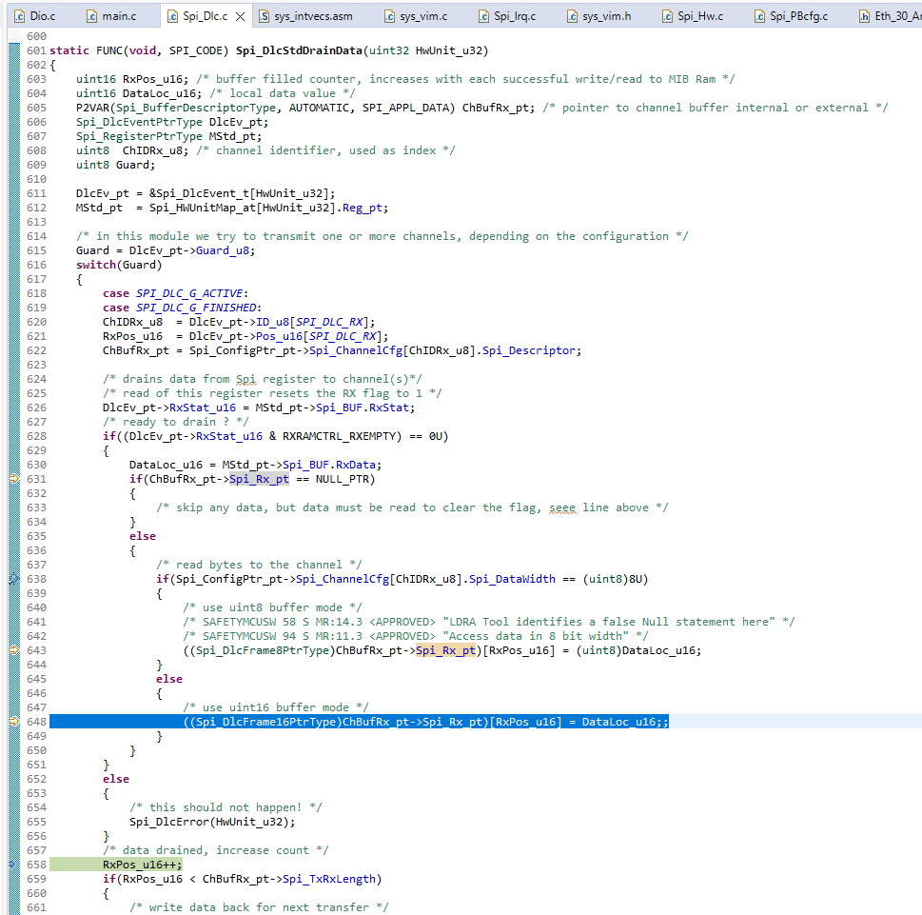

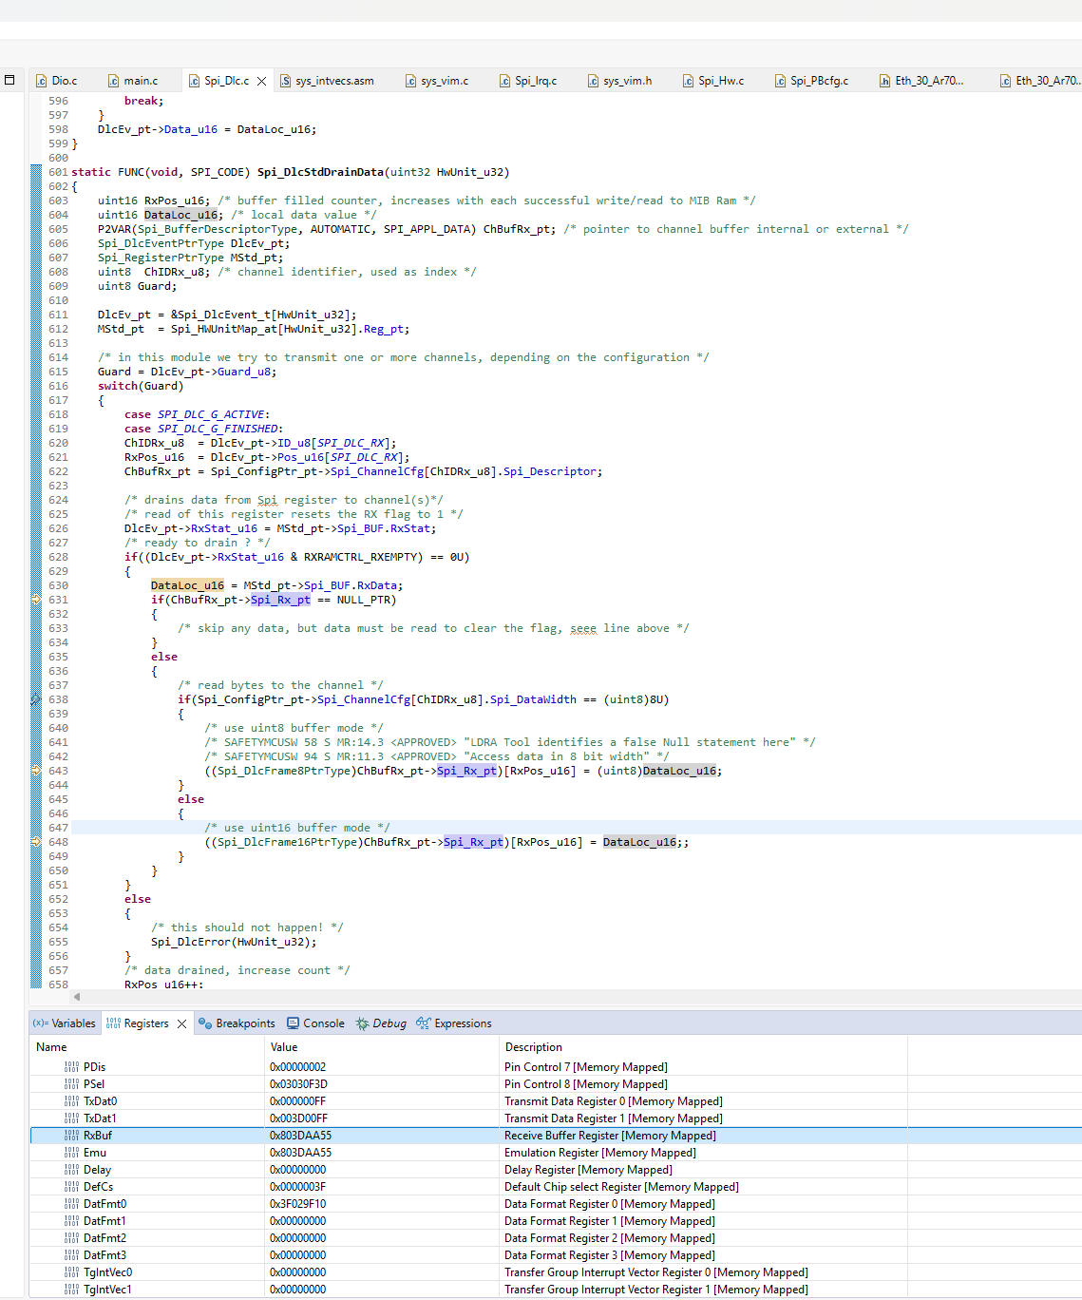

Observation:
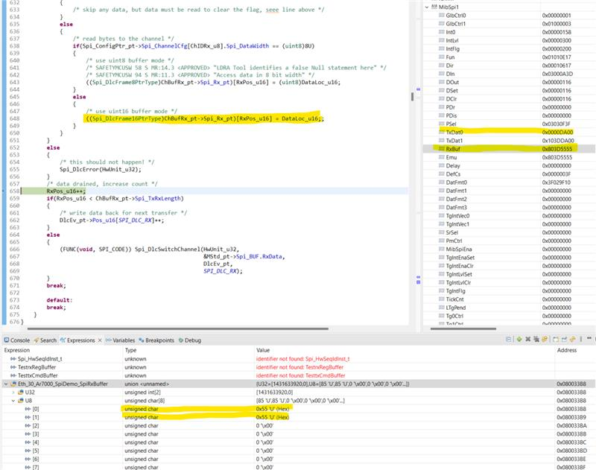
1st time after the first channel is transmitted the RxBuffvalue is 0x803D5555
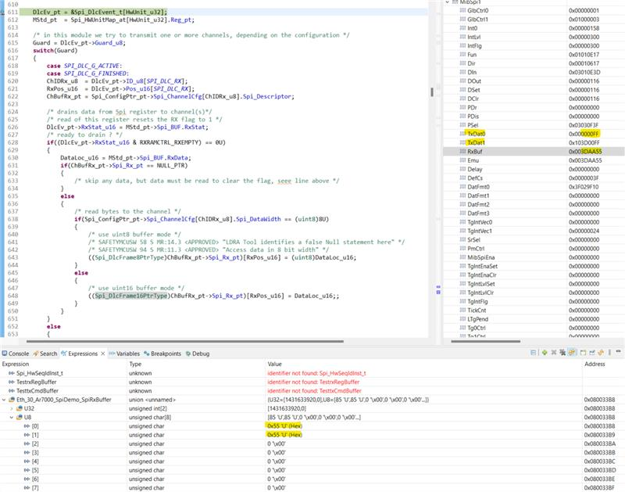
In the next call for the second channel (with actual data 0x0000) transmission before the copy happens the RX_BUFF is holding 0x003DAA55,
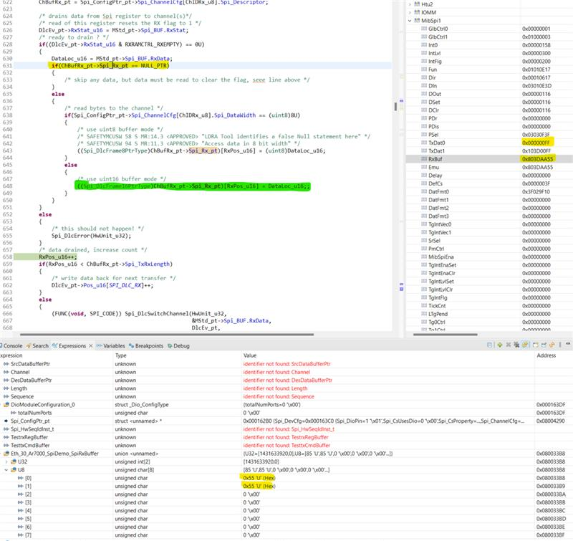
But, in the second iteration the Spi_Rx_Pt is also becoming Null. Because of which the data(0XAA55) is not copied from Register RX_BUFF to the Eth_30_AR7000_Spi_Demo_SpiRxBuffer.
But, as mentioned in the above figure the Spi_Setup_Eb is called with the proper references and it returns E_OK.

