Importing the rest of the simple demo can run, such as pwm_led_light.
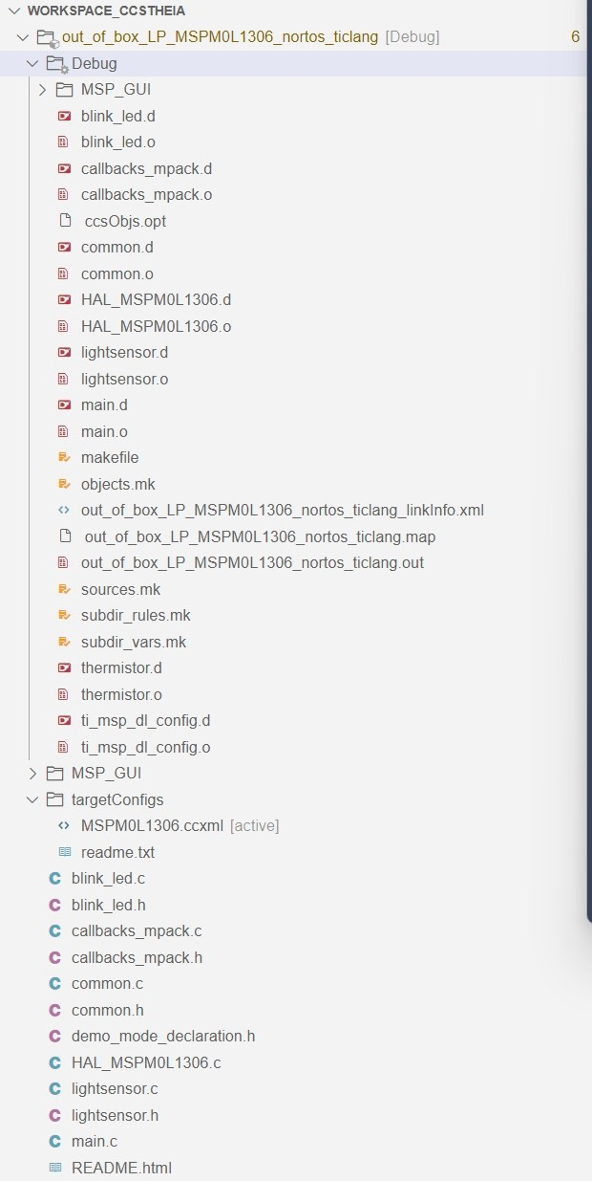
The debug error is as follows：
SEC_AP: DisAsmTPI: Failed to create TPI_DISASM.
Flash Programmer: Error in image size. Length of block is 9644, but it should be divisible by 8 since Flash Programmer writes in 64-bits
Flash Programmer: Error in image size. Length of block is 277, but it should be divisible by 8 since Flash Programmer writes in 64-bits
Error: (Error -1001 @ 0x0) Requested operation is not supported on this device. (Emulation package 12.6.0.00005)
Trouble Halting Target CPU: (Error -2064 @ 0x0) Unable to read device status. Reset the device, and retry the operation. If error persists, confirm configuration, power-cycle the board, and/or try more reliable JTAG settings (e.g. lower TCLK). (Emulation package 12.6.0.00005)
Error: (Error -614 @ 0x0) The target indicates there is an error condition from a previous SWD request. Clear the error the condition, and try the SWD request again. (Emulation package 12.6.0.00005)
Trouble Halting Target CPU: (Error -2064 @ 0x0) Unable to read device status. Reset the device, and retry the operation. If error persists, confirm configuration, power-cycle the board, and/or try more reliable JTAG settings (e.g. lower TCLK). (Emulation package 12.6.0.00005)
Error: (Error -614 @ 0x0) The target indicates there is an error condition from a previous SWD request. Clear the error the condition, and try the SWD request again. (Emulation package 12.6.0.00005)
Trouble Halting Target CPU: (Error -2064 @ 0x0) Unable to read device status. Reset the device, and retry the operation. If error persists, confirm configuration, power-cycle the board, and/or try more reliable JTAG settings (e.g. lower TCLK). (Emulation package 12.6.0.00005)
Error: (Error -614 @ 0x0) The target indicates there is an error condition from a previous SWD request. Clear the error the condition, and try the SWD request again. (Emulation package 12.6.0.00005)
Trouble Halting Target CPU: (Error -2064 @ 0x0) Unable to read device status. Reset the device, and retry the operation. If error persists, confirm configuration, power-cycle the board, and/or try more reliable JTAG settings (e.g. lower TCLK). (Emulation package 12.6.0.00005)
Error: (Error -614 @ 0x0) The target indicates there is an error condition from a previous SWD request. Clear the error the condition, and try the SWD request again. (Emulation package 12.6.0.00005)
Trouble Halting Target CPU: (Error -2064 @ 0x0) Unable to read device status. Reset the device, and retry the operation. If error persists, confirm configuration, power-cycle the board, and/or try more reliable JTAG settings (e.g. lower TCLK). (Emulation package 12.6.0.00005)
Error: (Error -614 @ 0x0) The target indicates there is an error condition from a previous SWD request. Clear the error the condition, and try the SWD request again. (Emulation package 12.6.0.00005)
Trouble Halting Target CPU: (Error -2064 @ 0x0) Unable to read device status. Reset the device, and retry the operation. If error persists, confirm configuration, power-cycle the board, and/or try more reliable JTAG settings (e.g. lower TCLK). (Emulation package 12.6.0.00005)
Error: (Error -614 @ 0x0) The target indicates there is an error condition from a previous SWD request. Clear the error the condition, and try the SWD request again. (Emulation package 12.6.0.00005)
Trouble Halting Target CPU: (Error -2064 @ 0x0) Unable to read device status. Reset the device, and retry the operation. If error persists, confirm configuration, power-cycle the board, and/or try more reliable JTAG settings (e.g. lower TCLK). (Emulation package 12.6.0.00005)
Error: (Error -614 @ 0x0) The target indicates there is an error condition from a previous SWD request. Clear the error the condition, and try the SWD request again. (Emulation package 12.6.0.00005)
Trouble Halting Target CPU: (Error -2064 @ 0x0) Unable to read device status. Reset the device, and retry the operation. If error persists, confirm configuration, power-cycle the board, and/or try more reliable JTAG settings (e.g. lower TCLK). (Emulation package 12.6.0.00005)
Error: (Error -614 @ 0x0) The target indicates there is an error condition from a previous SWD request. Clear the error the condition, and try the SWD request again. (Emulation package 12.6.0.00005)
Trouble Halting Target CPU: (Error -2064 @ 0x0) Unable to read device status. Reset the device, and retry the operation. If error persists, confirm configuration, power-cycle the board, and/or try more reliable JTAG settings (e.g. lower TCLK). (Emulation package 12.6.0.00005)
Error: (Error -614 @ 0x0) The target indicates there is an error condition from a previous SWD request. Clear the error the condition, and try the SWD request again. (Emulation package 12.6.0.00005)
Trouble Halting Target CPU: (Error -2064 @ 0x0) Unable to read device status. Reset the device, and retry the operation. If error persists, confirm configuration, power-cycle the board, and/or try more reliable JTAG settings (e.g. lower TCLK). (Emulation package 12.6.0.00005)
Error: (Error -614 @ 0x0) The target indicates there is an error condition from a previous SWD request. Clear the error the condition, and try the SWD request again. (Emulation package 12.6.0.00005)
Trouble Halting Target CPU: (Error -2064 @ 0x0) Unable to read device status. Reset the device, and retry the operation. If error persists, confirm configuration, power-cycle the board, and/or try more reliable JTAG settings (e.g. lower TCLK). (Emulation package 12.6.0.00005)
Error: (Error -614 @ 0x0) The target indicates there is an error condition from a previous SWD request. Clear the error the condition, and try the SWD request again. (Emulation package 12.6.0.00005)
Trouble Halting Target CPU: (Error -2064 @ 0x0) Unable to read device status. Reset the device, and retry the operation. If error persists, confirm configuration, power-cycle the board, and/or try more reliable JTAG settings (e.g. lower TCLK). (Emulation package 12.6.0.00005)
Error: (Error -614 @ 0x0) The target indicates there is an error condition from a previous SWD request. Clear the error the condition, and try the SWD request again. (Emulation package 12.6.0.00005)
Trouble Halting Target CPU: (Error -2064 @ 0x0) Unable to read device status. Reset the device, and retry the operation. If error persists, confirm configuration, power-cycle the board, and/or try more reliable JTAG settings (e.g. lower TCLK). (Emulation package 12.6.0.00005)
Error: (Error -614 @ 0x0) The target indicates there is an error condition from a previous SWD request. Clear the error the condition, and try the SWD request again. (Emulation package 12.6.0.00005)
Trouble Halting Target CPU: (Error -2064 @ 0x0) Unable to read device status. Reset the device, and retry the operation. If error persists, confirm configuration, power-cycle the board, and/or try more reliable JTAG settings (e.g. lower TCLK). (Emulation package 12.6.0.00005)
Error: (Error -614 @ 0x0) The target indicates there is an error condition from a previous SWD request. Clear the error the condition, and try the SWD request again. (Emulation package 12.6.0.00005)
Trouble Halting Target CPU: (Error -2064 @ 0x0) Unable to read device status. Reset the device, and retry the operation. If error persists, confirm configuration, power-cycle the board, and/or try more reliable JTAG settings (e.g. lower TCLK). (Emulation package 12.6.0.00005)
Error: (Error -614 @ 0x0) The target indicates there is an error condition from a previous SWD request. Clear the error the condition, and try the SWD request again. (Emulation package 12.6.0.00005)
Trouble Halting Target CPU: (Error -2064 @ 0x0) Unable to read device status. Reset the device, and retry the operation. If error persists, confirm configuration, power-cycle the board, and/or try more reliable JTAG settings (e.g. lower TCLK). (Emulation package 12.6.0.00005)
Error: (Error -614 @ 0x0) The target indicates there is an error condition from a previous SWD request. Clear the error the condition, and try the SWD request again. (Emulation package 12.6.0.00005)
Trouble Halting Target CPU: (Error -2064 @ 0x0) Unable to read device status. Reset the device, and retry the operation. If error persists, confirm configuration, power-cycle the board, and/or try more reliable JTAG settings (e.g. lower TCLK). (Emulation package 12.6.0.00005)
Error: (Error -614 @ 0x0) The target indicates there is an error condition from a previous SWD request. Clear the error the condition, and try the SWD request again. (Emulation package 12.6.0.00005)
Trouble Halting Target CPU: (Error -2064 @ 0x0) Unable to read device status. Reset the device, and retry the operation. If error persists, confirm configuration, power-cycle the board, and/or try more reliable JTAG settings (e.g. lower TCLK). (Emulation package 12.6.0.00005)
Error: (Error -614 @ 0x0) The target indicates there is an error condition from a previous SWD request. Clear the error the condition, and try the SWD request again. (Emulation package 12.6.0.00005)
Trouble Halting Target CPU: (Error -2064 @ 0x0) Unable to read device status. Reset the device, and retry the operation. If error persists, confirm configuration, power-cycle the board, and/or try more reliable JTAG settings (e.g. lower TCLK). (Emulation package 12.6.0.00005)
Unable to determine target status after 20 attempts
Failed to remove the debug state from the target before disconnecting. There may still be breakpoint op-codes embedded in program memory. It is recommended that you reset the emulator before you connect and reload your program before you continue debugging

